Quantic Backend Portal

A Simple Step-By-Step Guide

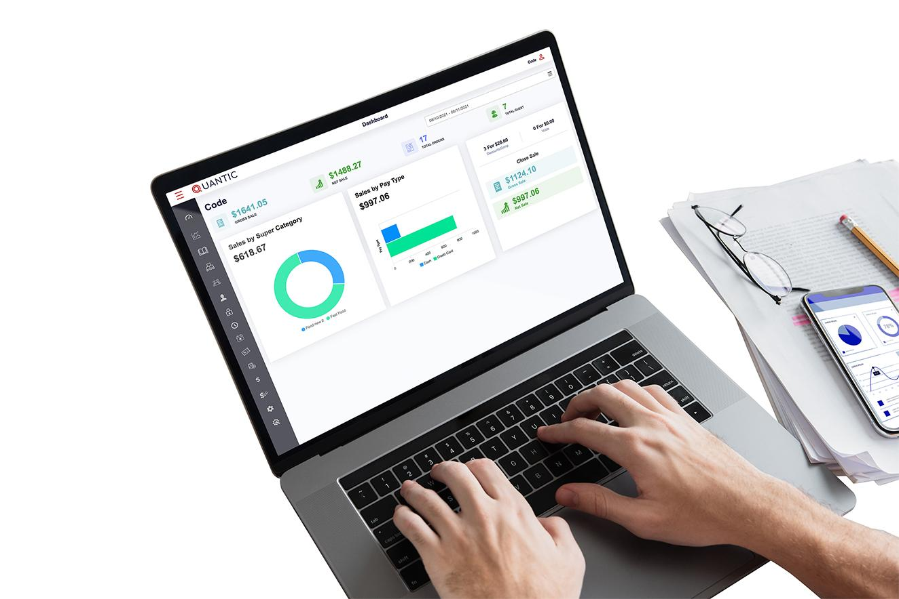

**Table of Contents**

**How to Create or Edit the Menu?** **4**

Create a Super Category 5

Create a Category 7

Create a Sub Category 11

Add item(s) to the menu 14

How to associate modifiers to categories or items? 21

Create a Modifier group 24

Create a Modifier 27

**How to Update a Catalog Using a CSV File?** **30**

**How to create combo meals in Quantic POS?** **33**

**Bulk Price Editor** **36**

How to update the price of a single item? 36

How to update the item prices in bulk? 37

How to increase/decrease the item(s) price by a fixed amount? 39

How to increase/decrease the item(s) price by a fixed percent? 41

**How to add Employees?** **43**

How to give portal access to existing employees? 45

How to generate QR code from the backend portal? 47

How to add a pay rate for an employee? 48

How to set up Only Clock In access for an employee? 50

**How to use Enterprise Data Management?** **52**

How to upload a .csv file to the backend portal? 52

How to push data to child locations? 54

**How to transfer sales?** **55**

**How to enable Inventory?** **56**

**How to use Time Management?** **58**

How to add Clock In/Clock Out time for any employee? 58

**How to add customers?** **60**

**How to create a new role?** **65**

**How to create a coupon?** **67**

Redeeming the Coupon 70

**Inventory Management** **72**

Creating a new Vendor 72

Adding a Designer 73

Adding a new Manufacturer 76

How to Add Inventory? 78

**How to Generate a Purchase Order?** **82**

Receiving a Purchase Order 85

**How to apply auto-gratuity based on the balance due?** **87**

**Adding General Information in the backend portal** **90**

**Adding and Setting up the Service Area** **93**

Adding the Service Area 93

Setting up the Service Area 96

**Adding the Tax Class** **98**

**Setup the User Defined Payment method** **99**

**How to create a meal period based menu?** **100**

Create a Meal Period 100

Associate the meal period with an item 103

Associate the meal period with a category 105

**Table Management** **106**

Adding a new table 108

Modifying the existing table 111

How does the table layout appear on the POS? 112

**How to Setup the Promotional Price from the Portal?** **114**

Setup the Promotion Rule 114

Setup the promotion 118

Associate an item with the promotion 120

**How to Create a Terminal Based Menu?** **123**

Enable the Terminal Based Menu Configuration 124

Filtering the Categories by Terminal 126

**Setup and Display Suggested Tip Amount on Receipt** **129**

Enabling the Suggested Tips on Receipt 129

Customizing the Suggested Tips for Each Service Area 130

Applying Tip Amount on the POS 132

**How to Setup and Display QR Code on the Receipt** **134**

Enabling the QR Code on the Receipt 135

Printing Receipt from the POS 135

## **How to Create or Edit the Menu?**

You can add a **Menu** from the **Catalog** section of the Quantic backend portal. Check the screenshot and keep following the instructions underneath.

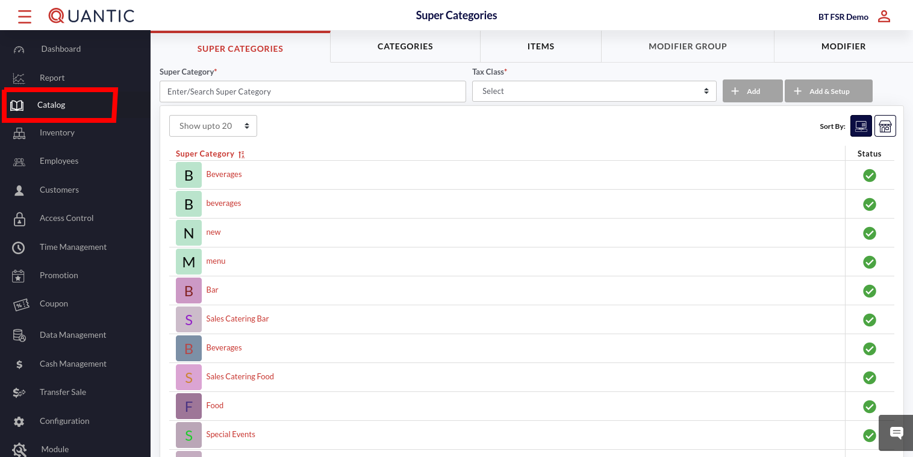

* Click the left navigation button, and click **Catalog** from the left panel.
* From here you can create, add or modify a menu. Now follow the below instructions in their given order to add the menu.

### **Create a Super Category**

Super Category is the parent category that is created to track your revenue for various groups based on association. This is used to consolidate groups into broader categories such as **Food** or **Alcohol** for high sales reporting purposes.

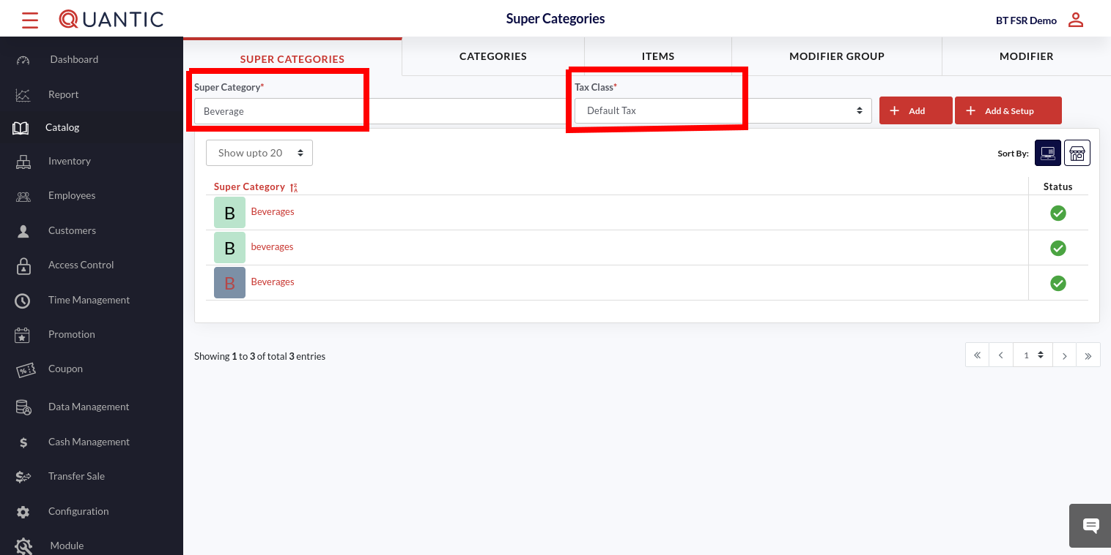

* To create a new **Super Category,** click **Super Category** located on the top left of the Menu Management screen.
* Now enter the name that you want to assign to a new Super Category.
* Select the **Tax Class,** and click the ➕ **Add** button.

You can also edit the existing Super Categories by clicking the name of the super-category and following the further instructions.

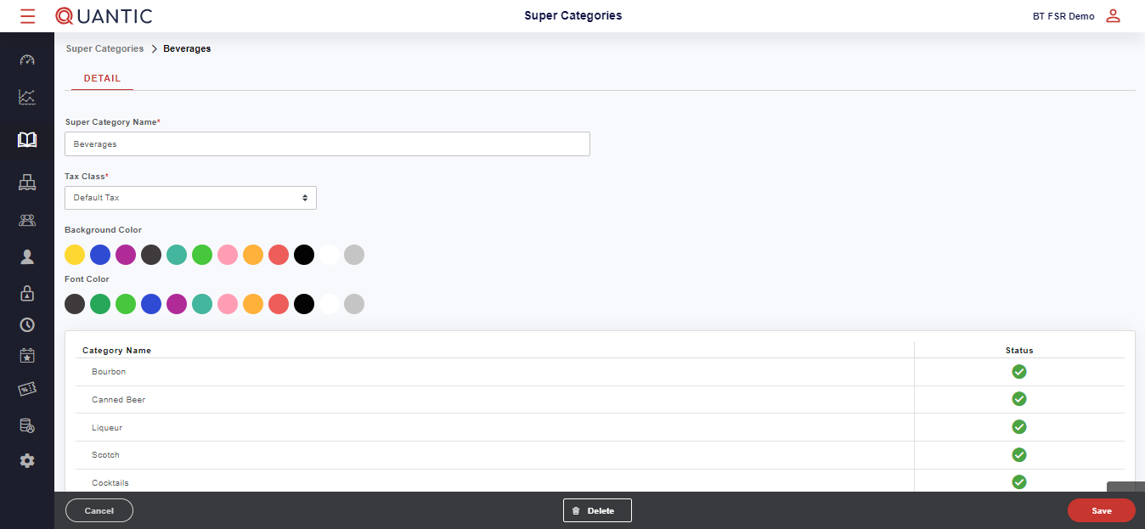

* The above screen will appear, here you can select a **Background** and **Font Color** from the color grid.
* Also, you can add different categories at the bottom.
* Any category can be disabled by selecting ❌ or ✅ under the **Status** section. Once done, click **Save** at the bottom right corner to create/modify a Super Category.

### **Create a Category**

After creating a Super Category, the next step is to create a Category and Sub Category. Categories and subcategories should reflect how your actual menu is organized or should be displayed for easy navigation.

Categories will inherit all settings for the Super Category and Subcategories will automatically inherit the Category settings, unless otherwise specified.

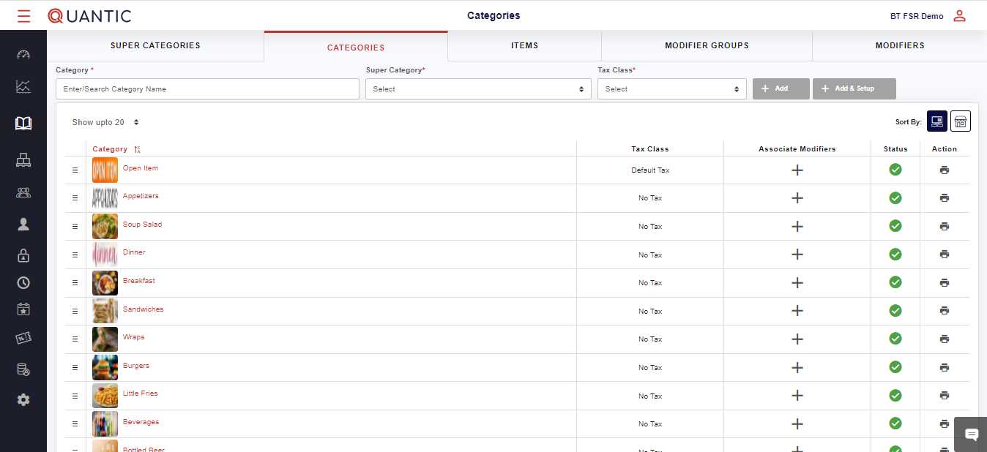

* To create the **Category**, click the **Categories** tab on top of the **Menu Management** screen.
* Now enter the name that you want to assign to a new Category.
* Select the **Super Category,** select the **Tax Class,** and click the ➕ Add & Setup button.

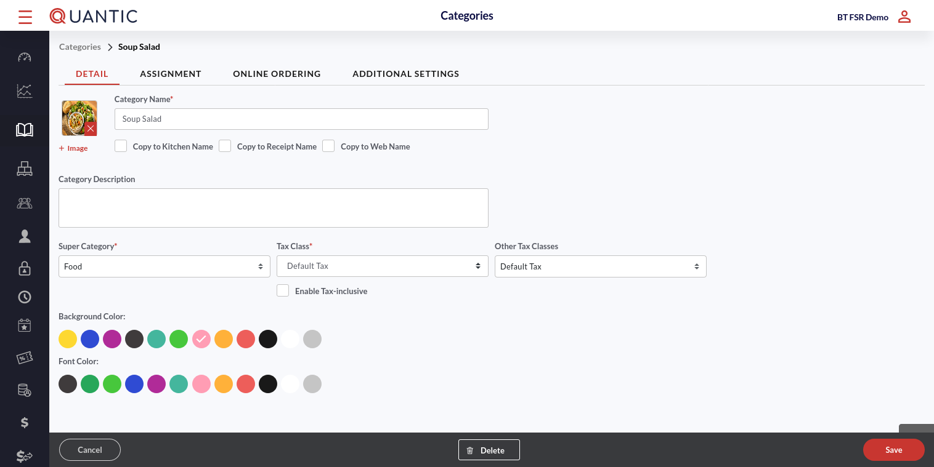

* Fill in all required fields as indicated in the screenshot. Add the image of the category in the image box. Enter the category name in the **Category Name** field.
* Tap the checkboxes next to **Copy to Kitchen name, Copy to Receipt name and Copy to Web name** (if you want to keep the same name of categories at these places).
* Select the **Super Category, Tax Class,** and **Other** **Tax Class** from the dropdown.
* Set the **Background color** and the **Font color** for the sub-category name in the POS.

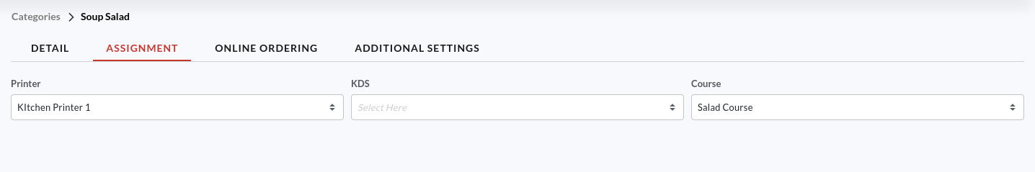

* Click the **Assignment** tab.
* Now select the **Printer**, **KDS**, and **Course** that you want to associate this category with.

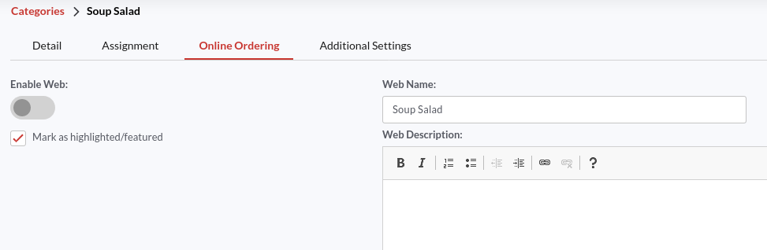

* Click the **Online Ordering** tab.
* To activate this category for online ordering, turn on the switch next to **Enable Web** and enter the name in **Web Name** field with which you want this category to be recognized in online ordering.
* To mark this as a featured category, ✔️ the checkbox next to **Mark as Highlighted/Featured**.
* You may also describe this category in the **Web Description** field. This description will show up on the location’s online platforms next to the category.

| **Note**: On enabling web at category level, all the associated sub-categories and items will inherit the same setting only if the **Inherit Online** is enabled for that sub-category or item.  The sub-category will inherit the sub-category name as a web name.  The item will inherit item price as web price, item name as web name, and item description as web description. |
| --- |

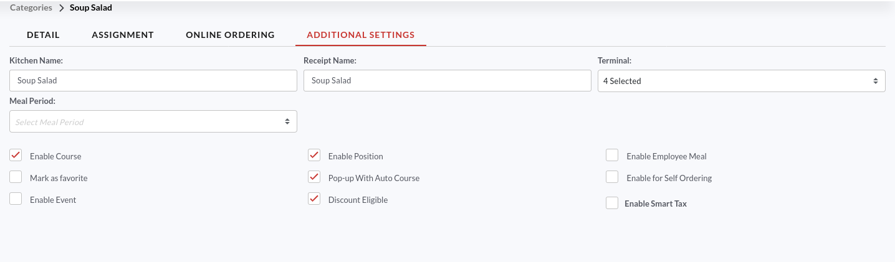

* Now go to the **Additional Settings** tab.
* Enter the name of the category you want to display in the **Kitchen printer** and **Receipt**.
* Select the **Terminal** to be associated with this category.
* Fill in the other details and click **Save** at the bottom right corner.

### **Create a Sub Category**

Creating subcategories will break things further for easier navigation for large categories.

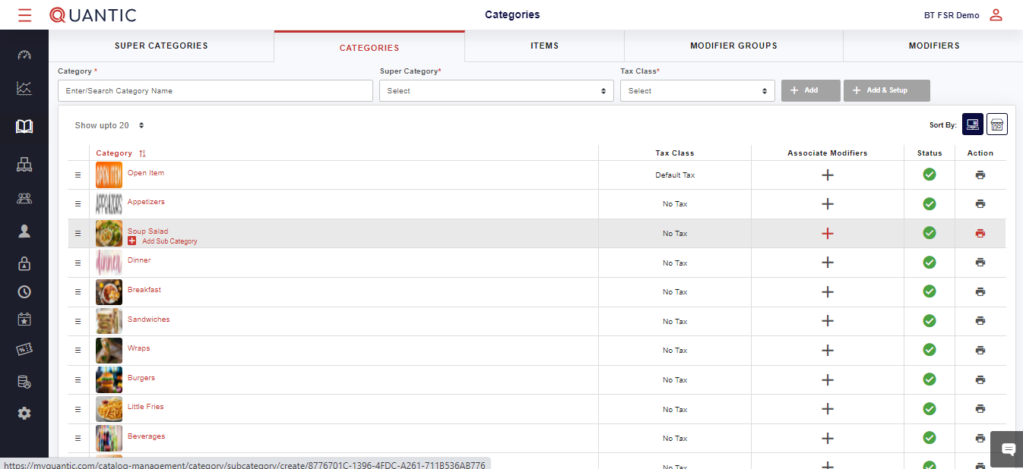

* To create a subcategory click on the ➕ **Add Sub-category** icon underneath the associated Category as displayed in the screenshot.

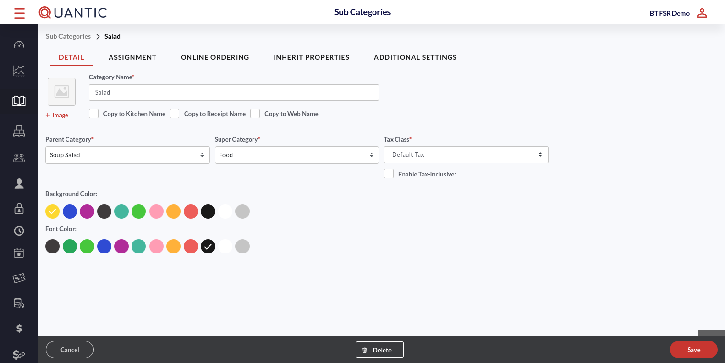

* Fill in all required fields as indicated in the screenshot. Add the image of the sub-category in the image box. Enter the sub-category name in the **Category Name** field.
* Tap the checkboxes next to **Copy to Kitchen name, Copy to Receipt name and Copy to Web name** (if you want to keep the same name of sub-categories at these places).
* Select the **Parent Category, Super Category**, and **Tax Class** from the dropdown.
* Set the **Background color** and the **Font color** for the sub-category name in the POS.

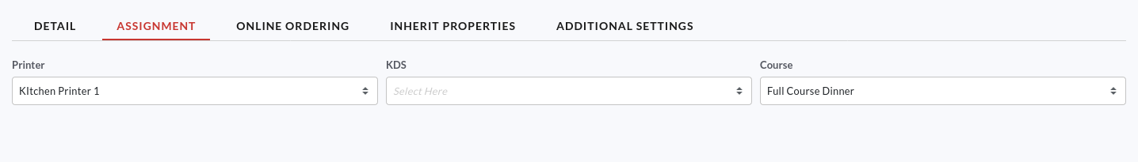

* Click the **Assignment** tab.
* Now select the **Printer**, **KDS**, and **Course that** you want to associate this sub-category with.

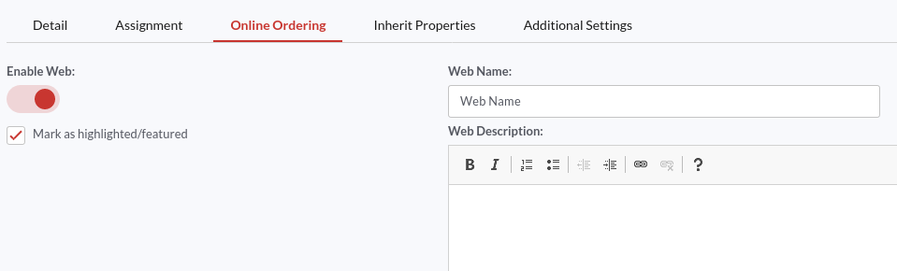

* Click the **Online Ordering** tab.
* To activate this sub-category for online ordering, turn on the switch next to **Enable Web** and enter the name with which you want this sub-category to be recognized for online order.
* To mark this as a featured sub-category, ✔️ the checkbox next to Mark as Highlighted/Featured.

| **Note**: **Enable Web** will be enabled automatically for this sub-category if the **Enable Web** is activated for its parent category and the **Inherit Online** is enabled for this sub-category. In such a scenario, the sub-category name will automatically appear in the web name. |
| --- |

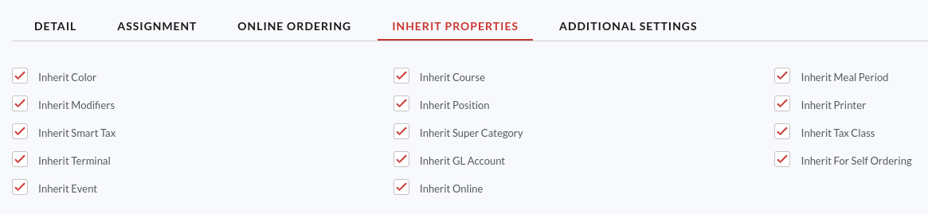

* Click the **Inherit Properties** tab.
* Here you will see that by default all boxes are marked. If you do not want the sub-category to inherit a specific setting, uncheck the box next to that setting.

| **Note**: If **Inherit Online** is selected, this sub-category will inherit the settings from the Online Ordering tab. |
| --- |

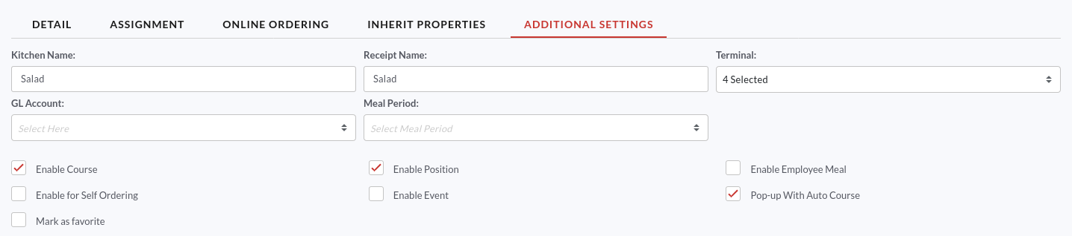

* Now go to the **Additional Settings** tab.
* Enter the name of the sub-category you want to display in the **Kitchen printer** and **Receipt**.
* Select the **Terminal** to be associated with this sub-category.
* Fill in the other details and click **Save**.

### **Add item(s) to the menu**

Adding an item to the menu is the same as creating a category. Here you can add/edit sale price, and create more specific settings such as adding custom colors, modifiers, images, or changing printers.

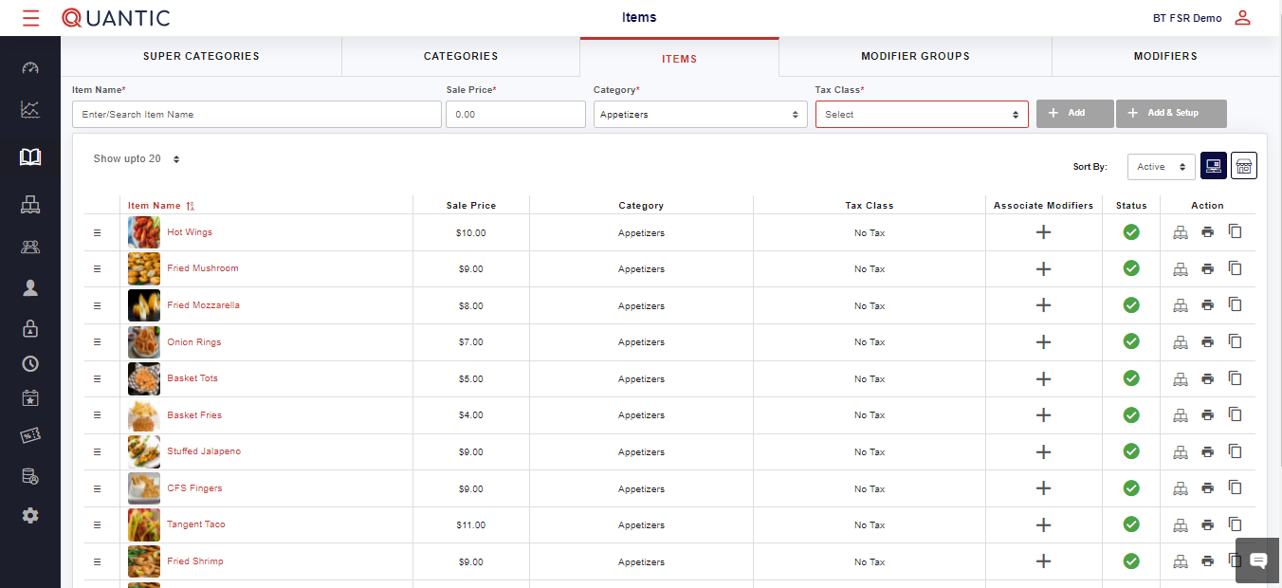

* Click the **Item** tab located on the top of the **Menu Management** screen.
* Now enter the name that you want to add and enter the **Sale Price**.
* Click the box underneath the **Category**.
* On the drop-down list, select the category/subcategory to be associated with the item being created.
* Select the **Tax Class** and click the ➕ **Add & Setup** button (in Red).

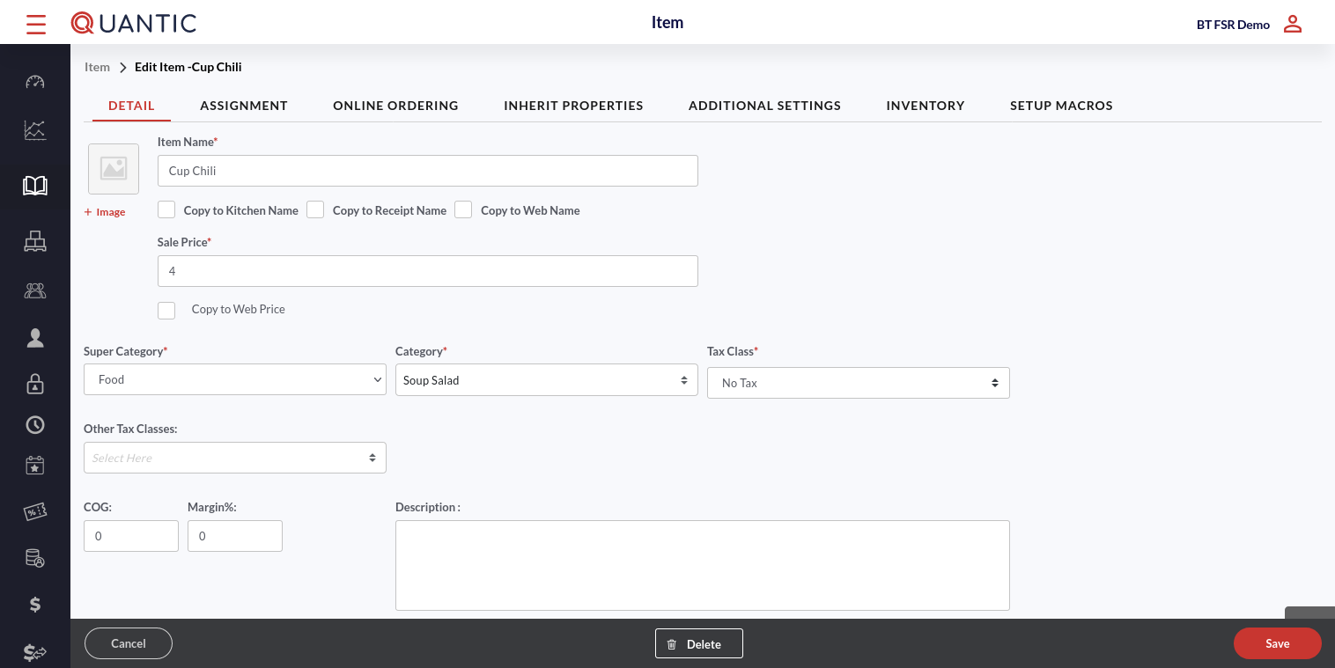

* Fill in all required fields as indicated in the screenshot. Add the image of the item in the image box. Enter the item name in the **Item Name** field.
* Tap the checkboxes next to **Copy to Kitchen name, Copy to Receipt name and Copy to Web name** (if you want to keep the same name of the item at these places).
* Enter the **Sale Price.** If you wish to keep the item price the same for the online orders, check the box next to **Copy to Web Price**.
* Now select the **Super Category, Category**, and **Tax Class** from the dropdown.
* Fill in other details including the **Background color** and the **Font color** for the item name in the POS.

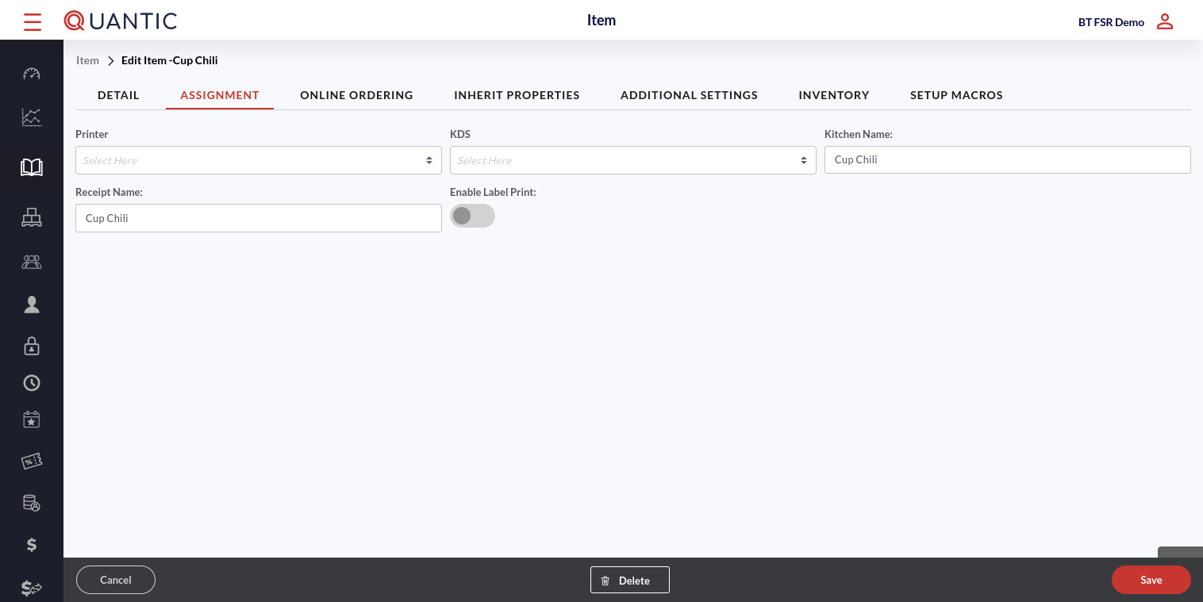

* Click the **Assignment** tab.
* Now select the **Printer** and **KDS** that you want to associate this item with.
* Enter the item name for the kitchen printer and receipt in the Kitchen Name and Receipt Name.

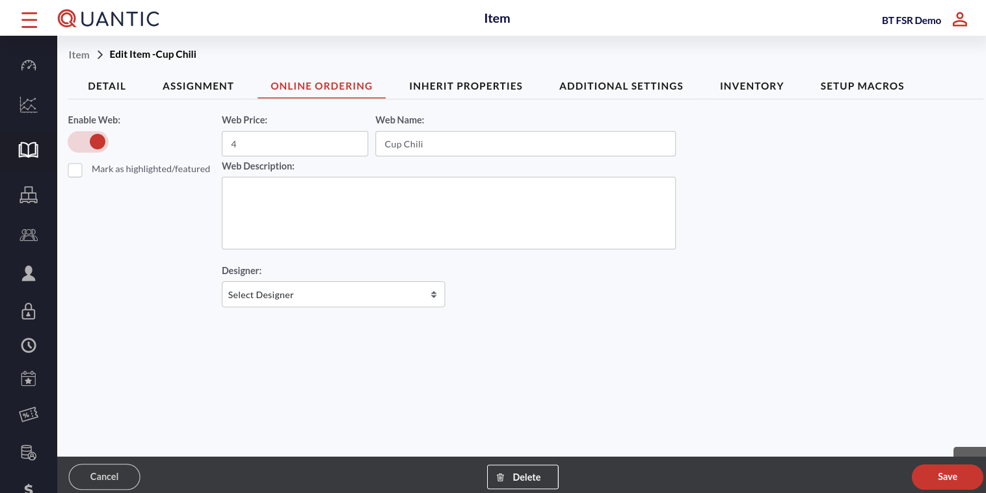

* Click the **Online Ordering** tab.
* To activate this item for online ordering, turn on the switch next to **Enable Web**.
* Enter the item name in Web Name with which you want this item to be recognized for online orders.
* Enter the item price for online orders in the **Web Price** field.
* To mark this as a featured sub-category, ✔️ the checkbox next to **Mark as Highlighted/Featured**.
* Enter the item description that you want to show up for online orders and select the Designer.

| **Note**: If the **Enable Web** is activated for the parent category and **Inherit Online** is activated for this item, it will have **Enable Web** automatically turned on. The item price will be reflected as web price, item name as web name, and item description as web description. |
| --- |

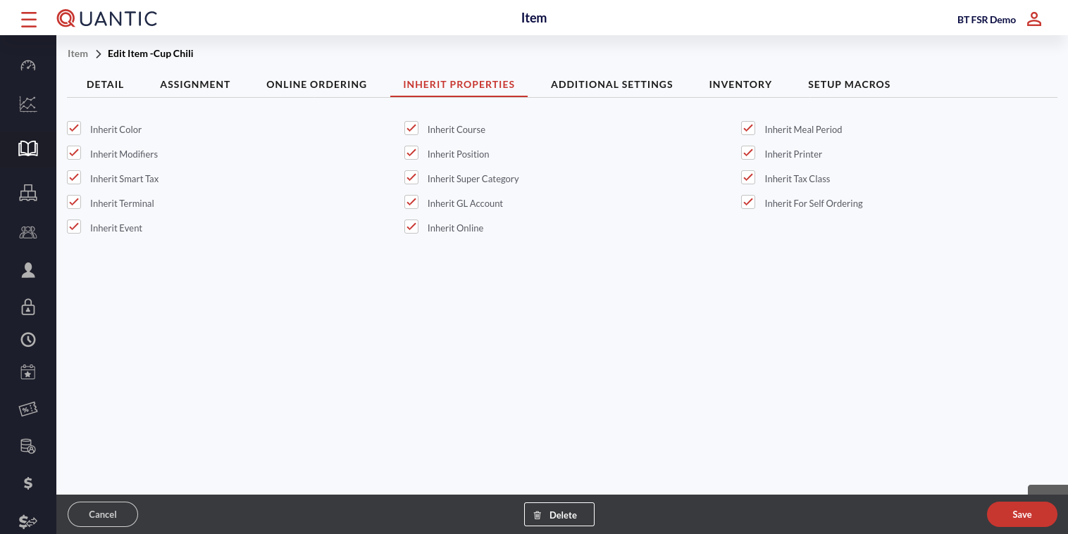

* Click the **Inherit Properties** tab.
* Here you will see that by default all boxes are marked. If you do not want the item to inherit a specific setting, uncheck the box next to that setting.

| **Note**: If **Inherit Online** is selected, this item will inherit the settings from the **Online Ordering** tab. |
| --- |

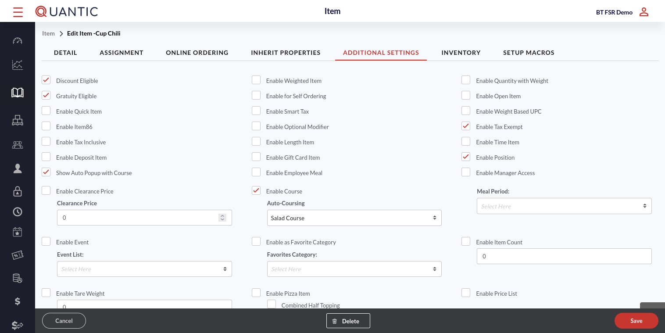

* Go to the **Additional Settings**, enable or disable the options in order to customize the POS as per your store’s requirement.

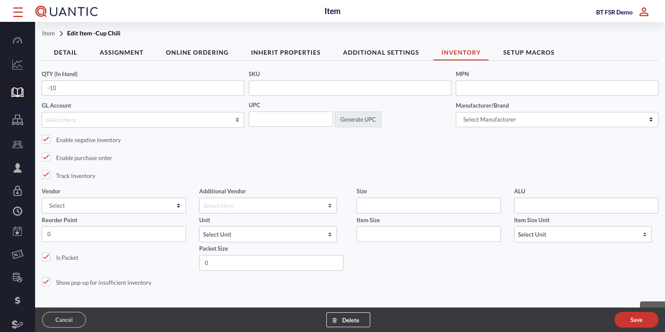

* Under the **Inventory** tab, enter the existing in-hand quantity of an item in the QTY (in hand) field.
* Put the item-related details in **SKU**, **MPN**, and **GL Account**.
* Click **Generate** **UPC**. It will generate a unique 12 digit number in the UPC field.
* Select the item manufacturer from the Manufacturer/Brand drop-down.
* Tapping on **Enable negative inventory** checkbox will allow you to put the negative value in the item quantity.
* Tapping on **Enable Purchase Order** checkbox will enable the purchase order for this item.
* Tapping on **Track Inventory** will unhide inventory-related sections for an item.
* **Vendor**: Select the name of the vendor (who is supplying the said item) from the drop-down list. If you can’t find the vendor in the list, first add it from the **Vendor** tab under **Inventory**.
* **Additional Vendor**: Select the name of the additional vendor if an item has multiple vendors.
* **Reorder Point**: Put the item quantity at which you want the item to be reordered.
* **Unit**: Select the unit to measure the item, for example, number, kg, etc.
* **Item Size**: This field will tell the size of the per piece if the unit is a piece.
* **Item Size Unit**: Select the item size measurement unit.
* **Is Packet**: Check this box if an item has been added as a carat or bundle.
* **Packet Size**: This field enables automatically when the *Is Packet* checkbox is marked. This field tells how many pieces are there in one carat or bundle.
* **Show pop-up for insufficient inventory**: Tapping this checkbox will notify you whenever there is insufficient inventory.
* Once done, click **Save**.

### How to associate modifiers to categories or items?

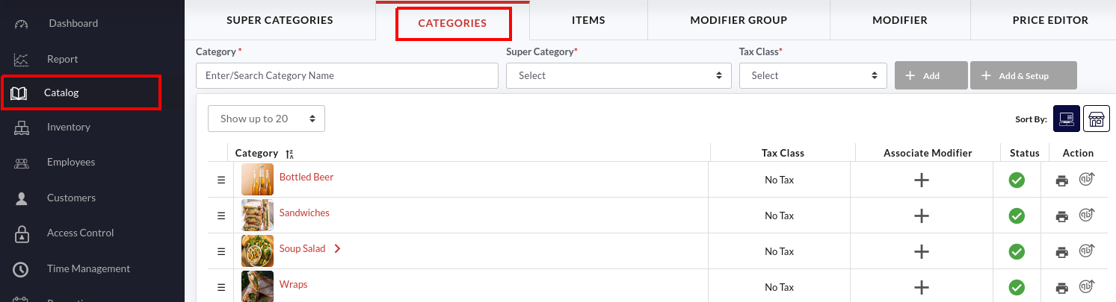

1. Click the **Catalog** on the left navigation panel.
2. Click the **Categories** tab on the top.

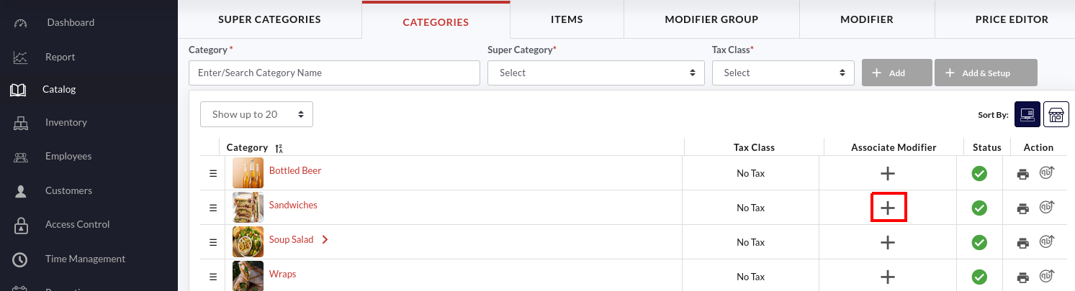

1. Now tap the 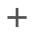 button next to the category to associate a modifier with this category.

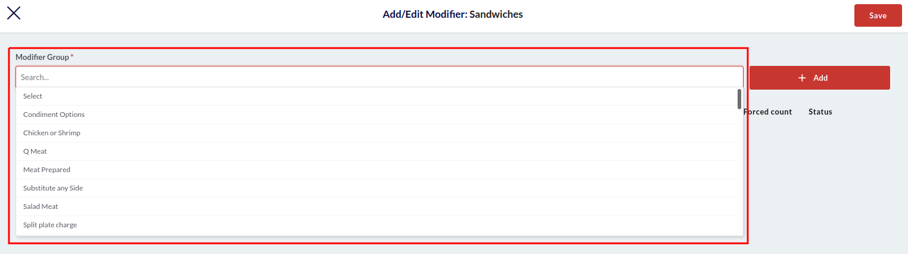

1. Select the modifier group from the **Modifier Group** drop-down. Click  button to add the modifier group in the section underneath. This way you can associate multiple modifier groups to the category.

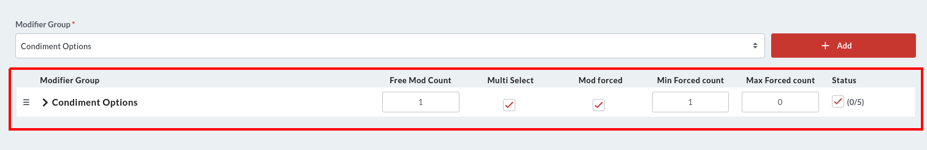

1. The added groups will be displayed underneath where you can customize them as per your choice.
   1. **Free Mod Count**: Enter the number of free modifiers you want to offer with this item category.
   2. **Multi Select**: Tap this checkbox, if you want the multiple modifiers to be selected at the same time from the same group.
   3. **Mod Forced**: Select the checkbox to make this a forced (mandatory) modifier.
   4. **Min Forced Count**: Enter the minimum forced modifier count.
   5. **Max Forced Count**: Enter the maximum forced modifier count.
   6. **Status**: Tap this checkbox under **Status** to enable all the modifiers in the group. To enable a specific modifier, you can click the Status box next to that particular modifier.
2. Unhide the list of modifiers by clicking the  icon adjacent to the modifier group.

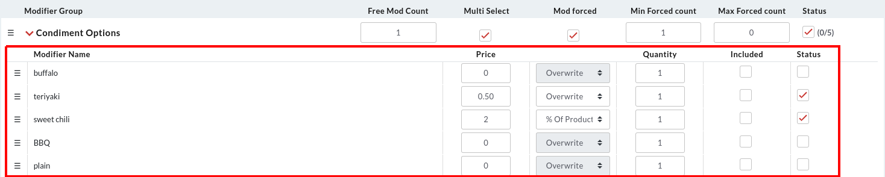

1. The list of modifiers will be expanded underneath. Here you can set the modifier price, choose to overwrite the existing price of the modifier, and enable or disable the modifier. Check the descriptions below:
   1. **Price**: Enter the price of the modifier. If *Overwrite* is chosen in the next field, the **Price** will overwrite the existing price of the modifier. On the contrary, if the *% of product* is chosen in the next field, the new modifier price will be the x percent of the product, where x is the figure mentioned in the Price. For example, if 2 is mentioned in Price and the item price is $7, the modifier price will be 2% of $7 = $0.14.
   2. **Quantity**: This is the default quantity of the modifier. For example, if you enter 2, by default the 2 number of modifiers will appear preselected on the POS.
   3. **Included**: Tap this checkbox if you want this modifier to be included automatically when any item of this category is chosen.
   4. **Status**: Tap the checkbox to enable this modifier.
2. Once done, please click the **Save** button to save the changes.

|  | 1. As we have associated two modifiers (Teriyaki and Sweet Chilli sauce) with the Sandwich category, both of them will be visible on the POS screen under the parent modifier when any item from the sandwich category is chosen. The price of the Teriyaki sauce is $0.5 (overwritten price) and the Sweet Chilli sauce costs 2% of $7.00 (the price of Tangent Grilled Cheese), i.e., $0.14. The prices will be reflected according to the settings you have done at the backend. |
| --- | --- |

Similarly, you can associate modifiers with the items. Go to the Items section in Catalog and follow the same steps as instructed above.

### **Create a Modifier group**

It is recommended to use logical modifier groups, such as alcohol preparation modifier groups can be called **Drink Prep**.

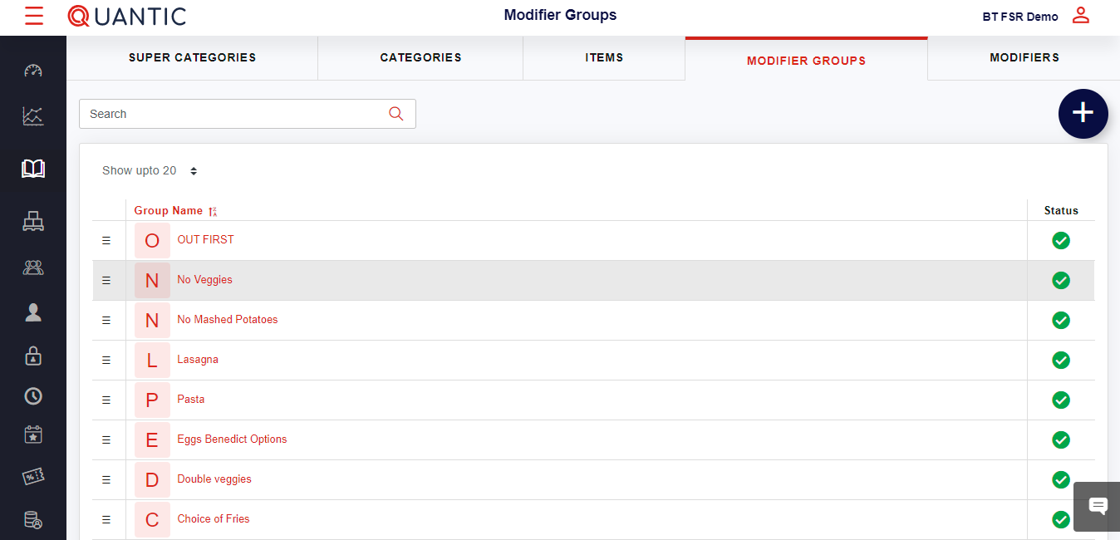

* Click the **Modifier Groups** tab on the top menu bar.
* To create a new Modifier group, click the ➕ icon on the top right corner.
* To modify the existing group, just select the one from the list.

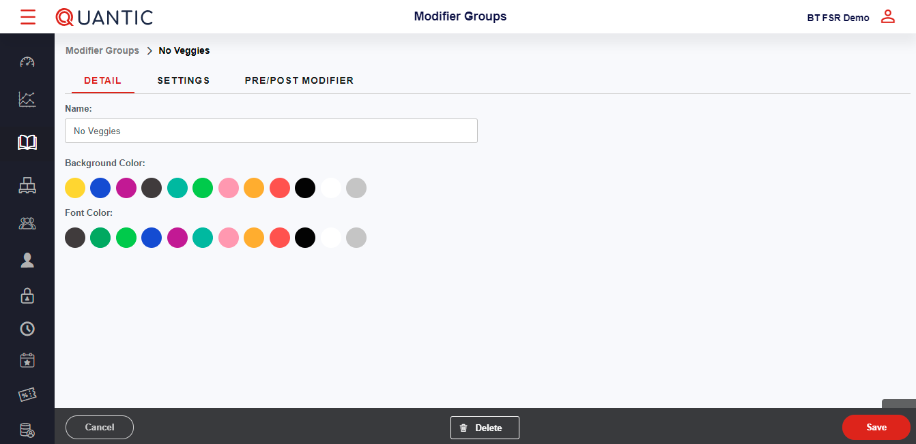

* Click the **Detail** tab.
* Enter the **Name**.
* Choose the **Background** and **Font** color as well.

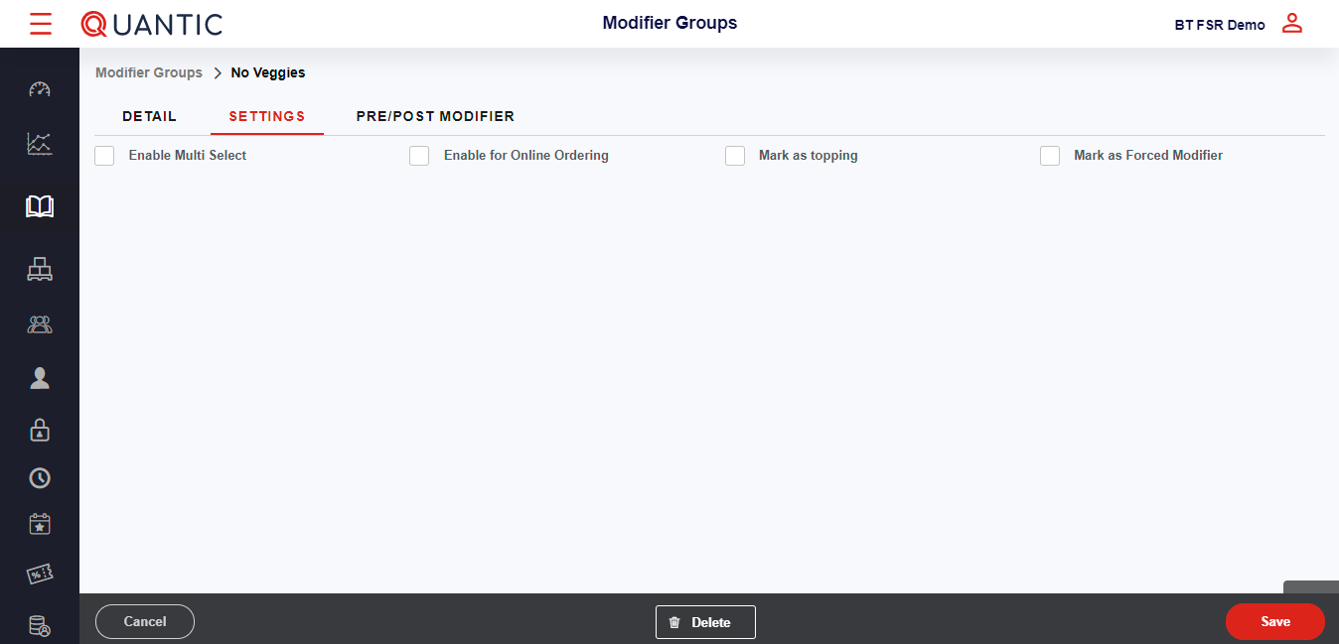

* Now click the **Settings** tab.
* Finally, select the box adjacent to **Mark as Forced Modifier** (recommended).

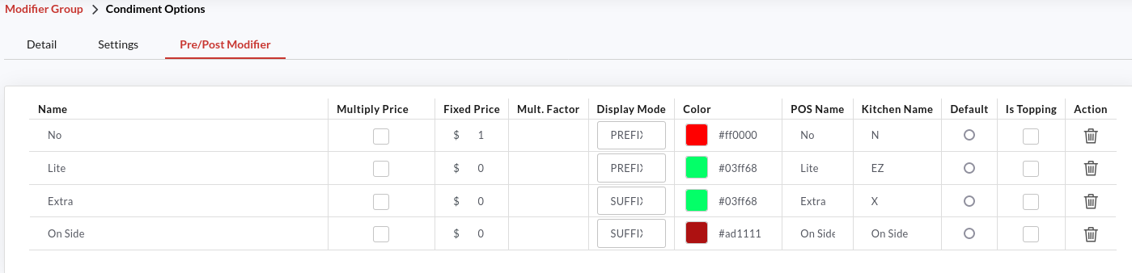

Finally, click the **Pre/Post Modifier** tab and fill in the required details. By setting pre/post on the modifier, the order accuracy enhances, leading to efficient restaurant operations. You also have the option to overwrite the price at the Modifier group level. Example: Extra Mustard can have a fixed price or the price can be a multiplier. You also have the option to enter a different name for the POS and the Kitchen. Abbreviations can be used for the Kitchen if required. It will print the kitchen ticket with the abbreviations.

| **Example**:  Condiment option is a modifier group and mustard and ranch are the modifiers under that group. With the help of pre/post modifiers, you can now associate the modifiers with prefixes such as **No Mustard** or **Light Ranch**. In this scenario, *No* and *Light* are the prefixes for the modifiers. Another option could be adding a suffix to the modifier as **Ranch On the side** or **Mustard Extra**. In this case *On the side*and *Extra* are acting as a suffix for the modifier. |
| --- |

### Create a Modifier

Modifiers are the add-ons that a customer can choose while making a purchase. To start creating a **Modifier**, you must first create a modifier group, as modifiers have to be associated with a particular group.

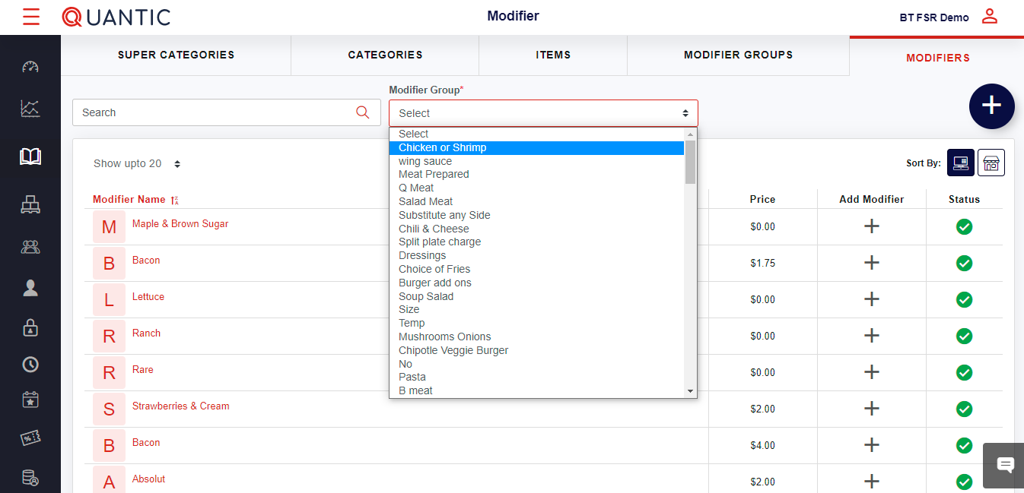

* Click the **Modifiers** tab on the top menu bar.
* Hit the box below **Modifier Group** and select the modifier group for which you want to create the modifier.
* Click the ➕ button on the top right side of the screen.

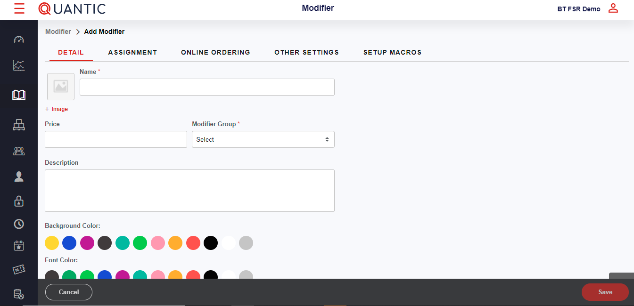

* Click the **Detail** tab.
* Enter the **Modifier Name** and fill in the other details.
* If there is a fixed cost associated with the modifier being created, you may add the price in the Price field.
* Finally, select the **Background color** and the **Font color**.

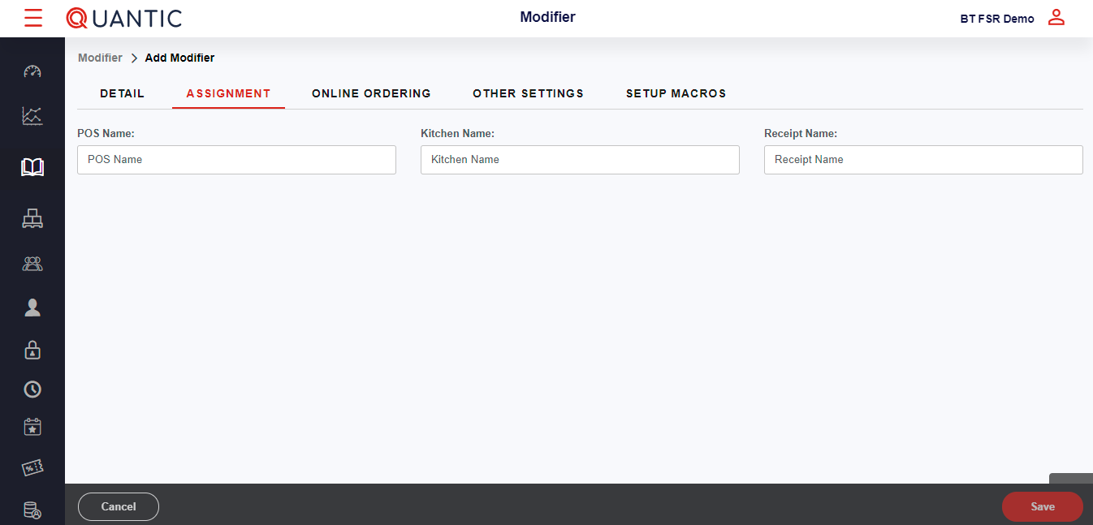

* Now click the **Assignment** tab.
* Select the POS name, Kitchen name, and Receipt name.

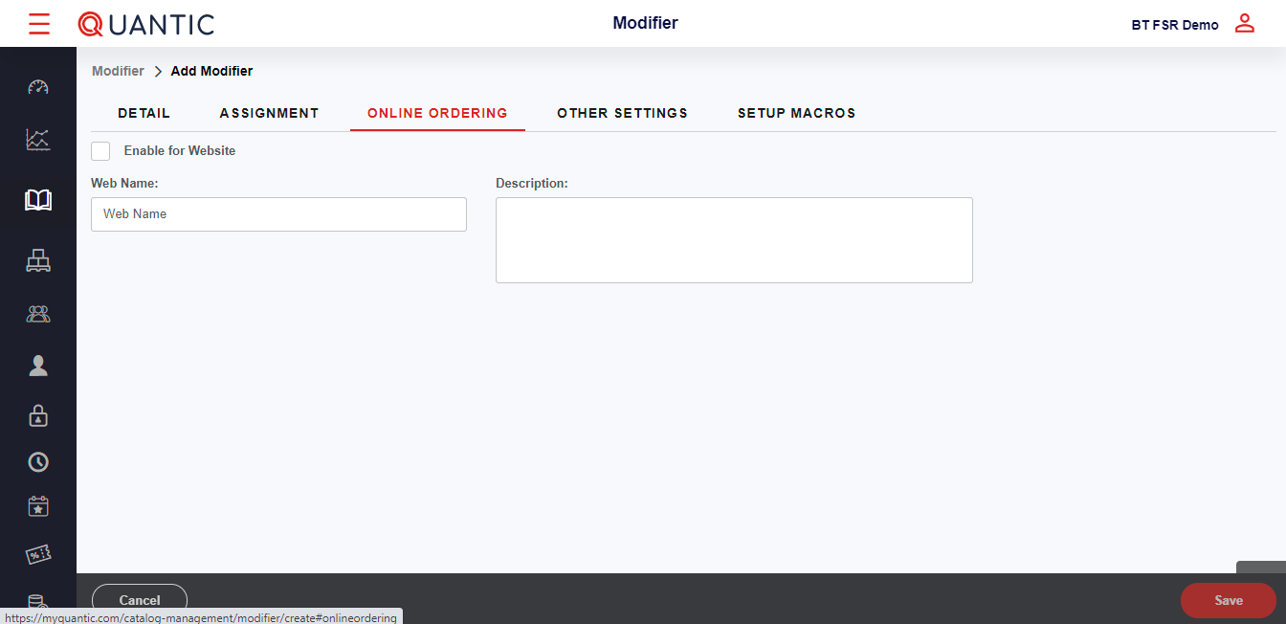

* Similarly, fill in the details in the **Online Ordering**, **Other Settings** tab, and **Setup Macros** as well.

## How to Update a Catalog Using a CSV File?

You can add or update the catalog on the backend portal and POS using a CSV file. To begin with, you will need to download the catalog data import template from the backend portal, fill in the item details and upload the file into the Data Management in the backend portal. Below is the complete overview of how you can update the catalog using a CSV file.

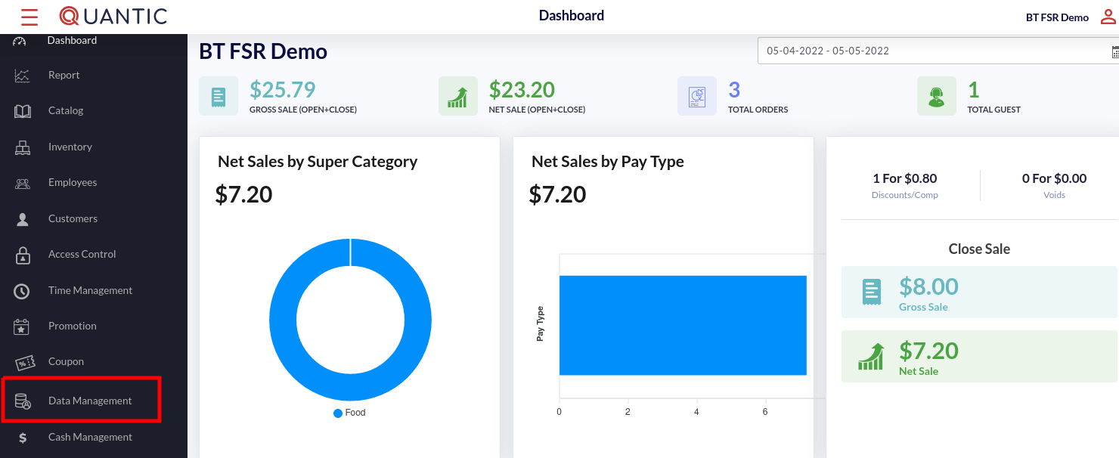

1. Login to your location’s backend portal.
2. Go to the left navigation and click **Data Management**.

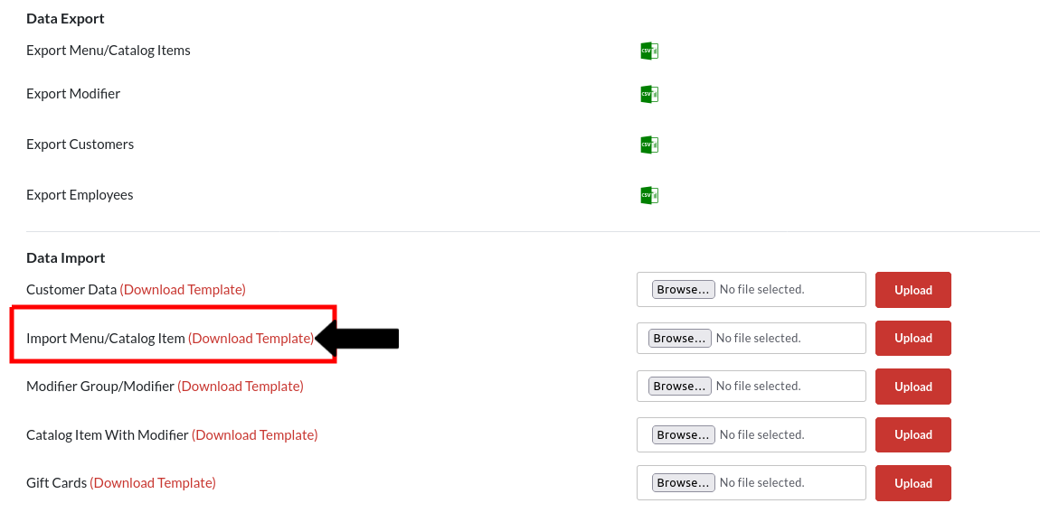

1. Now click the **Download Template** button next to the **Import Menu/Catalog Item**. In case you wish to update the catalog items with modifiers, please click the **Download Template** next to **Catalog Item With Modifier**.



1. The downloaded template will contain column headers that are required for uploading into the system.
2. All of the information does not need to be filled out. However, there will be an error if there is no product name.

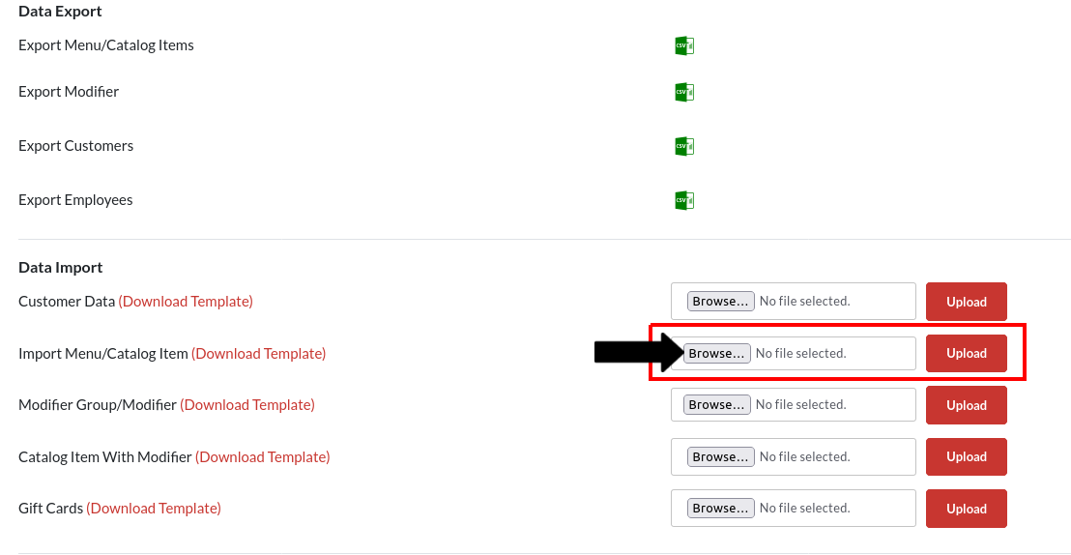

1. Once the appropriate information has been entered, we can return to the data management area and upload the .csv file.
2. Once the file has been chosen, click the **Upload** button as shown in the screenshot and a confirmation message will appear once the upload has finished.

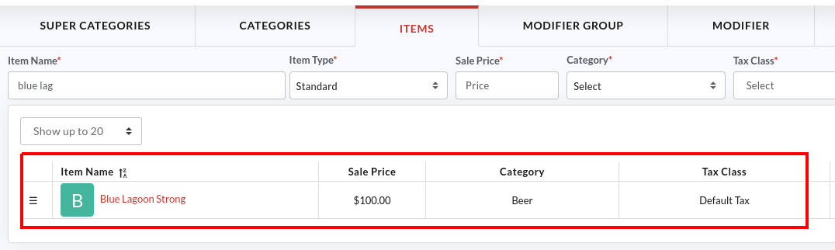

1. The uploaded items will appear in the Catalog. You can navigate to the **Catalog** on the left, click the **Item** tab and search the item that you have uploaded through the CSV file.

## How to create combo meals in Quantic POS?

Now you can create combo meals in the Quantic POS and offer multiple items in a single meal. For example, you can create a combo meal of burger, french fries, and diet coke. To get started, you simply need to go to the backend portal, choose the main product and add more items as a combo to it. Here we are going to create a combo meal that consists of Tangent Taco + Fries + Diet Pepsi. You can create your own combo items by replicating these steps.

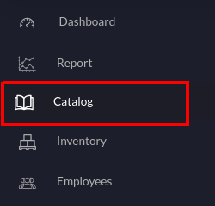

1. Login to the backend portal and click **Catalog** on the left navigation.

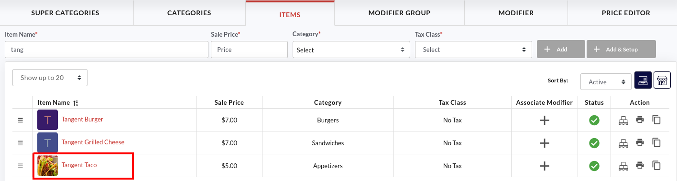

1. Select the main item of your combo meal. In our case, it is Tangent Taco.

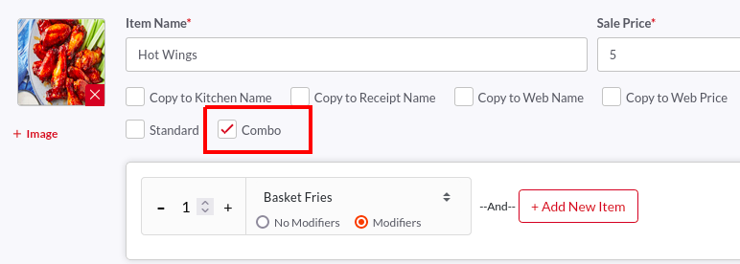

1. Tap the **Combo** checkbox to start adding more items to this combo meal.

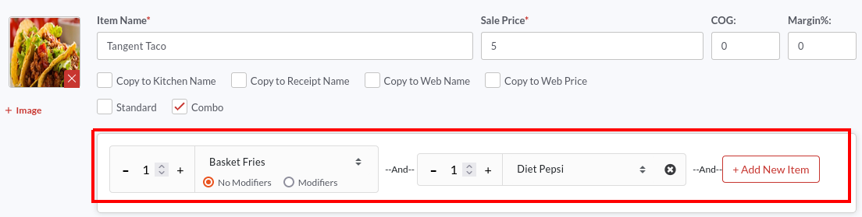

1. Tap the **Select Item** field and select items from the drop-down.
2. To add more items, click 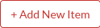 button. Similarly, you can create as many fields and add new items to it.

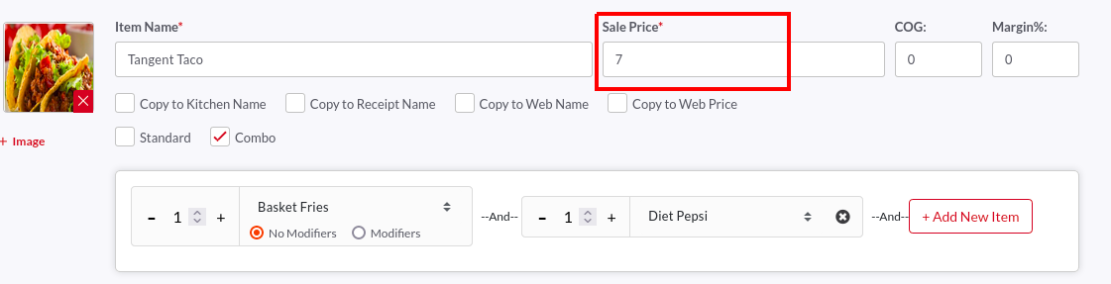

1. Enter the combo meal price in the **Sale Price** field. Here we want our combo meal to be priced at $7.00.
2. Once done, don’t forget to click the 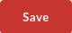 button to save the changes.

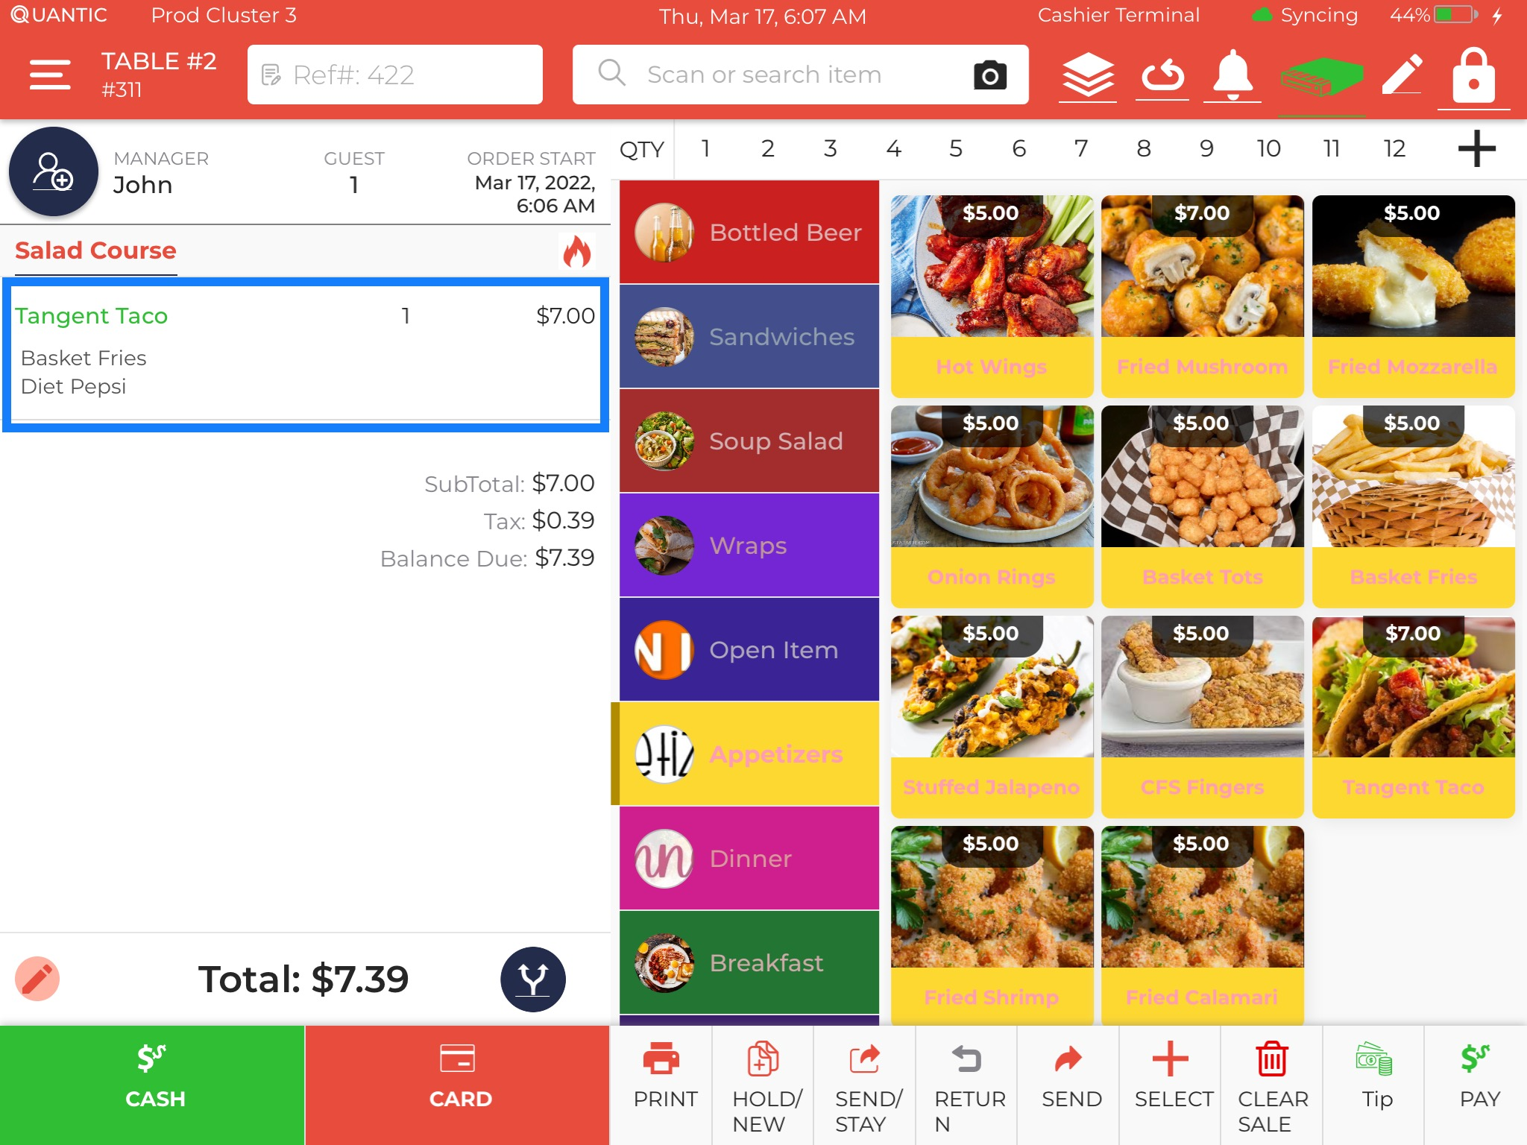

1. Here the Tangent Taco is clubbed with Basket Fries and Diet Pepsi. The revised price for this combo meal is $7.00.

## Bulk Price Editor

Quantic backend portal allows you to change the price/web price of all the items in a category in bulk. You can also select multiple items in a category and set one price for them all. Also, these prices can be increased/decreased by a set percent. Here is a high-level overview of how you can update the item prices in bulk.

### How to update the price of a single item?

To update the price of a single item from a Price Editor, you can navigate to the **Catalog** section in the backend portal and proceed with the following steps. Let us understand this with an example. Suppose you want to set the price of Fried Mozzarella (which falls under the Appetizers category) to $8. Here is how you can do it.

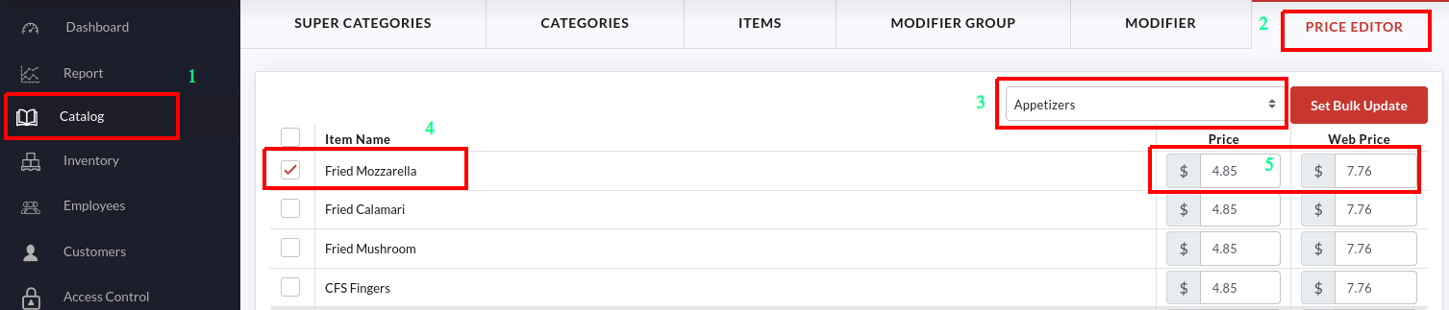

1. Go to the **Catalog** on the left navigation bar.
2. Click the **Price Editor** tab as shown in the screenshot.
3. Tap the **Category** drop-down and select **Appetizers** (the category where you want to update the item price).
4. The list of items under Appetizers will be displayed on the screen.
5. Look for the item you want to change the price, Fried Mozzarella, in our case.
6. Tap the field under **Price** and update the new price. Similarly, you can also update the web price for any item.
7. Don’t forget to click the **Submit** button once you have updated the item price.

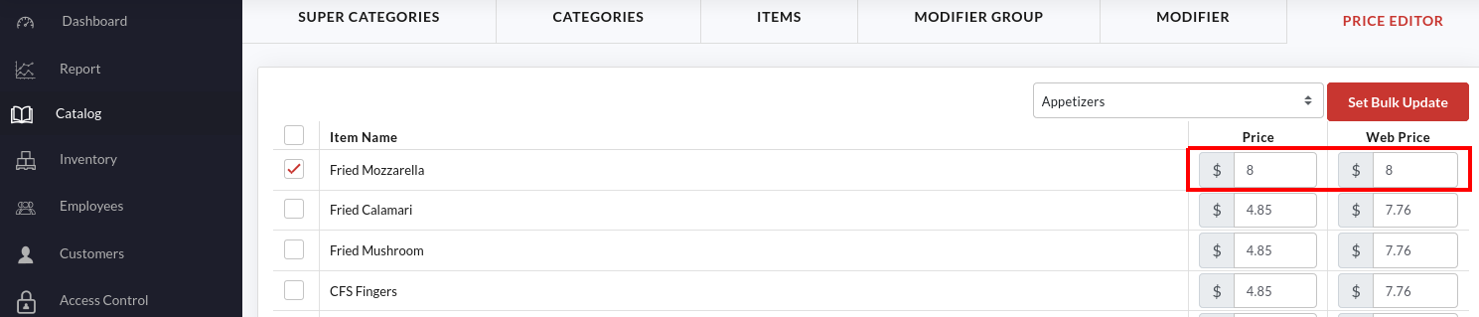

1. Once the price is updated, it will reflect adjacent to the item name as shown in the above screenshot. Here we have updated the price and web price of Fried Mozzarella to $8.

### How to update the item prices in bulk?

If you want to escape from updating the item prices one by one, you have an option to change the item prices at once using the Bulk Price Editor. Suppose you need to change the price of the items in the Appetizer category to $5; here is how you can do it.

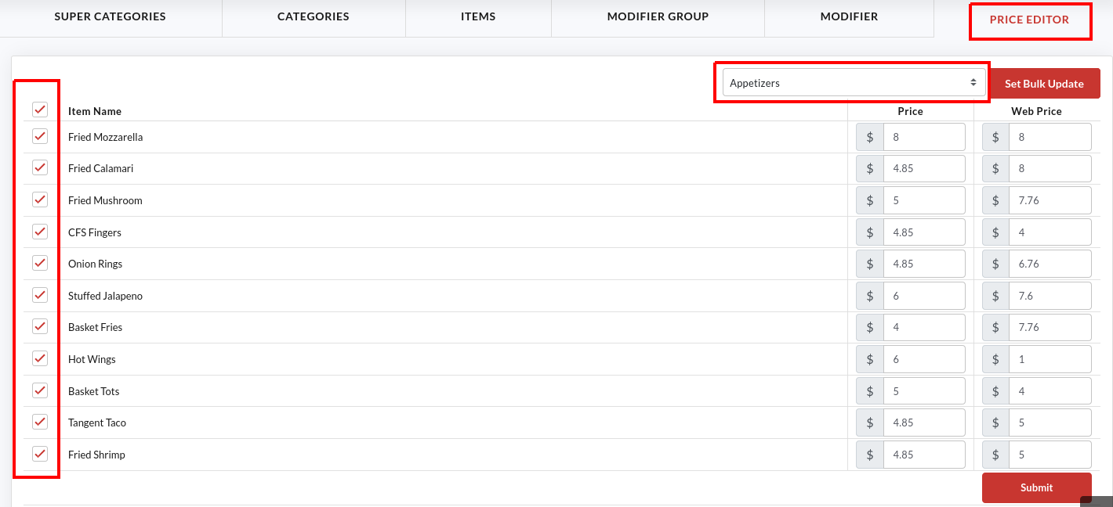

1. Under the **Catalog** menu, click the **Price Editor** tab.
2. Tap the Category drop-down and select **Appetizers** (the category where you want to update the item price).
3. The list of items under Appetizers will be displayed on the screen.
4. Select the checkbox next to the item(s) and click the 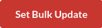 button as shown in the screenshot. To select all the items at once, tap the checkbox next to **Item Name**.

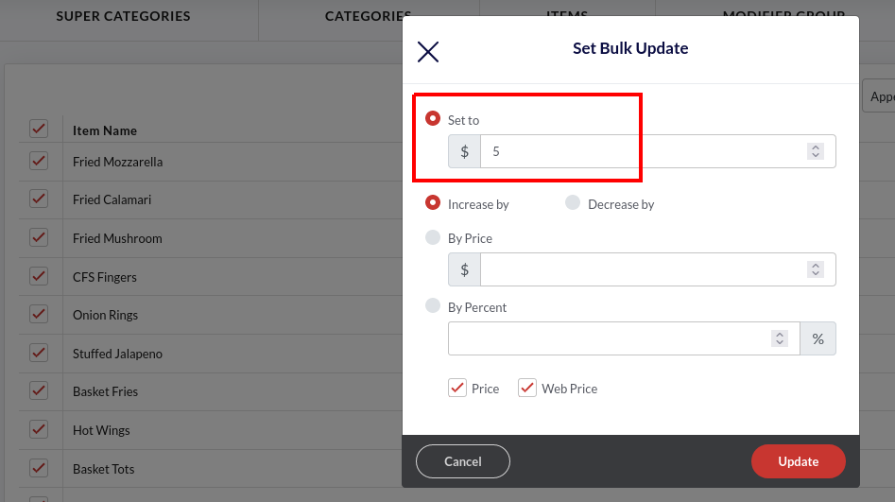

1. Tap the **Set To** option and set the price to $5.

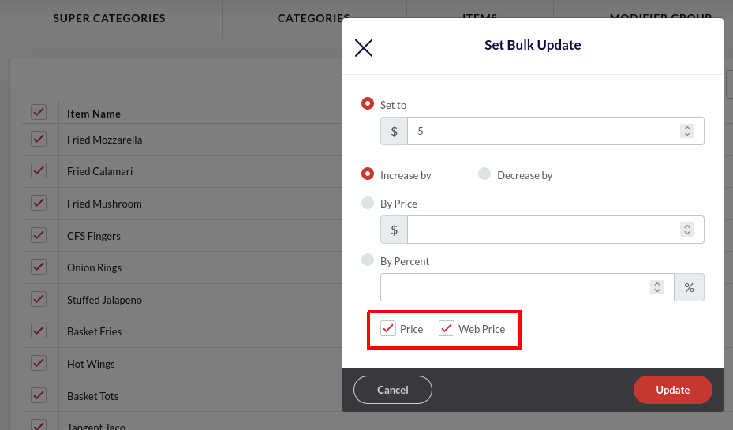

1. If you want to update the item(s) price on the eCommerce platforms as well, select the **Web Price** checkbox. Using this feature, you can keep the different prices for physical stores and the web portal.
2. Click the **Update** button to save the new price. Click **Ok** on the confirmation pop-up.
3. Click the **Submit** button once you have updated the item price.

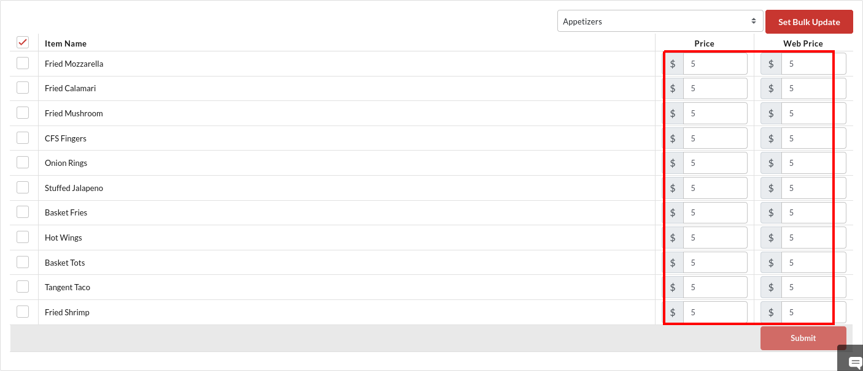

1. Once the price is updated, it will reflect adjacent to the item name as shown in the above screenshot. Here we have updated the price and web price of all the appetizers to $5.

### How to increase/decrease the item(s) price by a fixed amount?

What if you want to change the item(s) price by a fixed $ amount? Let’s say, increasing the price of all the bottled beer by $2. Here is what you need to do.

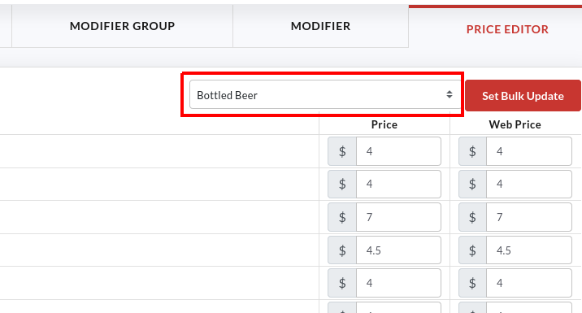

1. Select **Bottled Beer** from the category drop-down.

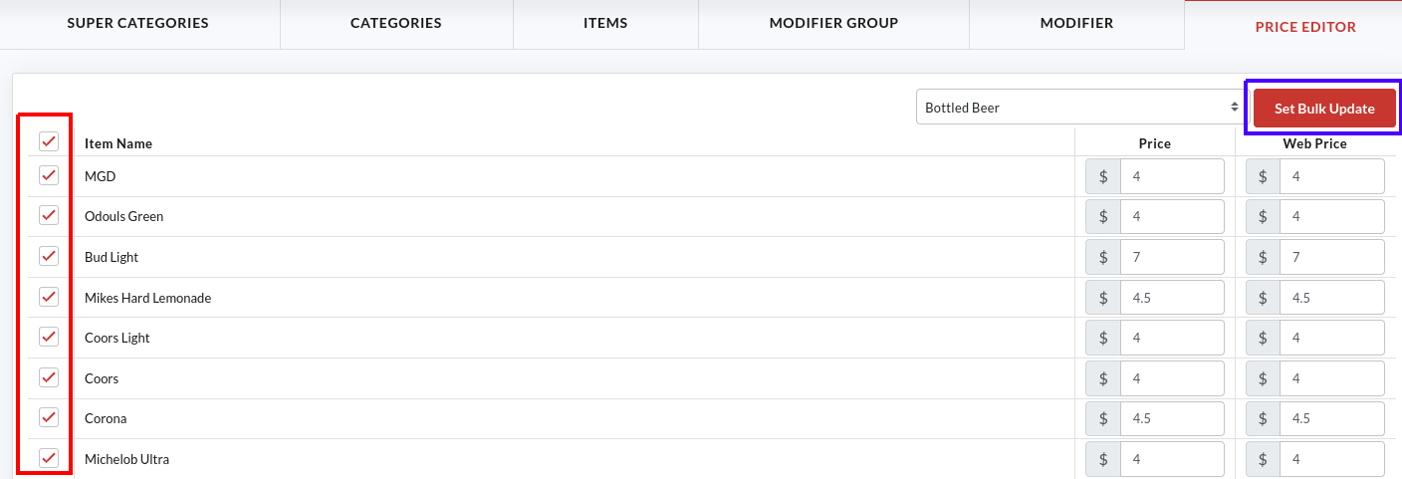

1. Tap the checkbox next to **Item Name** or select the specific item and click .

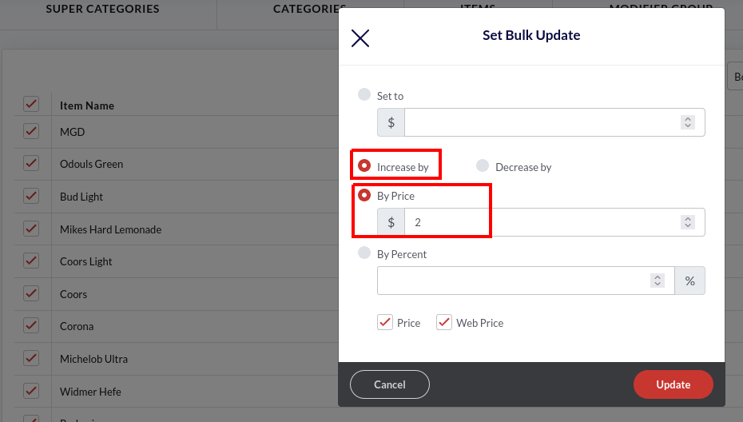

1. Set the option to **Increase By**.
2. Select **By Price** option and enter 2 in the given field.

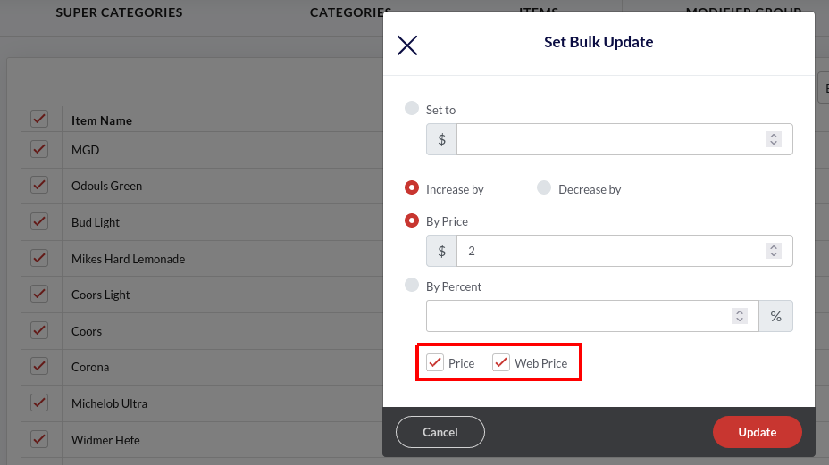

1. Select the **Price** and **Web Price** checkboxes to update the prices across the offline and online channels.
2. Click **Update** and click **Ok** on the confirmation pop-up.
3. Click **Submit** to save the prices.

### How to increase/decrease the item(s) price by a fixed percent?

Users, who want to change the item price by a fixed percentage, can do it using the following steps. Like decreasing the price of all the beverages by 1%.

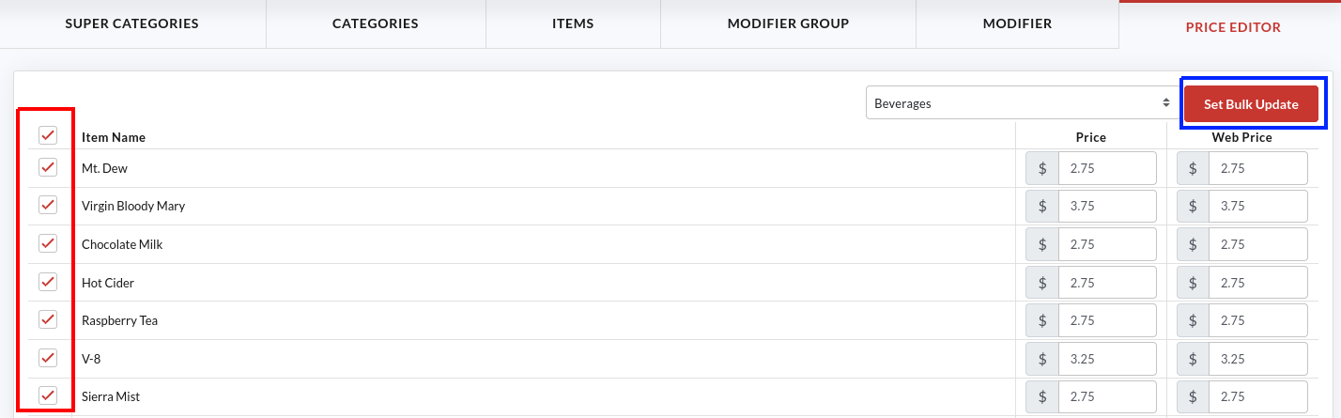

1. Select the **Beverages** option in the category drop-down.
2. Tap the checkbox next to **Item Name** or select the specific item and click the  button.

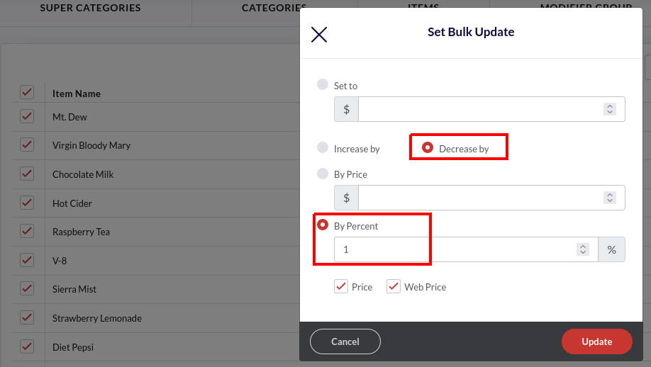

1. Select the **Decrease By** option.
2. Select the **By Percent** option and enter 1 in the field underneath.

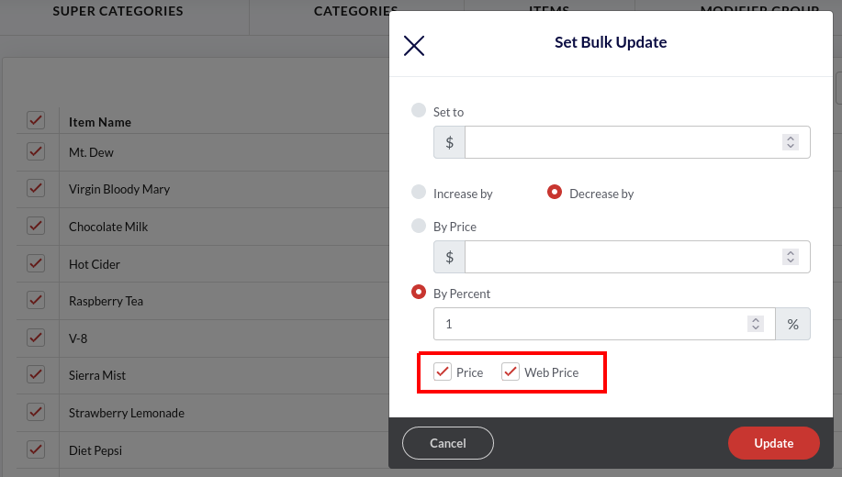

1. Select the **Price** and **Web Price** checkboxes to update the prices across the offline and online channels.
2. Click **Update** and click **Submit** to save the prices.

## **How to add Employees?**

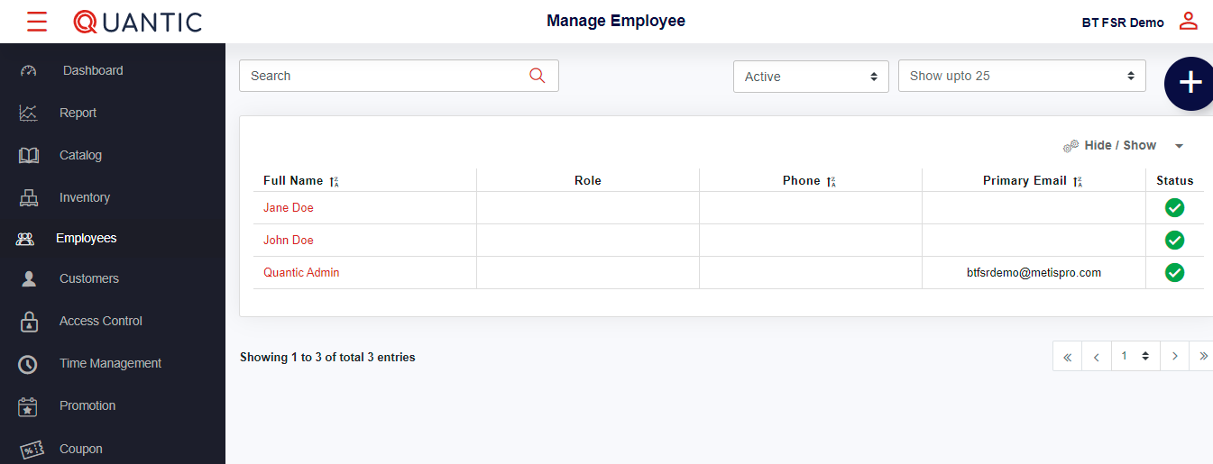

* Login to the Quantic backend portal, click **Employees** on the list. It will open a new screen as shown in the above screenshot.
* Click ➕ icon on the top right corner.

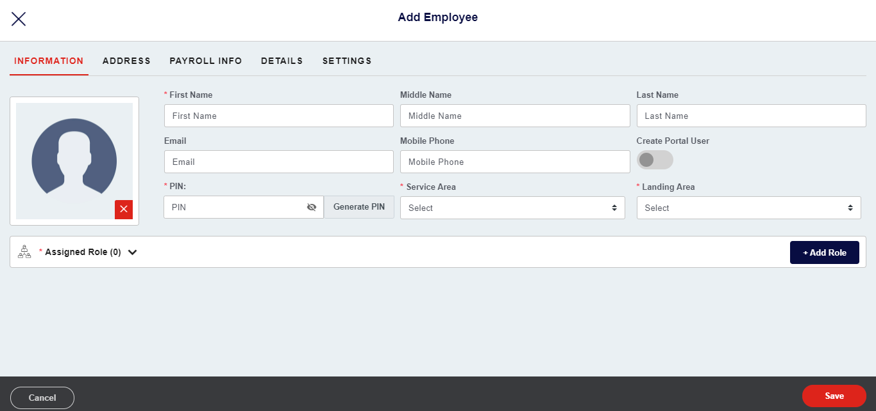

* Click the **Information** tab.
* Fill in the employee details - name, email address, phone number, select the assigned service area, landing area.

Click **Add Role** to select the multiple roles for the employee under the Assigned role tab. Also, fill in the details under **Address**, **Payroll info**, **Details,** and **Settings**. Once done click the **Save** button to create a new employee on the portal.

### **How to give portal access to existing employees?**



* Select the employee name to whom you want to give the portal access.

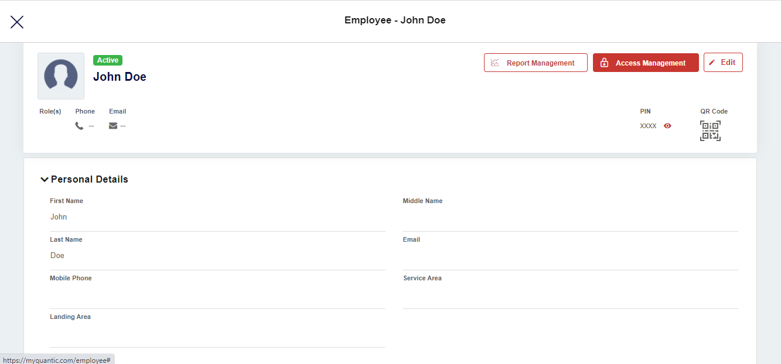

* Now click the **Access Management** button on the top right-hand corner.

|  | * A new screen will appear, here you can choose the type of portal access that you wish to assign to your employee. * Once you are done with the selection, click **Save**. |
| --- | --- |

### **How to generate QR code from the backend portal?**



* Login to the Quantic backend portal.
* Click the **Left navigation** button.
* Click **Employee** as seen in the screenshot.
* Click the **name of an employee** for whom you want to generate the QR code.



* Here you need to click on the **QR code** on the right side of the screen.
* The QR code will be downloaded in PDF format.

### **How to add a pay rate for an employee?**



* Login to the Quantic backend portal.
* Click the Left **Navigation** button and click **Employees**.

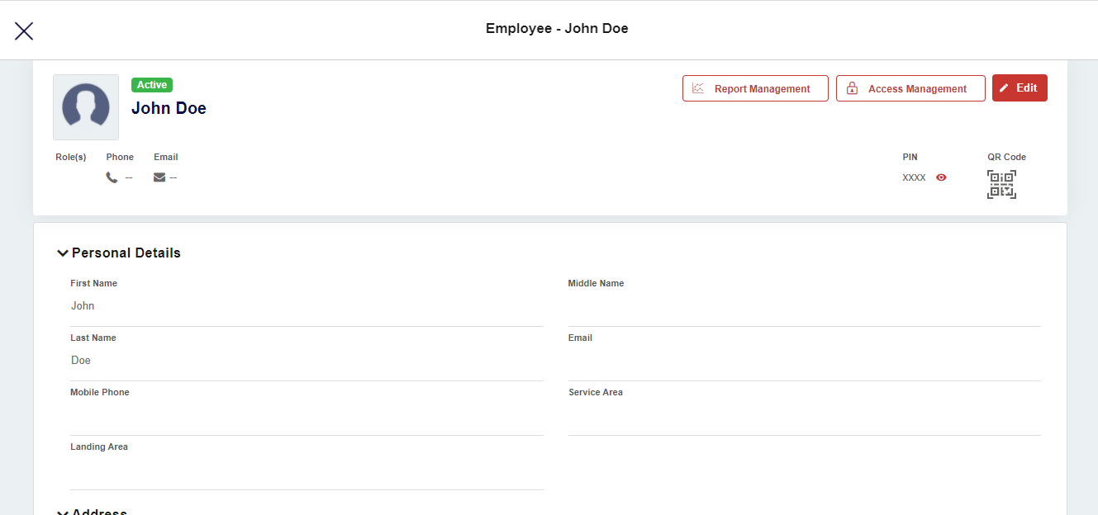

* On the **Employee** screen, click the **Edit** button on the top right-hand side.

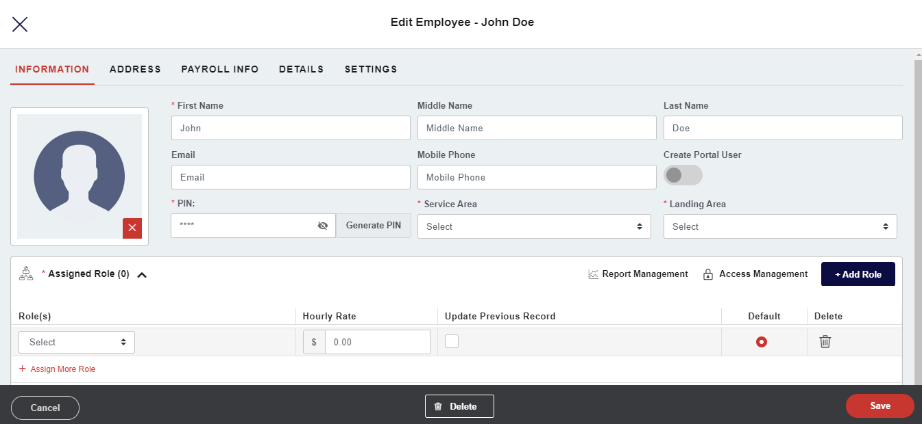

* Click the **Assigned Role** field to expand the further sections.
* Now simply update the current **Hourly rate** for a particular employee.
* Once done click the **Save** button.

### 

### **How to set up Only Clock In access for an employee?**



* Login to your Quantic backend portal.
* Go to the **Employee** section under the left navigation bar.
* Click **Access Management** on the top right-hand side of the screen.

|  | * On the Access Management screen, click **+Assign Additional Privileges.** |
| --- | --- |

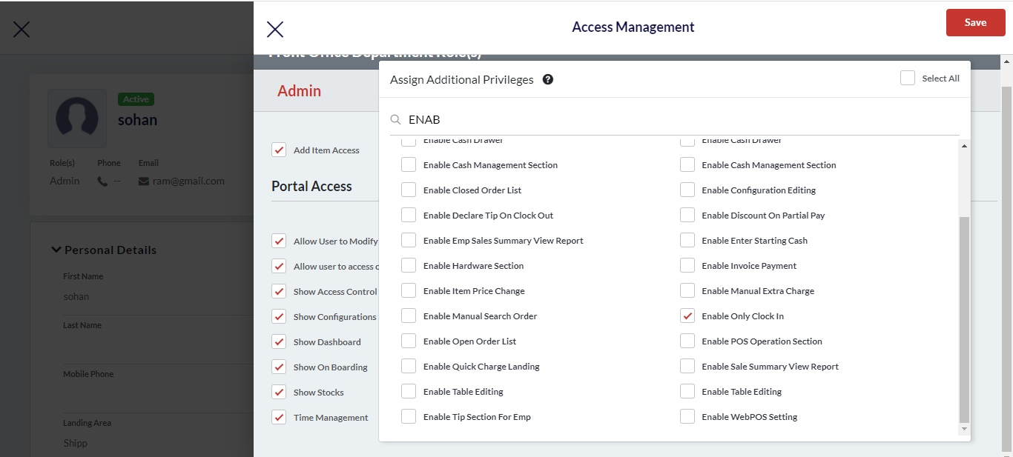

* Click the **Search** tab and type **Enable Only Clock In.**
* Select the appropriate checkbox as seen on the screen and click **Save**.

## **How to use Enterprise Data Management?**

Using Data Management in the Quantic backend portal you can upload a .csv file and push the data as well.

### **How to upload a .csv file to the backend portal?**

* After logging into the portal, click the **navigation** button on the top left.
* Click 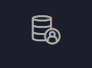 **Data Management** icon.

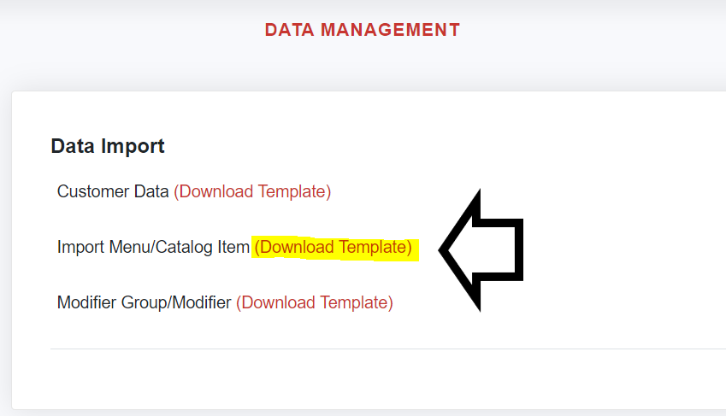

Once at the Data Management section, a link is provided that will allow you to download the excel template for

* **Customer Data**.
* **Import Menu/Catalog Item.**
* **Modifier Group/Modifier.**



The template will contain column headers that are required for uploading into the system. All of the information does not need to be filled out. However, there will be an error if there is no product name

Once the appropriate information has been entered, we can return to the data management area and upload the .csv file.

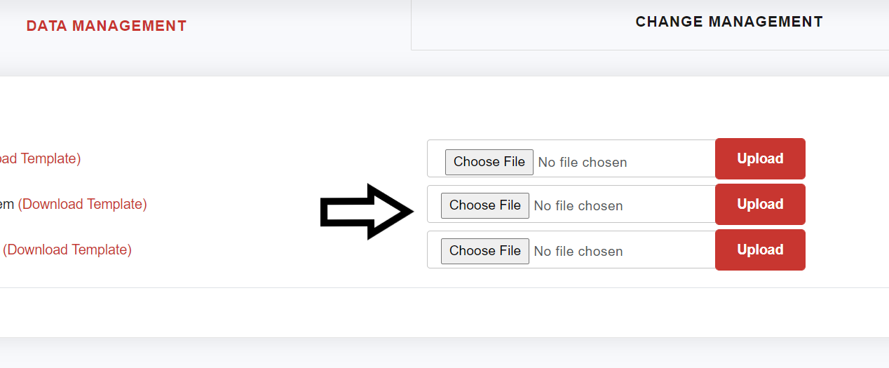

Once the file has been chosen, click the **Upload** button as shown in the screenshot and a confirmation message will appear once the upload has finished.

### **How to push data to child locations?**

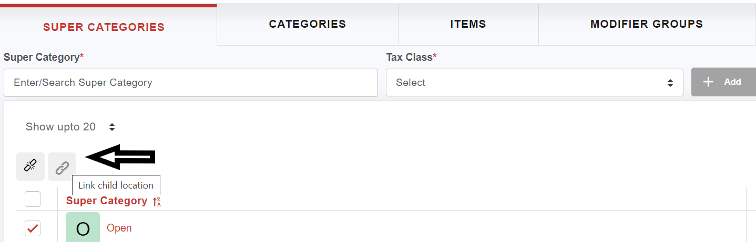

* From the backend portal, navigate to the Catalog section 
* At the catalog/menu section, select the **Super Categories** or **Categories** that need to be pushed to the other locations.
* Then click on the chain symbol 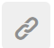to select which locations the data will be pushed to.
* Click the **Save** button once the appropriate locations have been determined.
* Next, repeat the process to the categories, items, modifier groups, and modifiers that need to be pushed.

## **How to transfer sales?**

The Transfer Sale section lets you transfer the sale after the order is closed/paid. For instance, if by mistake another server closed the order then s/he can transfer that sales to the correct server after the payment. Here is how you can transfer the sales.

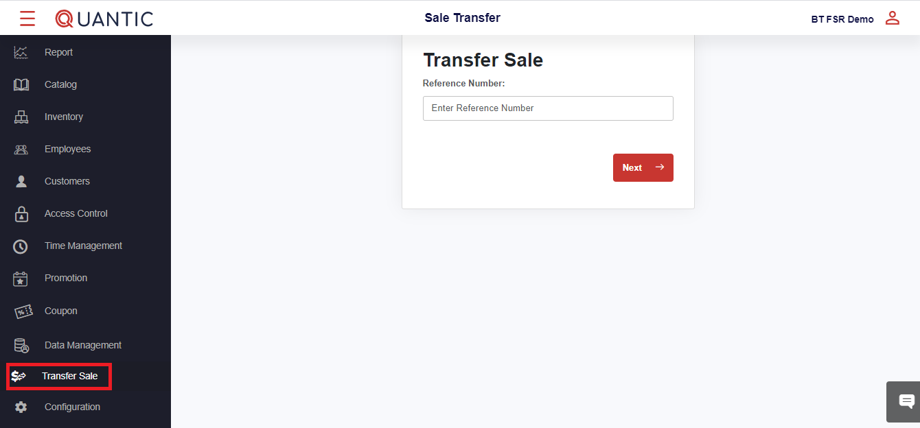

* Click the **left navigation** button and tap on the **Transfer Sale** button as seen in the screenshot.
* Enter the unfinished order’s **Reference Number** in the space provided.
* Click **Next** to proceed.

## 

## **How to enable Inventory?**

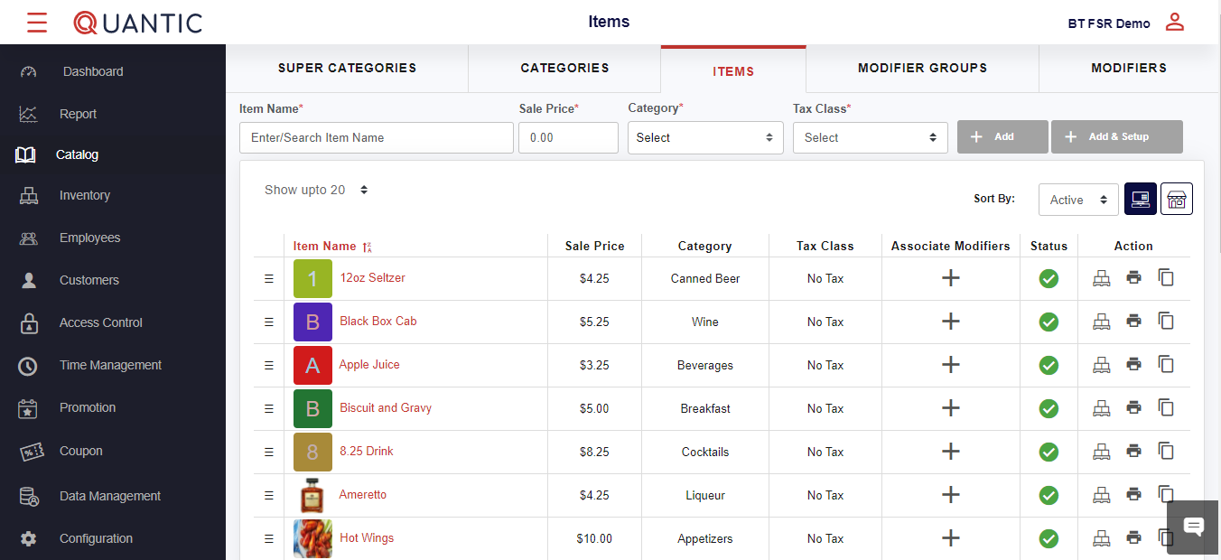

* Login to the Quantic backend portal, click the **Navigation** button on the top left corner.
* Click the **Catalog**  icon on the list.
* Now click the **Items** tab on the top header.
* The list of items will be displayed at the bottom, click on any item for whom you want to enable the inventory.

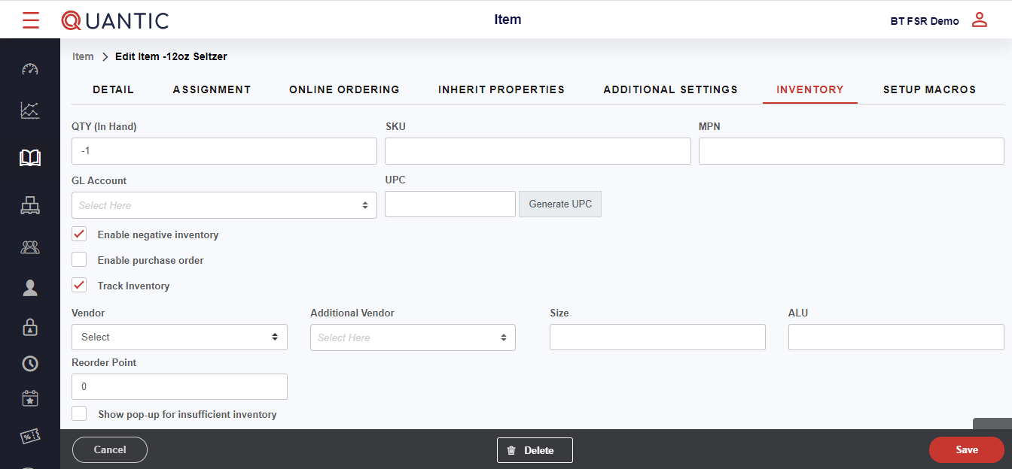

* Now click the **Inventory** tab on the top header.
* Fill in the required information in the field boxes and make sure the box adjacent to **Track Inventory** is check-marked.
* Finally, click **Save**. The inventory is enabled now.

## **How to use Time Management?**

With **Quantic POS,** you can track the working hours of your employees with the help of **Clock-In/ Clock-Out** feature.

Under **Time Managemen**t, you will be able to see all the employee’s clock-in and clock-out times.

You can edit the **clock-in/clock-out** time or add clock-in and clock-out for an employee if he/she has forgotten for that day.

### **How to add Clock In/Clock Out time for any employee?**

* Login to the Quantic backend portal.
* Click on the **left navigation bar** main menu, click on **Time Management**.

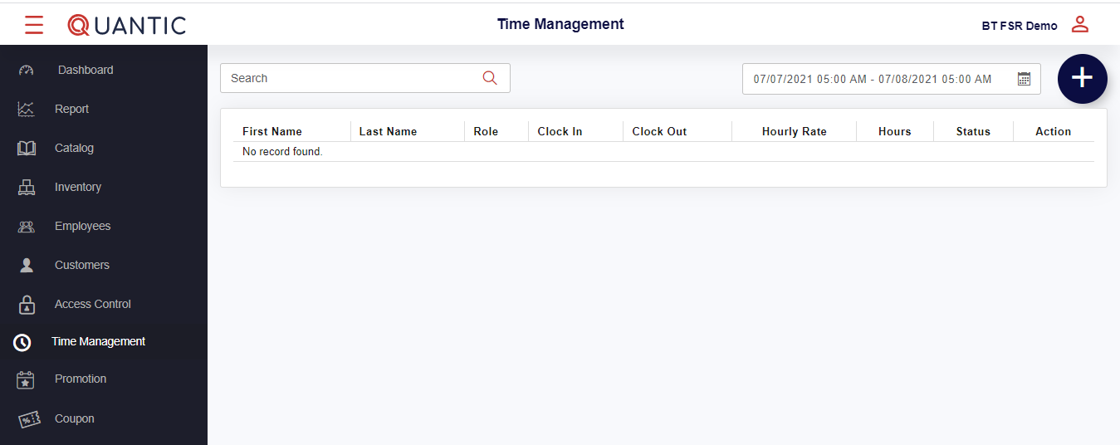

* To add a new time entry click on the 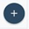sign on the top right corner as shown in the image above.
* To edit an existing time entry for an employee click on  on the right-hand side of the employee’s name.

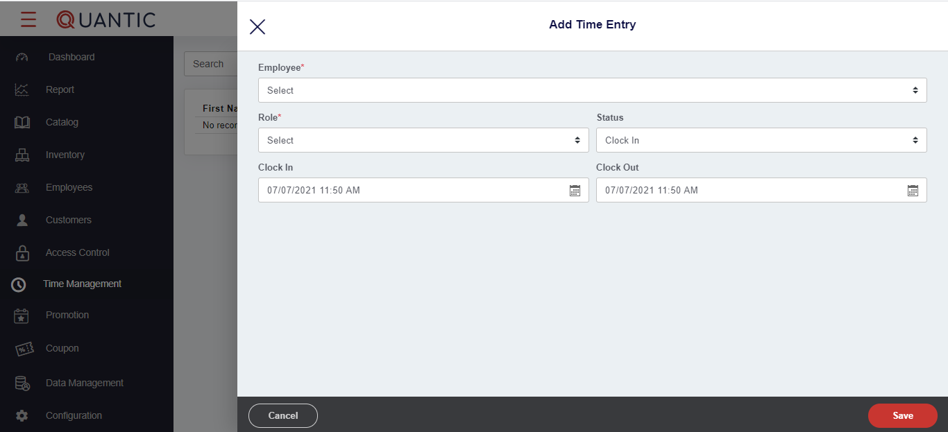

* Tap the **Employee** drop-down and select an employee from the list.
* Once an employee is selected, select the role for that employee from the **Role** drop-down that lists all the associated roles of the employees.
* From the **Status** drop-down, select the one for which you want to add the time entry.
* If it's a Clock-In entry, the status will be Clock-in, enter the Clock-In time and click on **Save**.
* If you want to enter a Clock-Out entry, the status will be Clock-out and enter Clock-Out time only.
* Finally, click 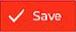as seen in the screenshot.

## **How to add customers?**

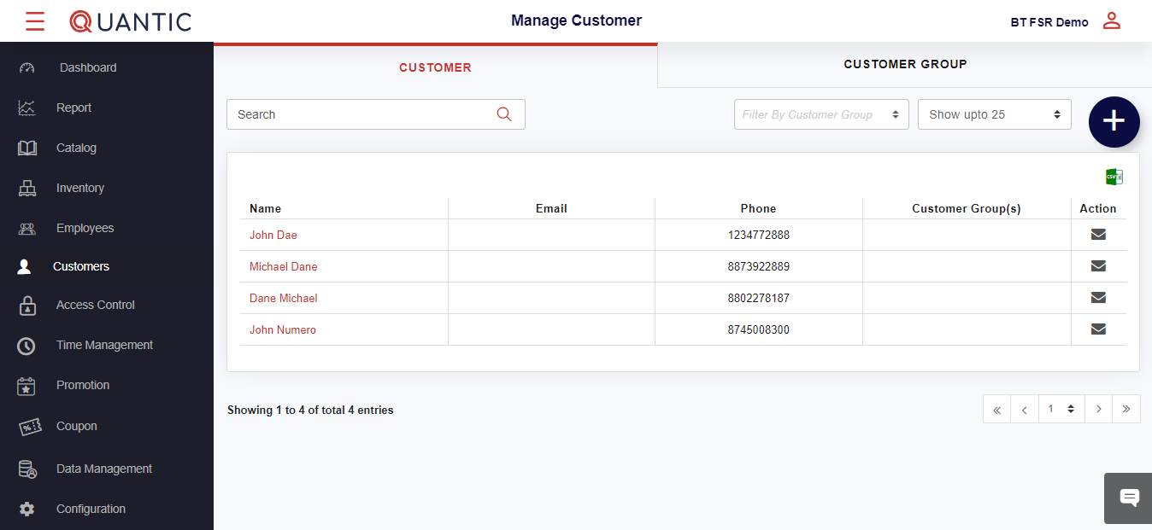

* Login to the Quantic backend portal.
* Enter your login credentials like User Id and the password.
* Click **Submit** to proceed to the portal.
* Once you are logged in, click on the left navigation bar.
* Select **Customers** under the left navigation and click ➕ sign as seen in the screenshot.

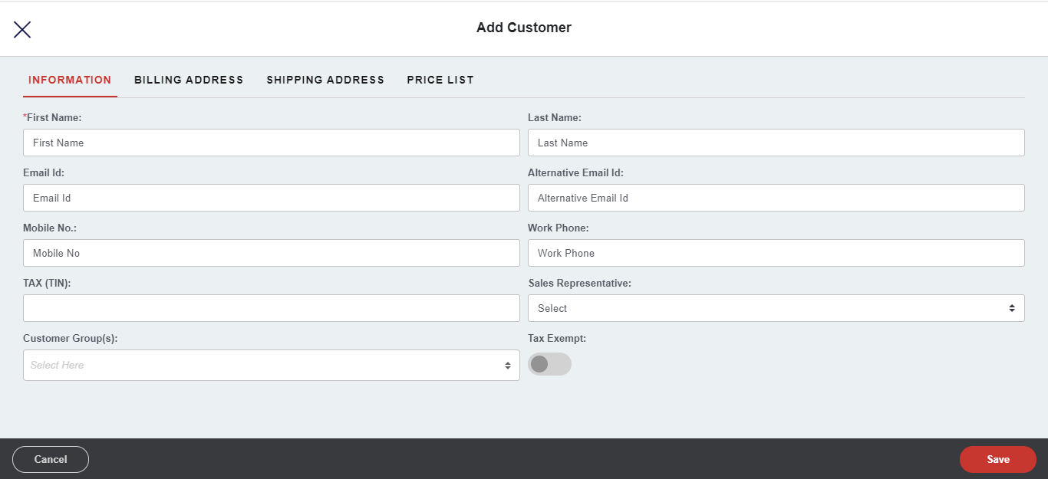

* A new window will pop up, enter the required fields like Name, email address, phone number, etc.
* If you wish to mark the customer as Tax-exempt, then **Tax-Exempt** should be enabled as seen in the screenshot.
* Click on **Save** to proceed.

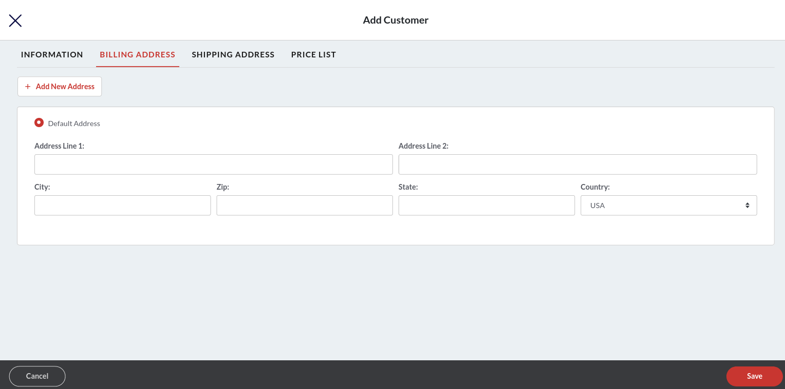

* Click the **Billing Address** tab.
* Put the address in the fields as shown in the screenshot.
* The **Country** field will show the USA by default, but you can select any other country from the drop-down.
* To add more addresses, click 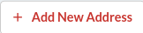.
* Also, you can set an address as default by tapping on the  button.

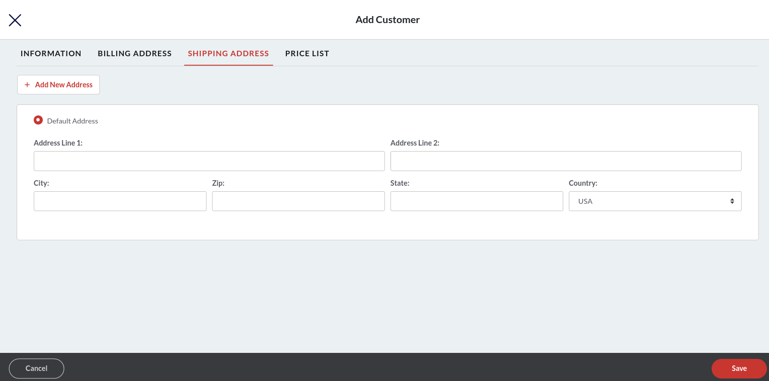

* Click the **Shipping Address** tab. Here you should enter the shipping address of the address. It may or may not be the same as the billing address.
* Put the address in the fields as shown in the screenshot.
* The **Country** field will show the USA by default, but you can select any other country from the drop-down.
* To add more addresses, click .
* Also, you can set the Shipping address as default by tapping on the  button.

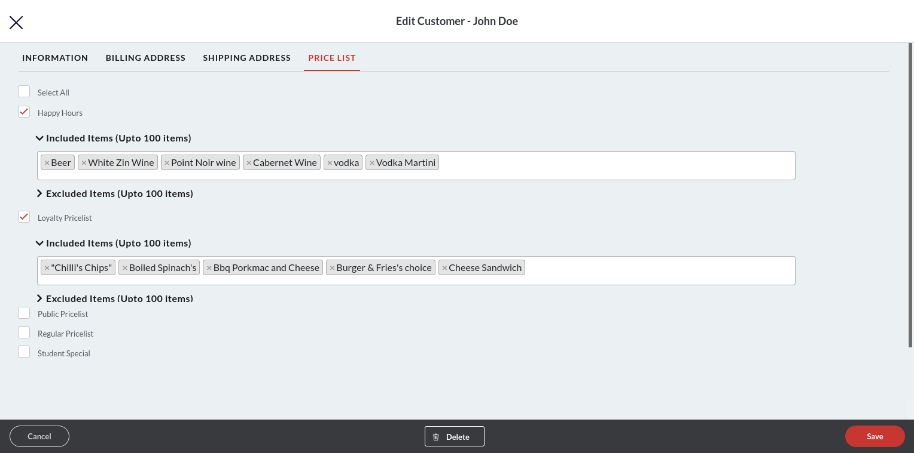

* Tap on the **Price List** tab.
* Select the applicable price list(s) for this customer.
* Every price list will have an expanded field where you can enter the items to include or exclude them from the price list. At the most you can add 100 items in the **Included Items** and **Excluded Items** field.
* Once done, click **Save**.

## **How to create a new role?**

You can use the Access Management section in the Quantic backend portal to create a new role for employees.

* Begin with logging in to the Quantic backend portal.
* Click on the left navigation bar  click on **Access Control.**

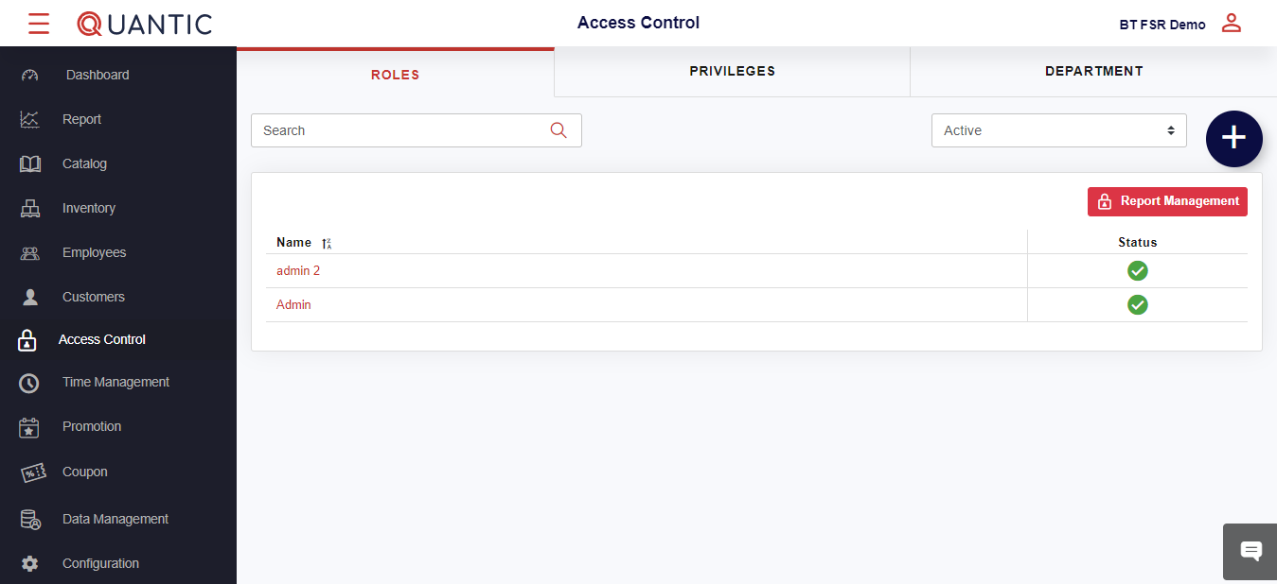

* To add a new role **click on** the 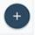 sign on the top right corner as shown in the image.

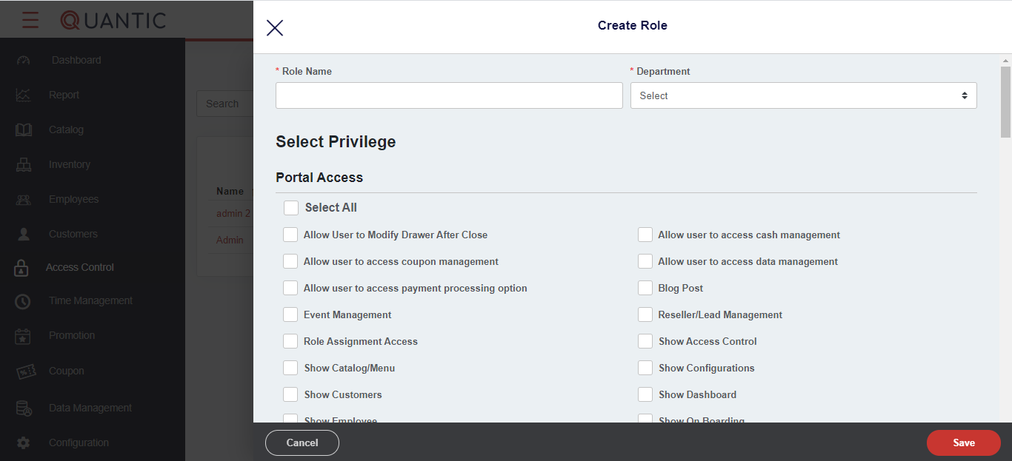

* A new screen will appear, select the roles that you want to assign to an employee.
* To edit an existing role, tap on the **employee name** and select an appropriate role on the new screen.

## **How to create a coupon?**

A coupon is a piece of information that is issued by a restaurant or a retail to buy goods or services at a lower price than the usual. The restaurants or retails that are using the Quantic POS can issue the discount coupons from the backend portal. Once the coupon has been issued, a customer can take it to the restaurant and get it redeemed for the order. Please go through the following document to learn about how to create a coupon and redeem it from the POS.

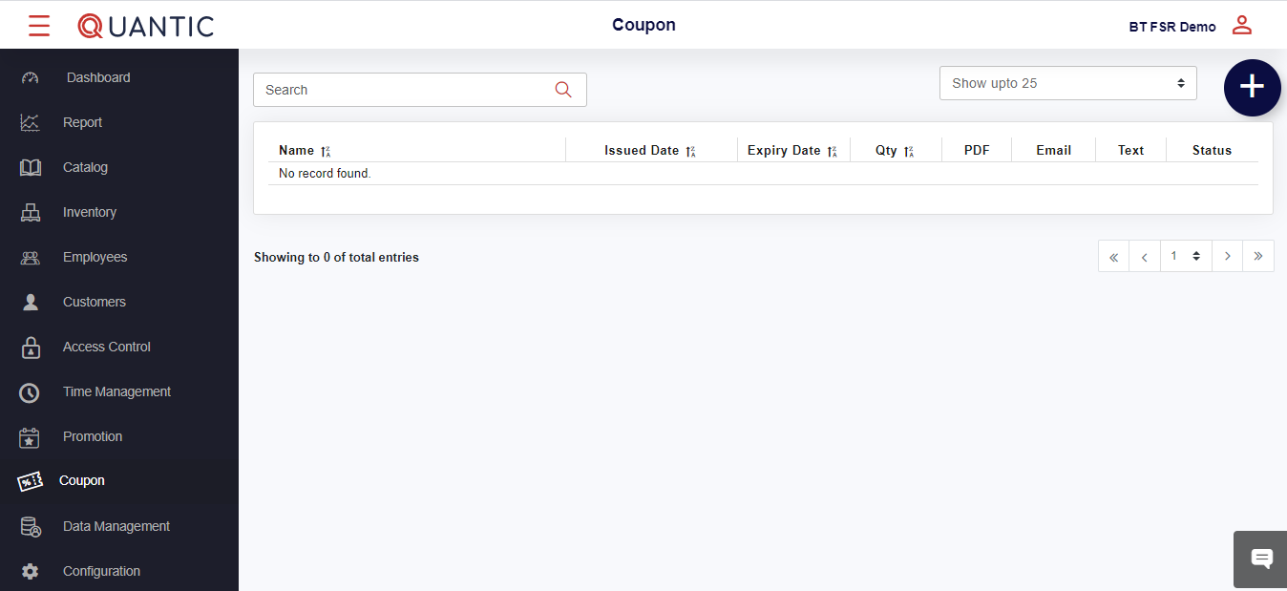

* After logging in to the Quantic backend portal, click the **Coupon** menu on the list.
* You will see the list of existing coupons on the screen. If you have not added any coupons, you will see nothing over here.
* To add a new coupon, click the ➕ icon on the top right of the screen.

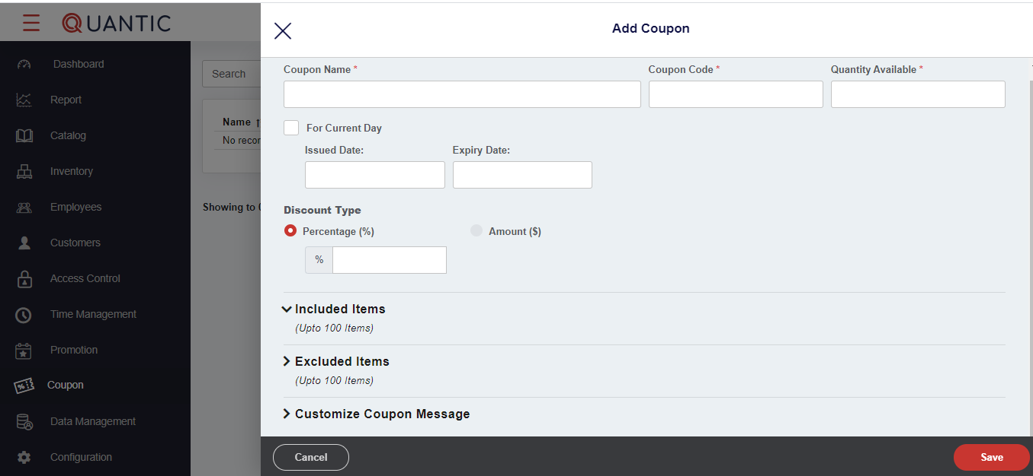

The **Add Coupon** screen appears where you need to follow the below steps.

* Tap on the **Coupon Name** field and enter the name of the coupon such as - 10%Off.
* **Coupon Code -** Enter the coupon code number that customers can use to redeem the coupon.
* **Available Quantity -**  Here you can put the available quantity of such coupons.
* **Issue Date** and **Expiry Date -** Here you can set an eligible time period for the coupon. During this time period, the coupon code can be used and it expires beyond this time limit.
* Now choose the **Discount Type** as **%** or **$**. Enter the value in the box underneath.
* In **Included Items**, enter the item names for whom this coupon code shall be applicable.
* In **Excluded Items**, enter the item names for whom this coupon code shall not be applicable.
* **Customize Coupon Message -** Here you can enter the message on the top and bottom of the coupon. Expand the Customize Coupon Message field by tapping on it, fill in **Line 1** and **Line 2** fields with a message that you want to appear on the top and bottom of the coupon.
* Once done, click **Save**.

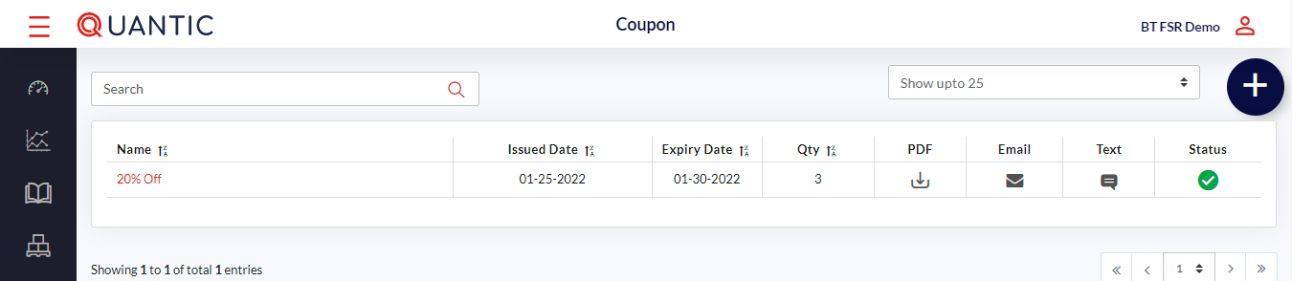

* Once you have created the coupon, it will appear under the coupon list as shown in the above screenshot.
* You can download the coupon, send it to the customers via text or email, and activate or deactivate the coupon as well.
  + Tap 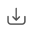 under PDF to download the coupon.
  + Tap  to email the coupon to the customer.
  + Tap  to text the coupon to the customer.

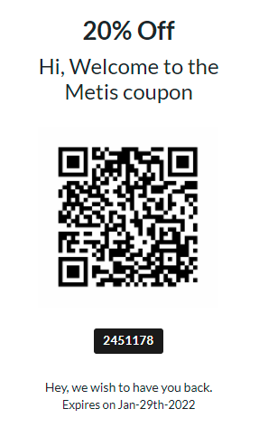

* This is how a standard coupon will look like. It has a coupon name written at the top and QR code printed at the centre that customers can scan to redeem. The coupon also mentions the expiration date at the bottom. Once a guest has been issued a coupon, s/he can take it to the restaurant/retail and get it scanned to avail of the discount.

### Redeeming the Coupon

Once the coupon has been issued, a customer can show that coupon to the cashier. The cashier/server will scan that coupon through the POS and the available discount will be offered to the customer. Please be informed the coupon will only be redeemable at the location from where it has been created.

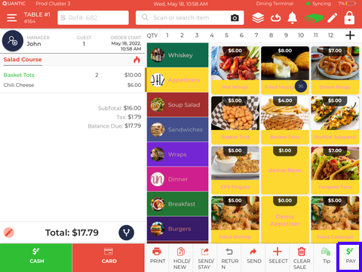

1. Login to the POS app using the same username and password that you have used to create the coupon.
2. Now add items to the cart.
3. Click the **Pay** button at the bottom of the POS.

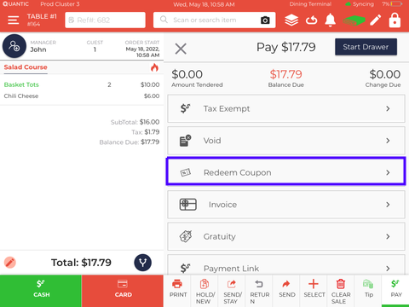

1. Scroll the list and click the **Redeem Coupon** button.

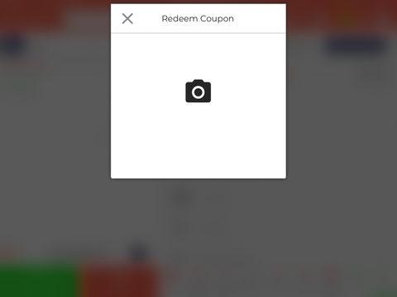

1. Tap the **Camera** popup, the POS camera will open.
2. Now bring the coupon QR code in front of the POS camera, it will be scanned and the coupon will be applied to the order.

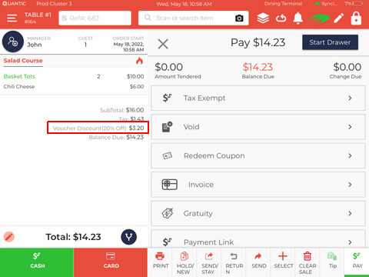

1. On successful validation, the applicable **Voucher Discount** will be displayed on the order screen.
2. The customer can pay the balance due via cash or card and the order will be closed.

## Inventory Management

With Quantic POS you can now track your inventory in real-time so you know what to reorder and when. Easily find thousands of items by organizing them in their respective categories. Quantic can update inventory count for you, send automatic stock alerts and generate purchase orders so you remain stocked always.

### Creating a new Vendor

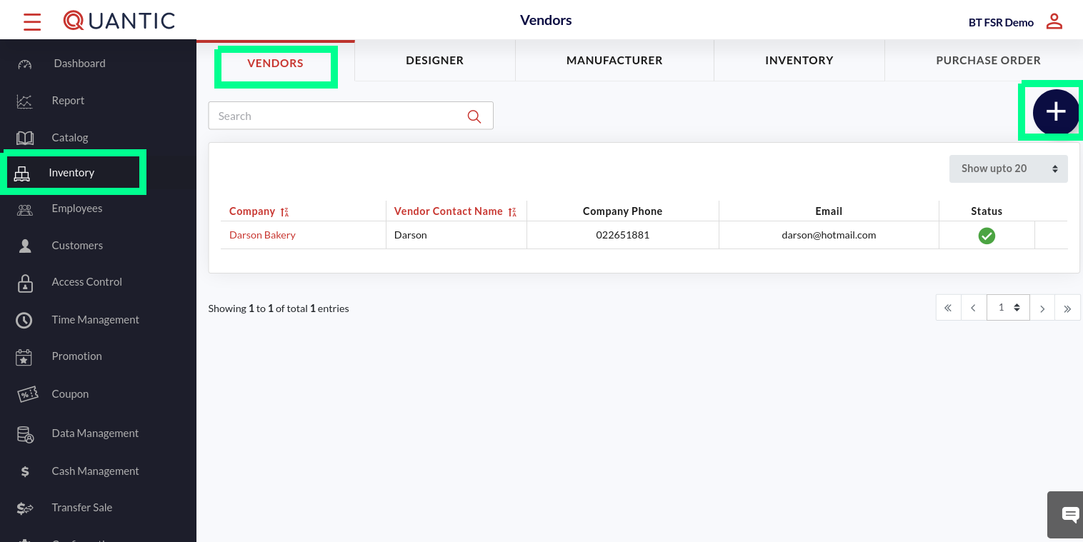

* Go to the left navigation and click **Inventory**.
* Now click the **Vendors** tab as shown in the screenshot.
* The existing vendor’s list will appear on the screen.
* You can tap on any vendor’s name to review or edit the vendor information.
* Click  to add a new vendor.

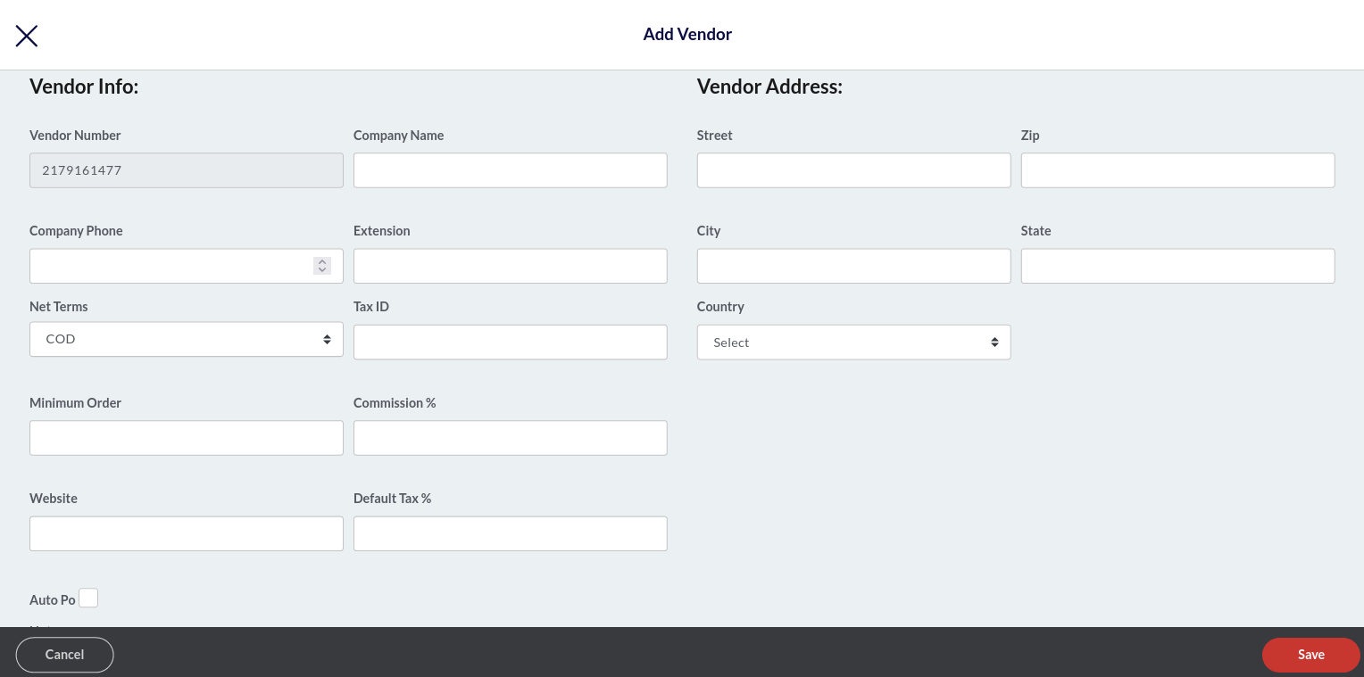

* Enter the vendor information like name, address, contact number.
* Click the **Net Terms** field and select the net payment term.
* Once the information is filled in, click **Save**.

### Adding a Designer

| **Note**: The Designer tab is only meant for E-Commerce Enterprise users. It will appear in the Inventory section when the E-Commerce Enterprise module is enabled for that location in the backend portal. |
| --- |

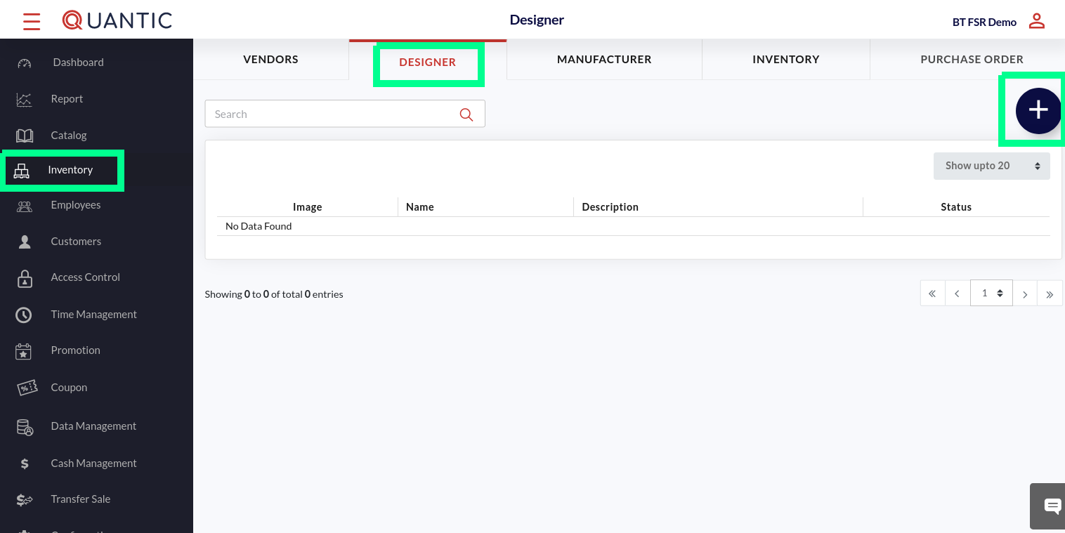

* Go to the left navigation menu and click **Inventory**.
* Click the **Designer** tab as shown in the screenshot.
* The list of existing designers will appear on the screen.
* Click .

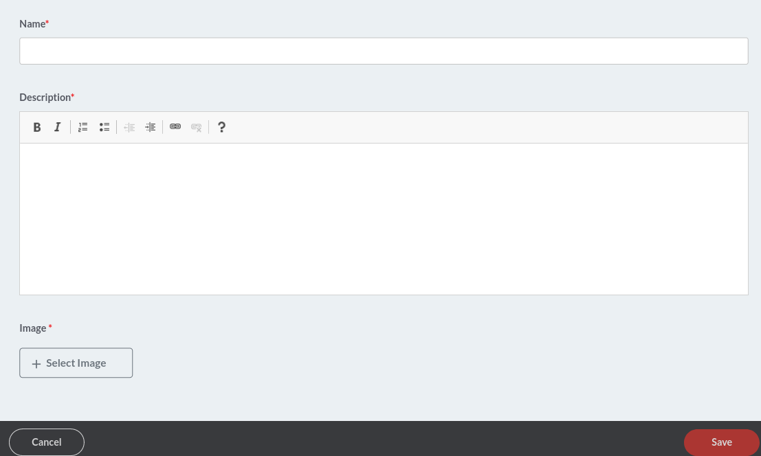

* A new window will appear, enter the designer name, write a description and insert an image.
* Once done, click **Save**.

### Adding a new Manufacturer

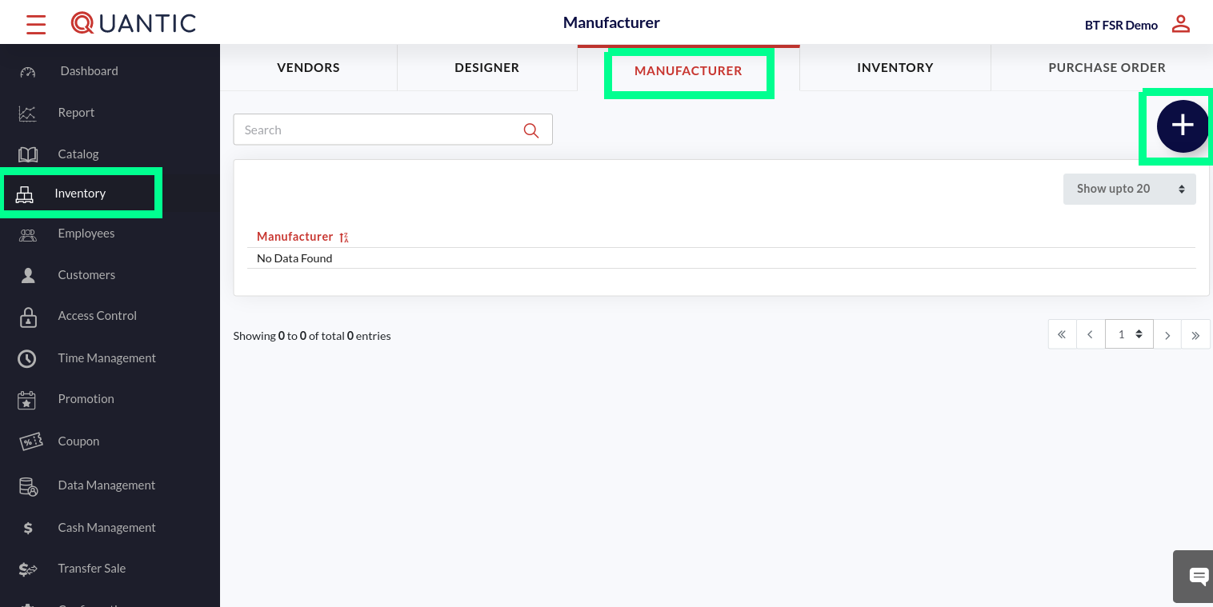

* Go to the left navigation menu and click **Inventory**.
* Click the **Manufacturer** tab as shown in the screenshot.
* The list of existing manufacturers will appear on the screen.
* Click .

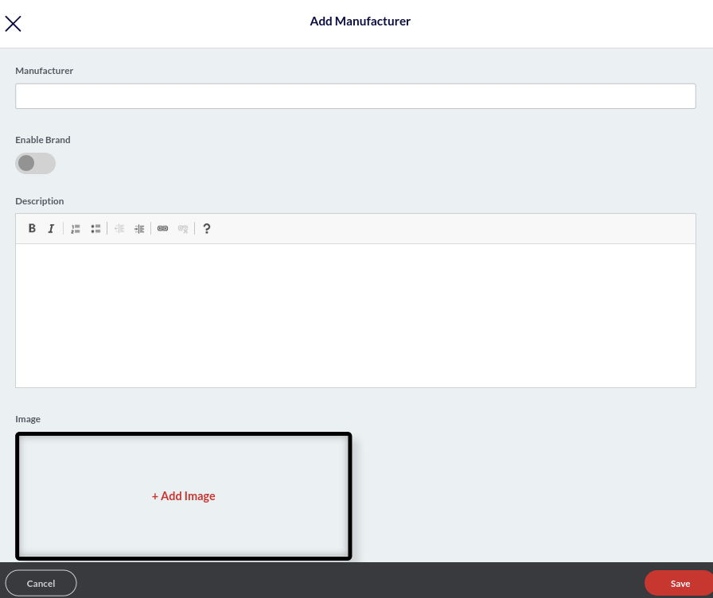

* A new window will appear, enter the manufacturer name in the Manufacturer field.
* Turn on the toggle switch underneath **Enable Brand** if you wish to mark this manufacturer as a brand.
* Enter the manufacturer description in the given field.
* Click **➕Add Image** button to upload the manufacturer’s brand logo.
* Click **Save**.

### How to Add Inventory?

You can add stock or inventory from the Quantic backend portal. Once stock is added, the portal also allows you to filter the inventory by Stock Status (over or under), Category (item category), and Status (active or deactivated). Here are the steps you can follow to add inventory in the Quantic backend portal.

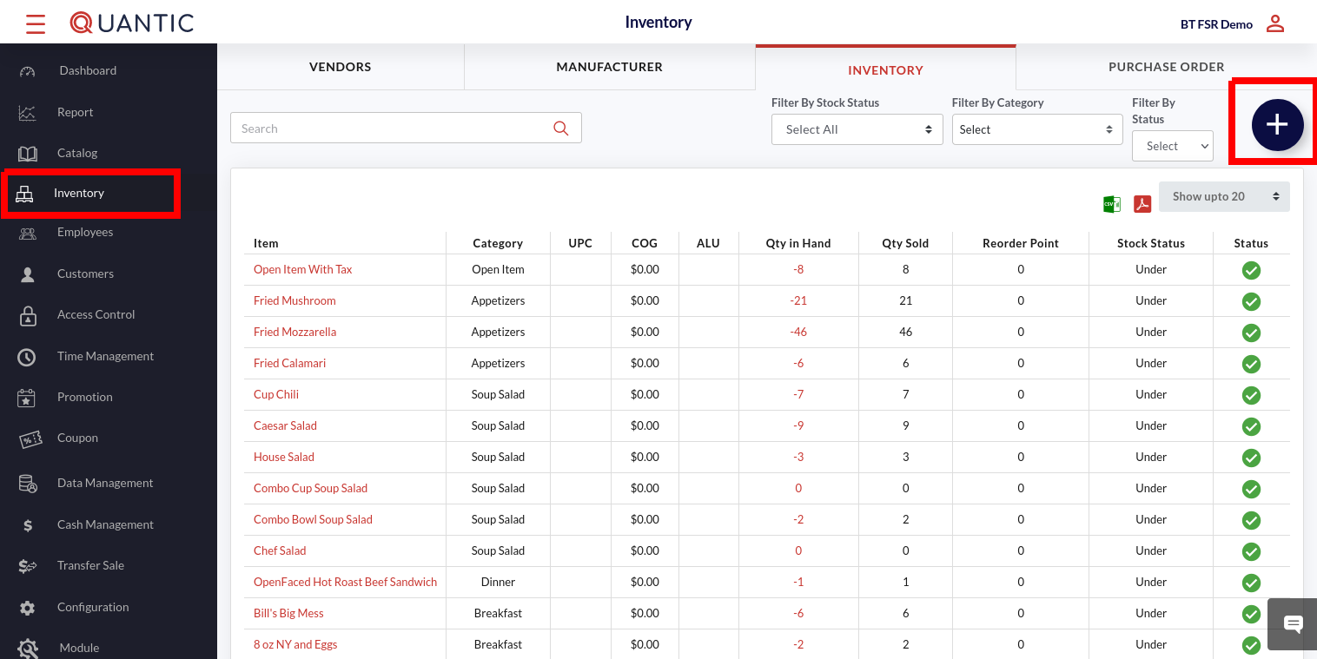

* Login to your Quantic backend portal.
* Click the **Hamburger** button on the top left corner.
* Click **Inventory** (make sure you are on the Inventory tab) and click  on the top left.

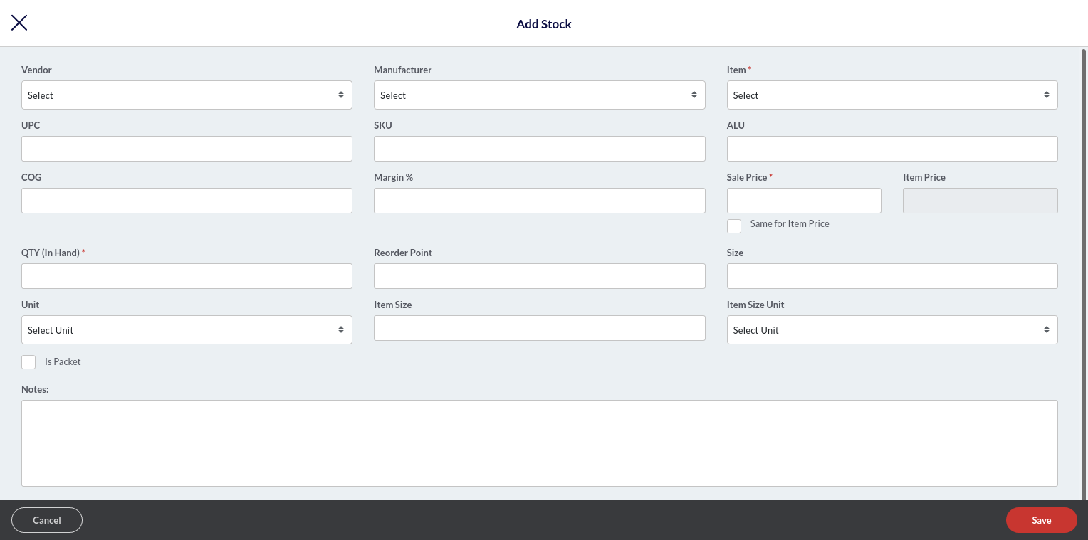

The **Add Stock** screen appears. Here you can add item details with the **Item** name, **Sale Price**, and **QTY (In Hand)** being the mandatory fields. The description for other fields are as follows:

| **Note**: The stock can only be created for those items that are already added to the backend portal. To add stock for any new item, you will need to create the item from the Category section by following this path - **Catalog** > **Super Category** > **Category** > **Items**. |
| --- |

| **Note**: Before creating the item stock, make sure you have added the vendor and manufacturer in the Vendors and Manufacturers tab in the Inventory section. |
| --- |

* **Vendor**: Select the name of the vendor (who is supplying the said item) from the drop-down list. If you can’t find the vendor in the list, first add it from the **Vendor** tab under **Inventory**.
* **Manufacturer**: Select the name of the manufacturer (who is manufacturing the said item) from the drop-down list. If you can’t find the manufacturer in the list, first add it from the **Manufacturer** tab under **Inventory**.
* **Item**: Select the name of the item from the drop-down list. If you can’t find the item in the list, first add an item in the Catalog section.
* **UPC**: Unique Product Code.
* **SKU**: Stock Keeping Unit.
* **COG**: Cost of Good
* **Margin%**: Put the margin in %.
* **Sale Price**: Put the item sale price. If you want to set the sale price the same as the item price, click **Same for Item Price**.
* **QTY (In Hand)**: Put the existing in-hand item quantity.
* **Reorder Point**: Put the item quantity at which you want the item to be reordered.
* **Unit**: Select the unit to measure the item, for example, number, kg, etc.
* **Item Size**: This field will tell the size of each piece if the unit is a piece.
* **Item Size Unit**: Select the item size measurement unit.
* **Is Packet**: Check this box if an item has been added as a carat or bundle.
* **Packet Size**: This field enables automatically when the *Is Packet* checkbox is marked. This field tells how many pieces are there in one carat or bundle.
* **Note**: Here you can add any note for the item you’ve added.

Once done, click **Save**.

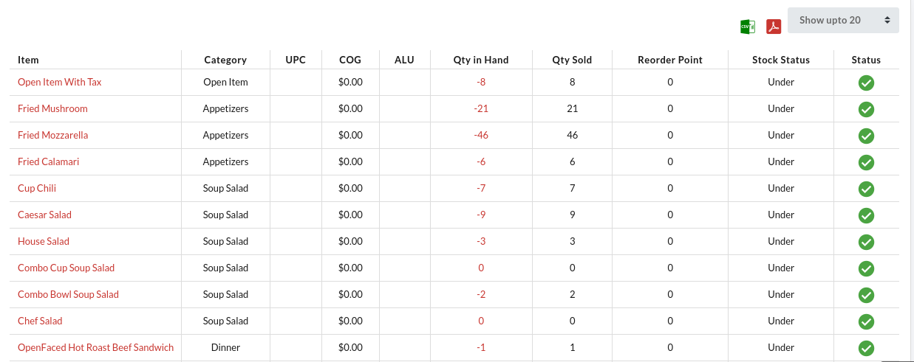

* The item stock will be added in the Inventory section. See the screenshot.

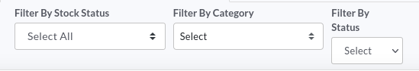

* You can filter the inventory by applying the appropriate filter:
  + **Stock Status:** Based on the Over inventory or Under inventory.
  + **Category:** Based on the item category.
  + **Status:** Based on the Active or Inactive items.

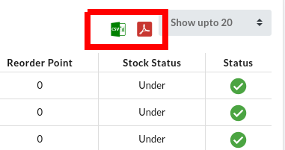

* Moreover, you can also download the inventory in CSV 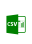or PDF  by selecting the appropriate option.
* Just filter the inventory by any of the three categories and click the CSV  or PDF button to download the file in your system.

## **How to Generate a Purchase Order?**

A purchase order is a legal document that a buyer sends to a vendor or supplier to authorize a purchase. Here are steps to be taken to create the one from the Quantic backend portal.

| **Note**: PO can only be generated for the items that exist in the backend portal. To create a PO for any new item, make sure to add an item and the vendor in the backend portal. Follow this path to add a new item **Catalog** > **Super Category** > **Category** > **Items** and associate it with a vendor in the **Inventory** tab. |
| --- |

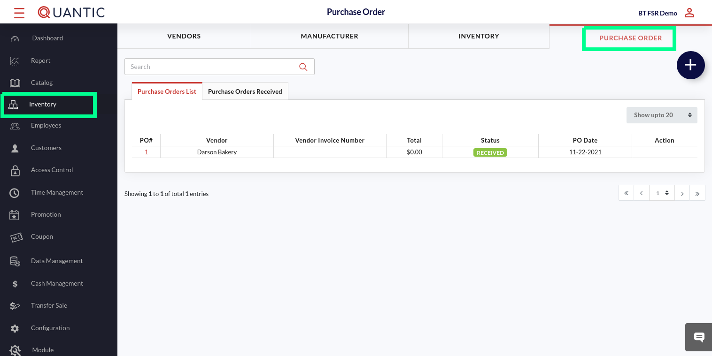

* Click the **Hamburger** button on the top left corner.
* Click **Inventory** on the left navigation menu.
* Click **Purchase Order** and click the ➕ icon.

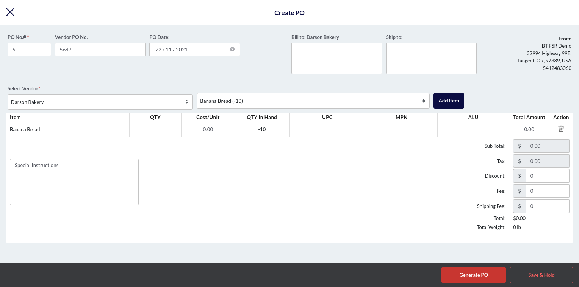

* Enter the details in the **Create PO** form.
* Put the **Vendor PO No., Bill To, Ship To**.
* Select the vendor from the **Select Vendo**r drop-down list.
* Select the item that you want to add in the PO from the **Select Item** field.
* Once done, click **Add Item**.

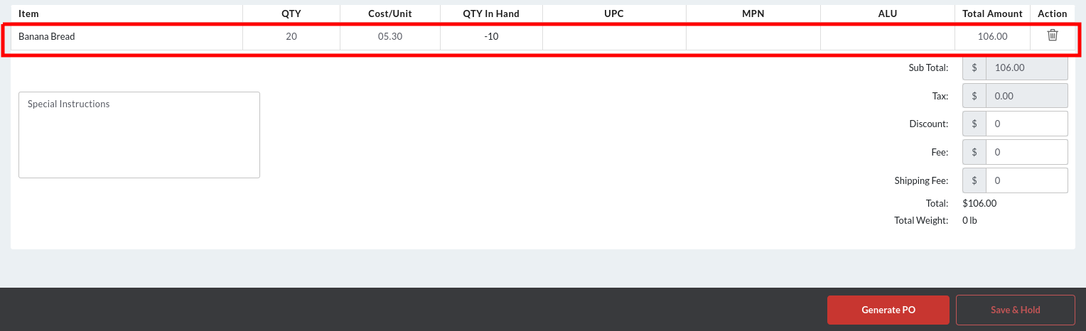

* Enter the details of the item you are creating the PO for.
* In the **QTY** section, enter the item quantity that you want to order from the vendor.
* In the **Cost/Unit** section, enter the per unit price of an item.
* Enter the **UPC**, **MPN** and **ALU** details of an item.
* To add more items, repeat the steps from selecting the vendor till the above step.
* Click **Generate PO** or if you do not want to generate now, click **Save & Hold**.
* On clicking the **Generated PO** button, the **PO# Generated Successfully** message will appear. Click the **Download PDF** button to download the PO in your system or you can click ✖️ if you do not want to download it now.

| **Generating a Negative PO**: You can create a negative purchase order by entering the negative quantity for the number of items (*that you are returning, transferring or crediting to the vendor for any reason*) in the **QTY** column. Negative purchase orders are also called reverse PO or credit PO. |
| --- |

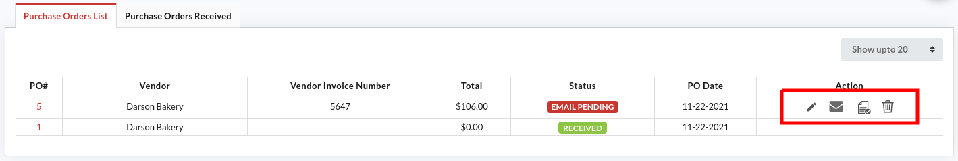

* Once the PO is generated, you will be sent back to the **Purchase Order** section. Here you can review the purchase orders under the **Purchase Orders List** tab.
  + Clickto edit the PO.
  + Clickto email the PO.
  + Click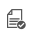to receive the item(s).
  + Clickto delete the PO# from the list.
* Click the **Purchase Orders Received** tab to review the purchase orders that have been received in the past.

### **Receiving a Purchase Order**

After receiving the items ordered, you need to enter the actual quantity received in the backend portal. Doing this will update the item quantity (in-hand) in the portal. Here are the steps to receive the purchase order.

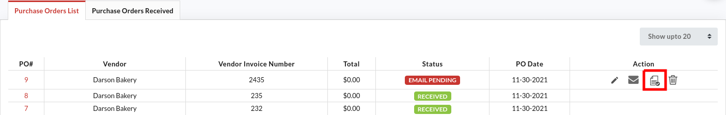

* Once you create a purchase order, you will land on this screen. If you didn’t, make sure to click the **Purchase Order List** tab.
* Clickto receive the PO.

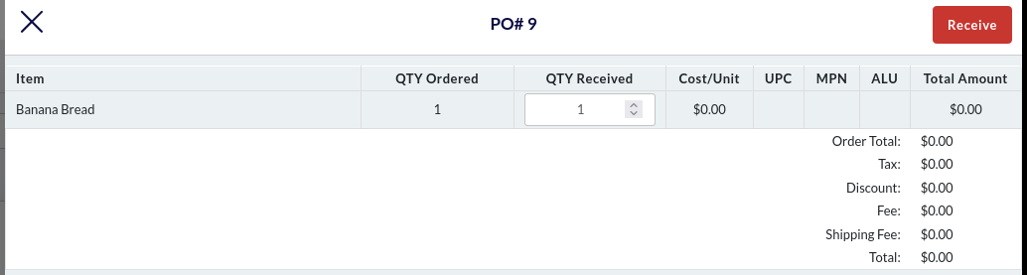

* Enter the items received in the **QTY Received** field.
* Click the **Receive** button on the top right corner.
* Click **Ok** on the confirmation screen.

|  | The purchase order pop-up will appear.  Click  to print the purchase order or click to download the purchase order. |
| --- | --- |

## **How to apply auto-gratuity based on the balance due?**

Now the auto-gratuity (in $ or %) can be applied if the total amount due exceeds the preset Gratuity Amount Limit. This feature can be implemented from the *Configuration* > *Service Area* in the backend portal. Here are the steps.

|  | Login to the backend portal.  Click the **Hamburger** button on the top left and click **the Configuration** option on the left navigation menu. |
| --- | --- |

|  | Expand the **Setup** navigation.  Click **Service Area**. |
| --- | --- |

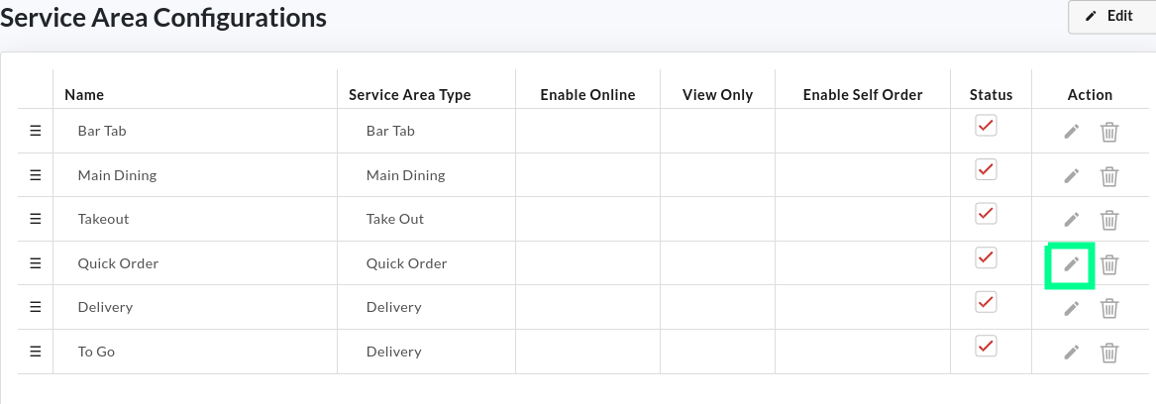

* Here you can edit the service areas to customize as per the need.
* Click  on the service area where you want to implement the auto-gratuity based on the amount due.
* As an example, we have chosen the **Quick Order** service area.

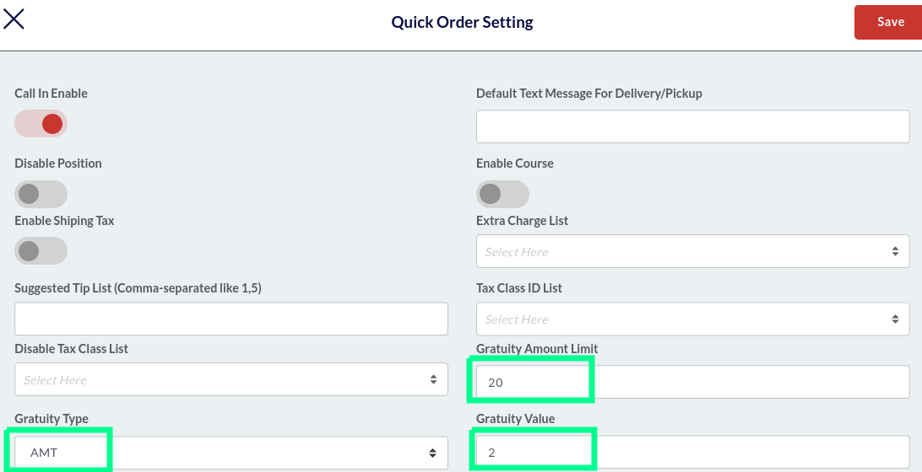

* In the **Gratuity Amount Limit** field, enter the amount due, which if exceeded, the gratuity will apply automatically.
* Select the **Gratuity Type**- % or $.
* Enter the gratuity value that should be added to the total amount due.
* Click **Save**.

|  | For example, you have set $20 as the Gratuity Amount Limit and $2 as the Gratuity Value. Now, if the total amount due is $26, the $2 gratuity will be added automatically to the bill, and the new balance due will be $28 (amount due + gratuity). However, if the total amount due remains $19 (less than the Gratuity Amount Limit), the auto-gratuity won't apply, and the balance due will remain the same, i.e., $19. |
| --- | --- |

## Adding General Information in the backend portal

You can add or edit your location name, upload brand logo, change address, time zone, business name, all by yourself from the backend portal. Follow the steps below, navigate to the General Information section and edit your business information.

|  | Log in to your Quantic backend portal.  Go to the left navigation and click **Configuration**. |
| --- | --- |

|  | Click the  symbol in front of Setup. Doing this will explore further sections underneath the setup. |
| --- | --- |

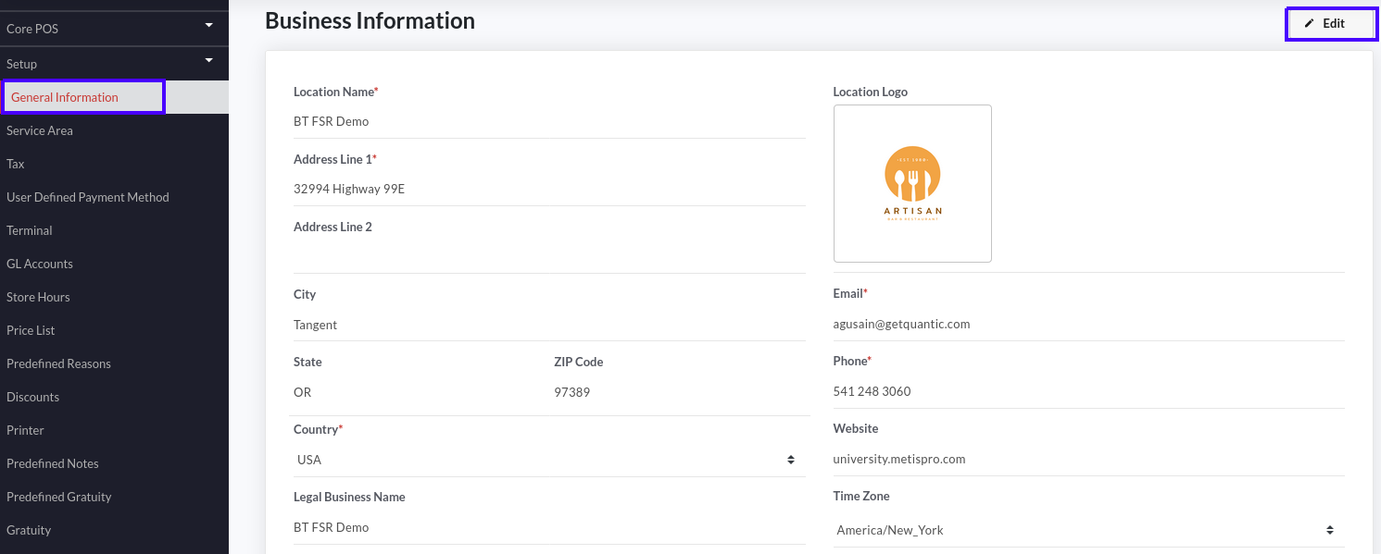

* Click the **General Information** tab as shown in the screenshot.
* The **Business Information** will be displayed on your screen.
* Here you need to click the  button on the top right corner.

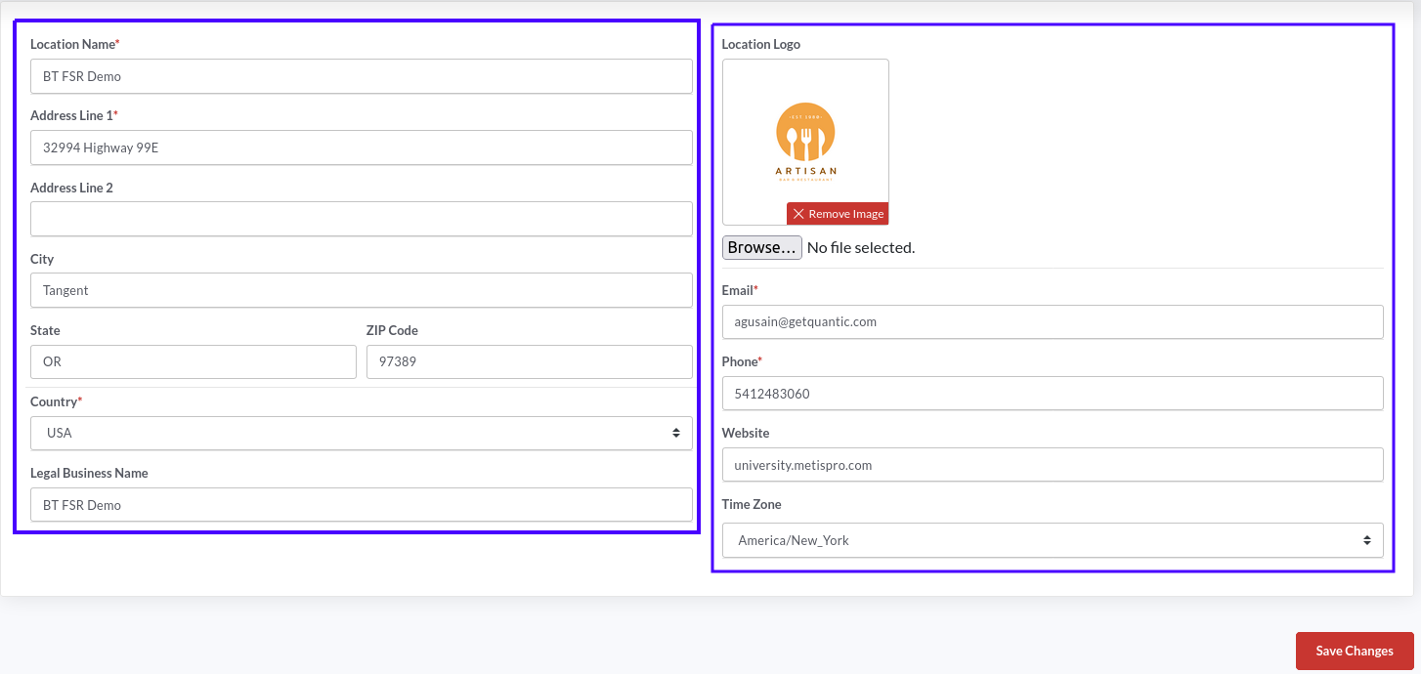

* Now you can tap on any field to edit or add the relevant information.
* To edit or add your business logo, click the **Browse** button, select the image from the location in your system and upload it.
* Similarly you can add other details such as email, address, phone number, website etc.
* Click the **Time Zone** box and select the time zone from the drop-down based on where your business is located.
* Once you are done with the changes, click **Save Changes**.

| **Note**: Boxes marked with asterisk ”*” are mandatory fields and cannot be left empty. |
| --- |

## Adding and Setting up the Service Area

Here you can add the service areas and customize them for better functioning. Let’s first begin with adding the service area.

### Adding the Service Area

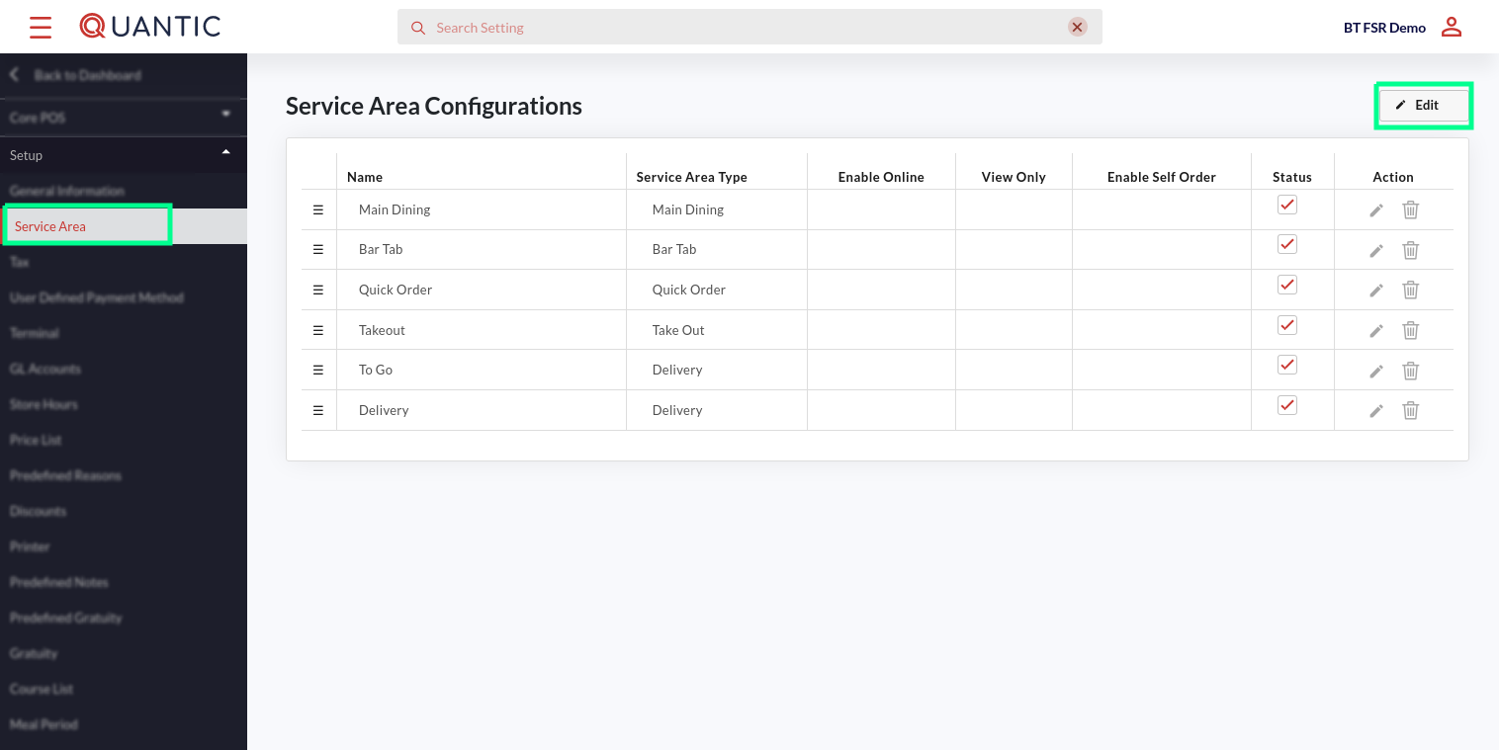

* Begin by navigating to the **Service Area** under **Setup**.
* See the screenshot for visual interpretation.
* To add a new **Service Area**, start by clicking  on the top right corner.

|  | Click the  on the bottom right below the service areas. |
| --- | --- |



* A new field will appear, tap on it and enter the name of the service area that you want to create.

|  | Tap the Select drop-down in the **Service Area Type** column and pick the service area type. |
| --- | --- |

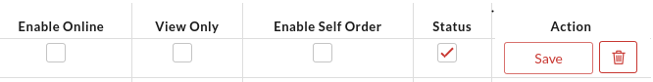

* Tap these checkboxes only if you want to enable them, otherwise leave them unchecked. Their description is given below.
* **Enable Online**: Check this box if the service area has to be enabled for the online orders.
* **View Only**: Check this box if the service area is meant just to display the menu online and not for accepting orders. (This setting will hide the Add to Cart button).
* **Enable Self Order**: Check this box to enable this service area for self-ordering.
* **Status**: Check this box if you want to activate this service area.
* Click 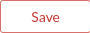 to save the settings.
* Click 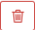 to delete the service area.

### Setting up the Service Area

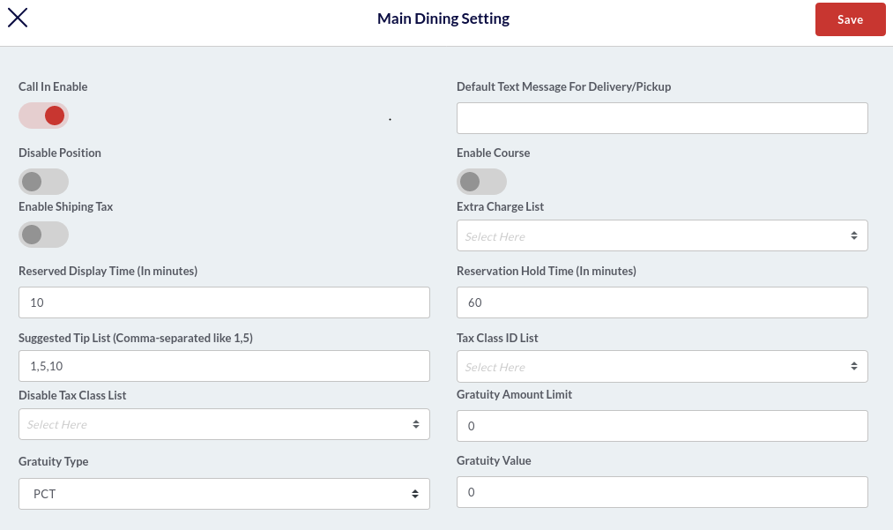

Click  in front of a service area under the **Action** column to start setting up that service area. The **Setting** screen will appear with lots of customization options. These options may vary for different **Service Area Types**. For example, this screen appears for the **Main Dining** service area. The description for the fields is given below.

* **Call In Name**: Enable this toggle switch (turn it red) to show the customer call in name input option for this service area.
* **Default text message for delivery/pickup**: Enter the default text message that you want to display for delivery/pickup.
* **Disable Position**: Turning on the toggle switch (turn it red) will disable the position selection for this service area.
* **Enable Course**: Turning on the toggle switch (turn it red) will enable the course selection for this service area.
* **Enable Shipping Tax**: Turning on the toggle switch (turn it red) will enable the additional shipping tax for this service area.
* **Extra Charge List**: Here you can select the extra charges that should apply on all orders under this service area.
* **Reserved Display Time (in minutes)**: Enter the table reserve time (in minutes).
* **Reservation Hold Time (in minutes)**: This is the holding time for a reserved table.
* **Suggested Tip List**: Enter the tip amount that you want to show on the payment screen. To enter multiple tip amounts, separate them with a comma “,”.
* **Tax Class ID List**: Select the applicable tax classes for this service area.
* **Disable Tax Class List**: Select the not-applicable tax class(s) for this service area.
* **Gratuity Amount Limit**: Here you can set the maximum amount due limit, which if exceeded, the gratuity will apply automatically.
* **Gratuity Type**: Select the gratuity type- **%** or **Amount**.
* **Gratuity Value**: Enter the gratuity amount that should apply when the *Total Amount Due* exceeds the *Gratuity Amount Limit*.

Once you are done with the settings, click **Save** on the top right corner.

## Adding the Tax Class

Here you can add the tax class, set the tax rate (%) and mark them default tax or smart tax.

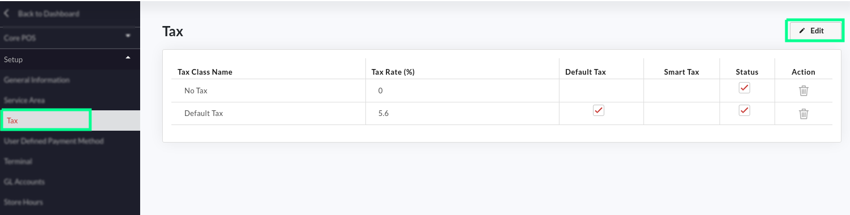

* Go to the **Tax** menu on the left navigation.
* Click  on the top-right corner.

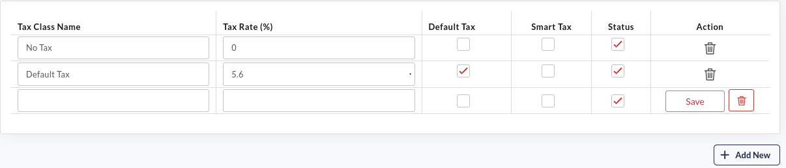

* Click  button.
* A new field will appear. Enter the tax class name, set the tax rate (in %).
* Tap on the **Default Tax** checkbox, if you want to set this tax as a default.
* Tap on the **Smart Tax** checkbox, if you want to set this tax as a smart tax.
* Tap on the **Status** checkbox to activate the tax class.
* Click  to save the settings.
* Click  to delete the tax class.

## Setup the User Defined Payment method

User defined payment method section allows you to set up the most popular payment methods and customize them to fit the restaurant’s needs.

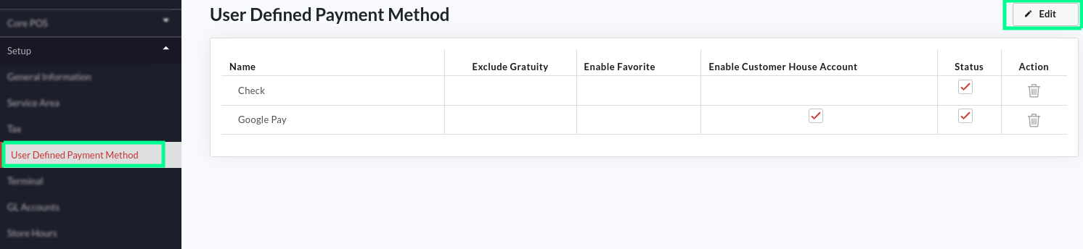

* Go to the left navigation menu, expand the **Setup** section and click the **User Defined Payment Method**.
* Click the  button on the top right.

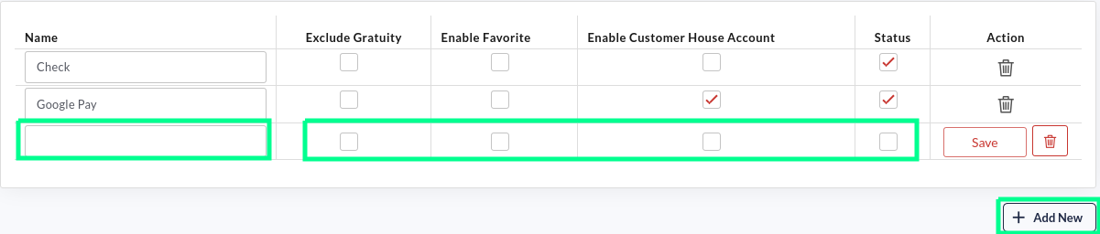

* Click  as shown in the screenshot.
* A new field will appear; enter the name of the payment method that you want to add.
* Tap the **Exclude Gratuity c**heckbox if you want this payment method to be free of Gratuity.
* Tap the **Enable Favourite** checkbox if you want to set this payment method as a favourite.
* Tap the **Enable Customer House Account** checkbox to enable a payment method for customer **House Account**.
* Tap the **Status** checkbox to activate a payment method.
* Click  to delete the payment method.

## How to create a meal period based menu?

A typical meal period could be breakfast, lunch, dinner, Sunday brunch, happy hour, etc. You can even create special meal periods for special events like new year, valentine’s day, etc., and enable those meal periods to show up during a particular period. Suppose you want to create a special Lunch meal period, and you want the server to see it only on Saturday between 09:00 PM and 10:00 PM; here is what you need to do:

1. Go to the backend portal.
2. Create a meal period.
3. Associate the items/categories with that meal period.

That’s it. Check out the detailed steps below.

### Create a Meal Period

|  | 1. Login to the Quantic backend portal. 2. Tap the hamburger icon to open the left navigation menu. 3. Click the **Configuration** as shown in the screenshot. |
| --- | --- |

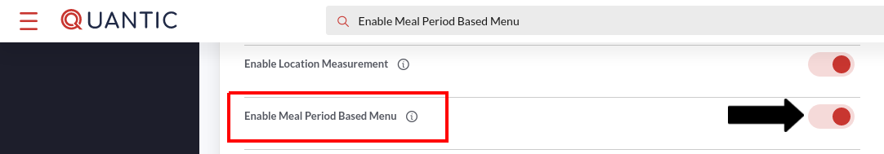

1. Search the configuration **Enable Meal Period Based Menu** and turn on the toggle switch next to it.

|  | 1. Login to the Quantic backend portal. 2. Tap the hamburger icon to open the left navigation menu. 3. Click the **Configuration** as shown in the screenshot. |
| --- | --- |

|  | 1. Expand the **Setup** menu. 2. Scroll down and click the **Meal Period**. |
| --- | --- |

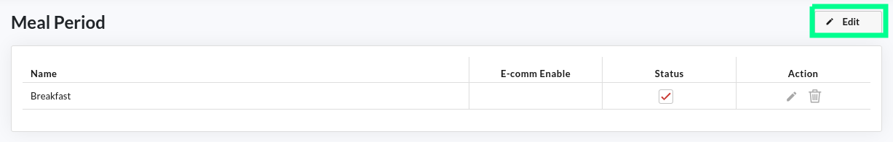

1. Here appears the **Meal Period** screen, where you can add a new meal period and edit or delete the existing ones.
2. To create a meal period, click the  button.

|  | 1. Click the  button as shown in the screenshot. |
| --- | --- |

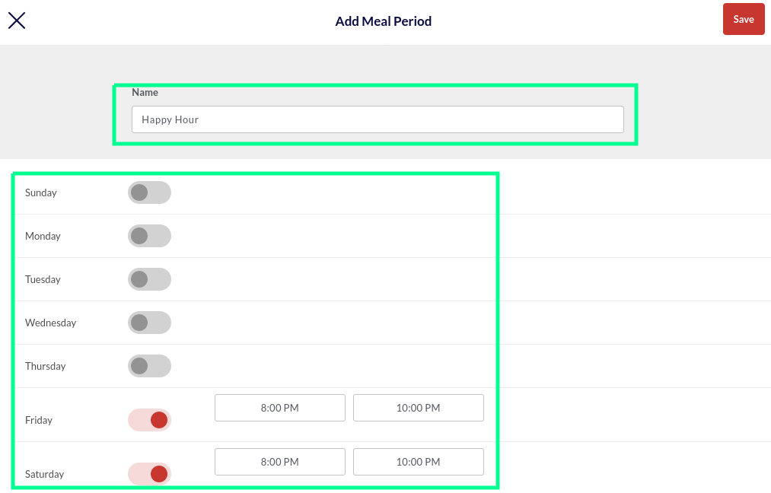

1. A new screen will open; here you can name the meal period and set the start time and end time.
2. Tap on the toggle switch next to the day for which you want to enable the meal period.  symbol means the meal period is disabled for a day, and  symbol means the meal period is enabled.
3. The **Start Time** and **End Time** fields will open next to it. Tap on the **Start Time** field and select the time at which you want the meal period to begin. Similarly, you can choose the end time as well. Or, you can enter the time manually in HH:MM AM/PM format.
4. Once done, click **Save**.
5. For example, in the above screengrab, we named the meal period *“happy hour”* and set its availability for Friday and Saturday from 8:00 pm to 10:00 pm.
6. Repeat steps 7-12 to create a new meal period.

#### **Associate the meal period with an item**

| **Note**: You can associate multiple meal periods with an item, but please make sure that you have added all the needed meal periods by following the steps explained above. |
| --- |

|  | 1. Click the **Hamburger** icon and tap **Catalog** on the left navigation. Check the screenshot. |
| --- | --- |



1. Click the **Items** tab.

|  | 1. Click on the item that you want to associate the meal period with. |
| --- | --- |

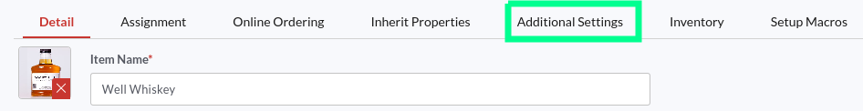

1. Tap on the **Additional Settings** tab as shown in the screenshot.

|  | 1. Locate the **Meal Period** field, click on it. 2. Select the meal periods from the drop-down to associate them with this item. Click **Select All** to associate all the available meal periods with this item. 3. Once done, click **Save** at the bottom right corner. |
| --- | --- |

**Note**: In this example, we have associated the “*Well Whiskey*” drink with the “*Happy Hour*” meal period. Doing this will make the Well Whiskey drink be available during the Happy Hour meal period only, on Friday and Saturday from 8:00 pm to 10:00 pm. Similarly, you can create a unique meal period for some special events like New year, Valentine’s day, etc.

#### Associate the meal period with a category

|  | 1. Click the **Hamburger** icon and tap **Catalog** on the left navigation. Check the screenshot. |
| --- | --- |



1. Click the **Category** tab.

|  | 1. Click on the category that you want to associate the meal period with. |
| --- | --- |

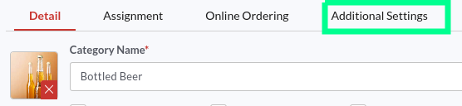

1. Tap on the **Additional Settings** tab as shown in the screenshot.

|  | 1. Locate the **Meal Period** field, click on it. 2. Select the meal periods from the drop-down to associate them with this category. Click **Select All** to associate all the available meal periods with this category. 3. Once done, click **Save** at the bottom right corner. |
| --- | --- |

In this example, we have associated the “*Bottled Beer*” category with the “*Happy Hour*” meal period. Doing this will make the Bottled Beer category be available during the Happy Hour meal period only, on Friday and Saturday from 8:00 pm to 10:00 pm. Similarly, you can create some unique categories and make them available for specific meal periods.

| **Note**: Please note that the meal period setting for an item will override the category’s meal period setting for this specific item. |
| --- |

## Table Management

Quantic backend portal allows the clients to replicate the table positions of their restaurant. The tables can be added as per their exact specifications, such as shape, size, and position in the restaurant. The tables can be allocated serial numbers for easy identification. The tables can also be modified or relocated at any point in time. Once the table layout is created, the server can tap on a table (in the POS) to take orders on that table. It helps the servers take and serve orders with zero errors, especially when the their shift changes. The new server knows which table is occupied and which is not just by seeing the color coding on the table layout. The occupied table goes red, the partially paid table goes green, while the unoccupied table remains grey. Below are the steps on adding, editing, and modifying tables at your convenience from the backend portal.

|  | 1. log in to your backend using the username and password. 2. Tap the **hamburger** icon on the top left. 3. Click **Configuration** on the left panel. |
| --- | --- |

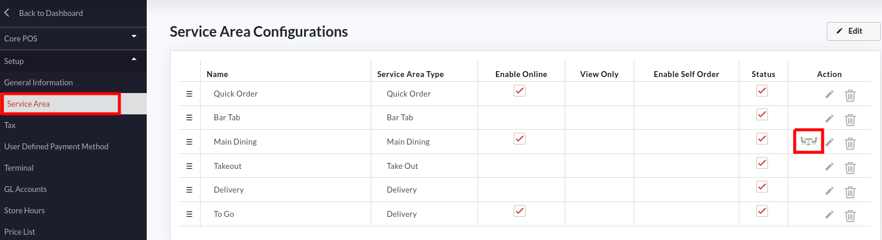

1. Tap on the **Service Area** under the **Setup** menu.
2. The **Service Area Configurations** page will open up.
3. Tap  under **Actions** in the **Main Dining** row.

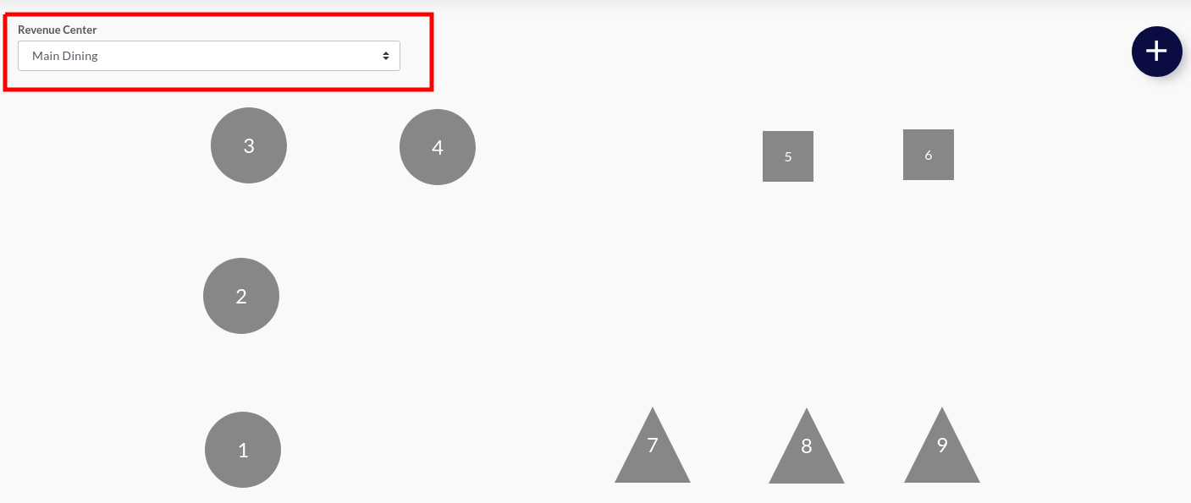

1. The **Manage Table** page will appear. Here you can see the existing table layout, modify the table and add a new table.
2. Tap the **Revenue Center** tab and select the dining area where you want to set up the tables.

### Adding a new table

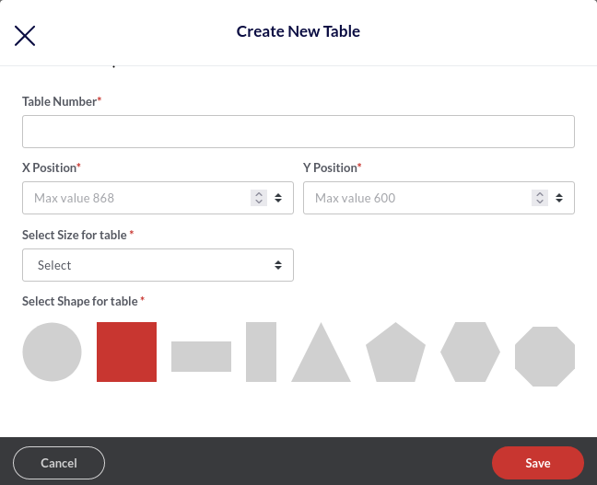

1. To add a new table, tap  on the top right of the **Manage Table** screen.
2. The **Create New Table** popup will appear. Fill in the table details as given below:
   1. **Table number** - Enter the table number. Please make sure to assign different numbers to the tables for streamlined ordering. Similar table numbers may create unnecessary confusion for servers.
   2. **X Position** - This is the position of the table on the horizontal axis.
   3. **Y Position** - This is the position of the table on the vertical axis.

| **Note**: You can set any default position for now and drag and drop the table to the desired position later on. |
| --- |

* 1. **Select Size for Table** - Select the table size from the drop-down - You can choose from these options - normal, medium, or large.
  2. **Select Shape** - This setting allows you to choose the shape of the table. The available options are circle, square, rectangle, triangle, etc.

1. Click **Save** to save the table layout settings.

### Modifying the existing table

You can edit the shape and size of the virtual table at any point in time. Below are the detailed steps.

|  | 1. Hover your cursor over the table that you want to edit. 2. Tap  as shown in the screenshot. |
| --- | --- |

|  | 1. The **Edit table** screen will open. 2. Modify any of the given fields and once done, click **Save**. 3. You can also delete the table by clicking the  button. |
| --- | --- |

### How does the table layout appear on the POS?

The table layout on the POS is the exact replica of the backend portal table management. Below you can see the backend portal table layout on the left and how that reflects in the POS, on the right.

|  |  |
| --- | --- |
| **Backend portal table layout representation** | **POS table layout representation** |

1. You can review the table positioning at **Main Dining** under the **Service Areas** tab.
2. Please make sure to log in to your POS using the same username that you have used to access the backend portal for table creation.
3. Navigate to the **Service Area** menu tap the **Main Dining** (or the Revenue Center where you have created the table).
4. The exact replica of the backend portal table management will be displayed on your POS screen (Check out the screenshot on the right).
5. Now the server can tap on any table and start taking the orders right away.
6. Below is a cutout of a table similar to table 2 and table 3 as shown in the above illustration. The table in red means it is occupied and the green table symbolizes the table is vacant. Following is a detailed observation of the layout.

|  | 1. The red table indicates that the table is occupied. Below is the detailed observation. 2. The timer on top is in **HH:MM** format. This is the time the guests have spent at the table. In the above example, the guests have been at the table for the past 04 hours and 18 minutes. 3. **John D** is the name of the employee serving the guests. 4. **2** is the table number. 5. The number **2** in the brackets ahead of John D is the number of guests at the table. |
| --- | --- |

|  | 1. The table in green shows the order placed is partially paid, and some balance due is still remaining to be paid. 2. The grey tables are unoccupied. |
| --- | --- |

## How to Setup the Promotional Price from the Portal?

Restaurants can offer special promotions or discounts to the guests on special events. The promotional pricing can be applied to the entire group of items in the store. Rather than changing the price of items individually, you can create a promotion rule that will apply to all the items in a category. Also, you can apply the promotion rule to the individual items and set the start and end date of the promotion rule.

### Setup the Promotion Rule

You can customize the promotion rules here, such as the start and end date/time of the promotion, price of the item during the promotional period, and whether the promotion should keep repeating without any end date. For example, you can offer promotional prices for summer holidays, weekends, clearance sales, etc. Below are the steps to set up the promotion rule in Quantic.

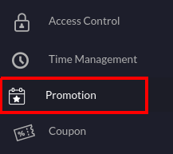

1. Navigate to the **Promotions** in the left navigation menu.

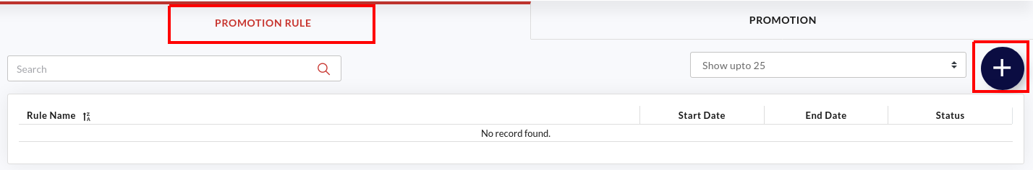

1. Select the **Promotion Rule** tab as shown in the screenshot.
2. Click  to create a new promotion rule.

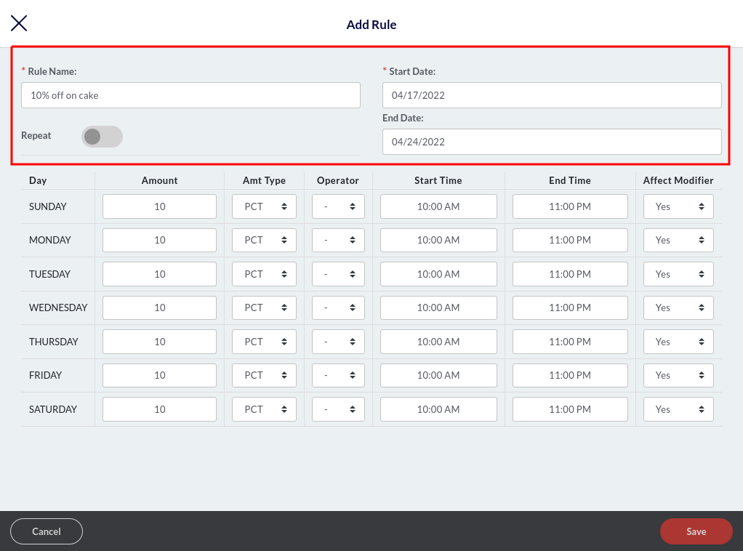

1. A new window will appear here. You can create a new rule and customize it the way you want. Below are the descriptions.
   1. **Rule name**: Enter the name of the promotion rule such as 10% off on cakes, Happy Hours, Friday 20% off, etc.
   2. **Start Date**: Select the start date of this promotion rule. From this date onwards, the promotion rule can be applied to items. So if you select April/17/2022 as the start date, the promotion rule will come into effect from the 17th of April.
   3. **End Date**: Select the end date of this promotion rule. The promotion rule will end on this date. If you select April/24/2022 as the end date, this promotion will end on the 24th of April.
   4. **Repeat**: Tap the **Repeat** button if you want the promotion rule to keep repeating every day, without any end date. This will apply the same promotional price every day on the associated items.

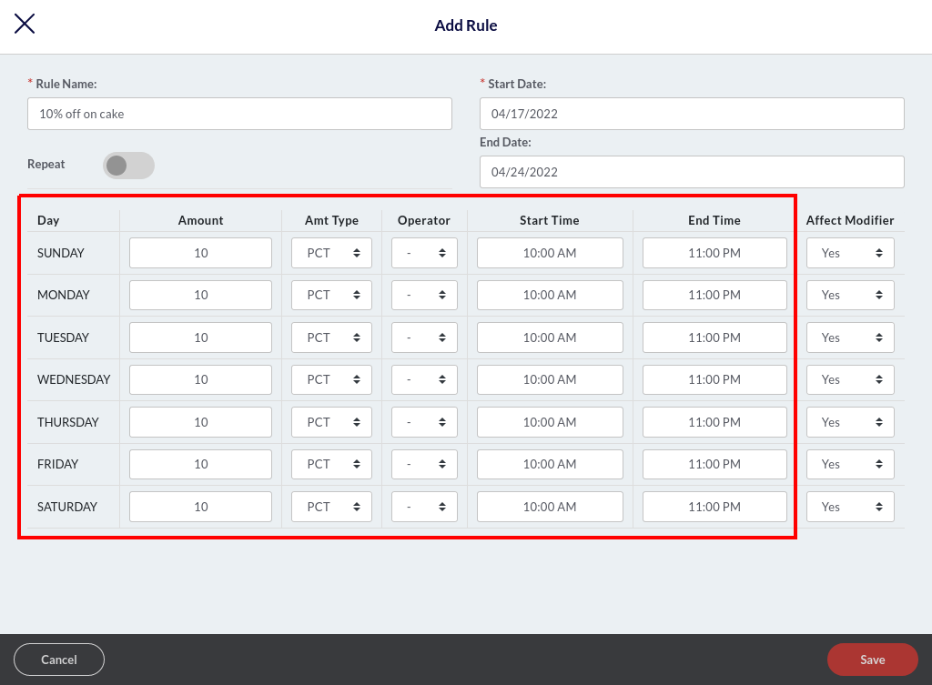

1. Enter the amount next to the day. The amount should be in numbers. So, if you want to offer the 10% off on cakes, enter 10 next to Friday, select **PCT** (percent) in **Amt Type,** and select (➖) in the **Operator Type**. Below are some important abbreviations to help set up the rules.
   1. **PCT**: Percentage%. For example, 10%.
   2. **AMT**: Amount. For example, $10.
   3. **Operator** (➖): Apply this operator when you want to offer a discount. For example, to activate the 10% off on items, simply put 10 in Amount and (➖) in Operator.
   4. **Operator** (➕): Apply this operator when you want to increase the price of items. For example, to raise the price of items by 10%, simply put 10 in Amount and (➕) in Operator.
   5. **Operator** (=): Apply this operator when you want to override the existing amount of the item. For example, if you put 10 in the Amount field and select (=) operator, the existing price of the associated item will be overridden to $10.
2. Next, you should select the start and end time to choose the duration during which you want the promotion rule to remain in effect during the day. For example, you want the 10% off on cakes promotion rule to stay active between 10:00 am to 11:00 pm, so select 10:00 am as the Start Time and 11:00 PM as the End Time.

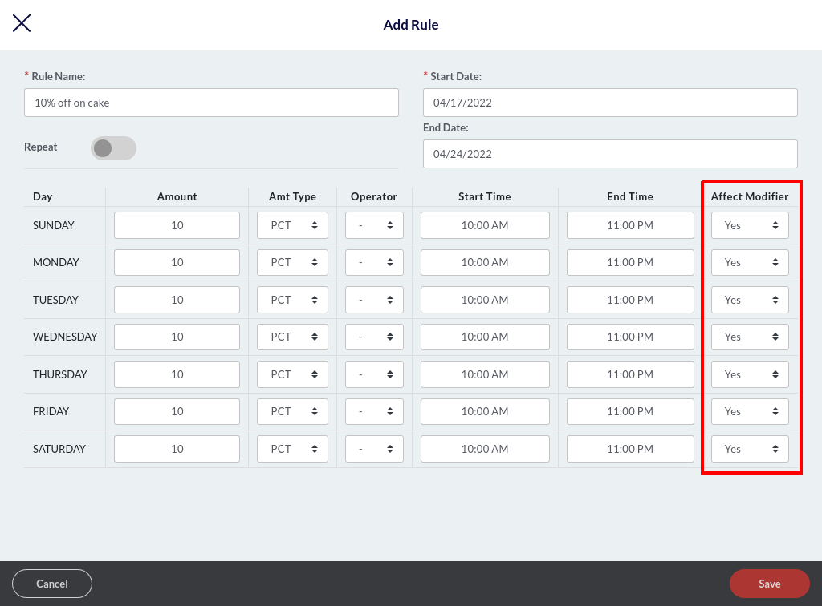

1. Select **Yes** in the **Affect Modifier** field if you want the promotion rule to be applied to the associated modifiers as well. Let’s understand this with an example of an item - *Hot Wings*. It is usually served with a *Sweet Chilly* modifier. So, there can be two scenarios - first, you want the promotion rule to be applied on the modifier as well, and second, you want to exclude the modifier from the promotion rule. Let’s see the calculations in both scenarios.

**Scenario 1**. Applying the promotion rule on item and modifier.

You apply a 10% off promotion rule on Hot Wings and select **Yes** in the **Affect Modifier** field; the final price will be calculated on *Hot Wings + Sweet Chilly*, as given below.

Price of Hot Wings = $5

Price of Sweet Chilly = $1

Total Price = $6

Final price after applying the promotion rule (10% off) = $5.4

**Scenario 2**. Applying the promotion rule on item only.

You apply a 10% off promotion rule on *Hot Wings* and select **Yes** in the **Affect Modifier** field; the final price will be calculated as given below.

Price of Hot Wings = $5

Price of Sweet Chilly = $1

Final price after applying the promotion rule (10% off) = $5.5.

1. Don’t forget to click the **Save** button to save the changes.

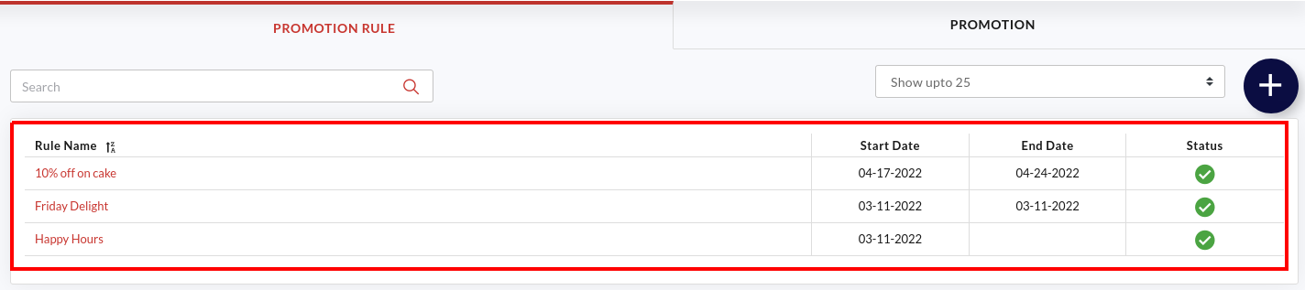

1. The added promotion rules will appear under the **Promotion Rule** tab, as shown in the screenshot above.
2. The **Start** and **End Date** will also appear next to the promotion rules.
3. The  under **Status** symbolizes the promotion rule is active and  means a promotion rule is inactive. You can tap on the  or  to reverse the action.

### Setup the promotion

Once you have set up the promotion rules, it’s time to create an event and associate a promotion rule with it. This section will allow you to choose employees who can apply the promotion rule to an item and the service areas and terminals where the promotion rule can be applied. For example, you have an Easter Event around the corner. And you want to offer 10% off on chocolate truffles. Here is how you can do it - create a promotion rule called 10% off on chocolate truffles, create a promotion called the Easter Event, and associate the chocolate truffles item with Easter Event. Follow this path to associate an item with specific promotion - **Catalog** > select **chocolate truffles cake** > **Additional Settings** > **Enable Event**.

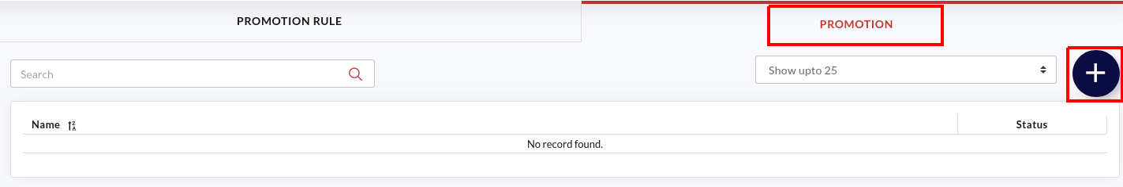

1. Tap the **Promotion** tab as shown in the screenshot above.
2. Click  to create a new promotion.

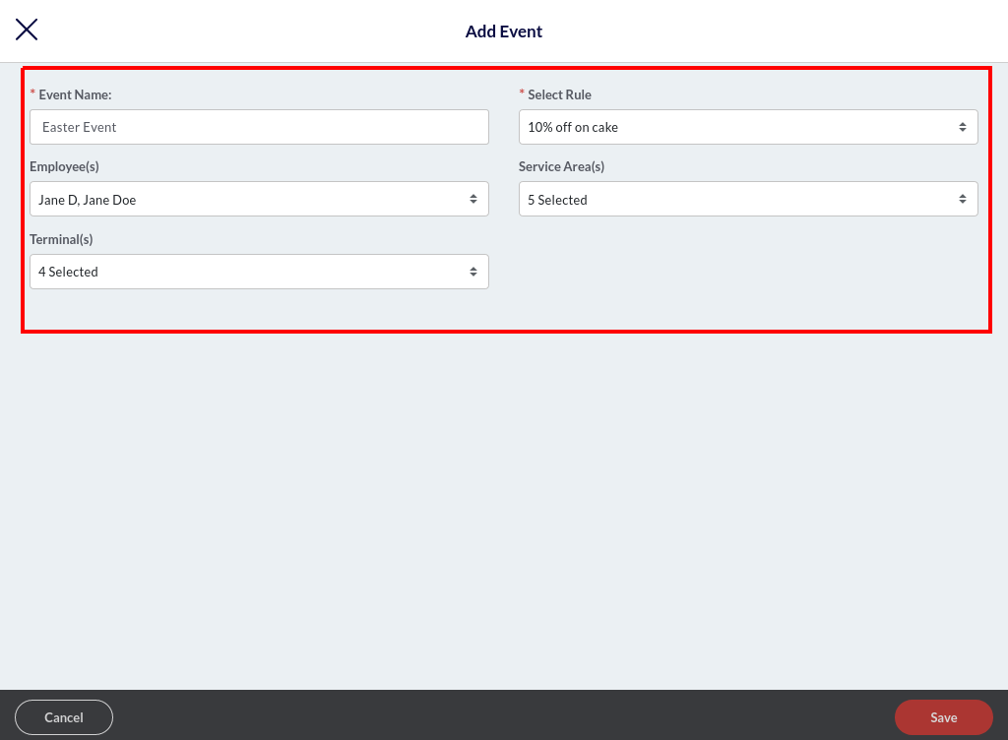

1. A new window will appear, here you can create an event and customize it the way you want.
   1. **Event Name**: Enter the event name. For example, Easter Event.
   2. **Select Rule**: Tap this field and select the promotion rule from the drop-down. This will associate the event with the selected promotion rule, and the preset prices will apply during the promotional period. For example, you can select 10% off on cake promotional rules for the Easter Event.
   3. **Employees**: Select the employees to authorize them to apply this promotional price. Other employees won’t be able to apply the Promotion.
   4. **Service Areas**: Select the service areas where you want this promotion to be applicable.
   5. **Terminals**: Select the terminals where you want this promotion to be applicable.
2. Once done, please click the **Save** button.

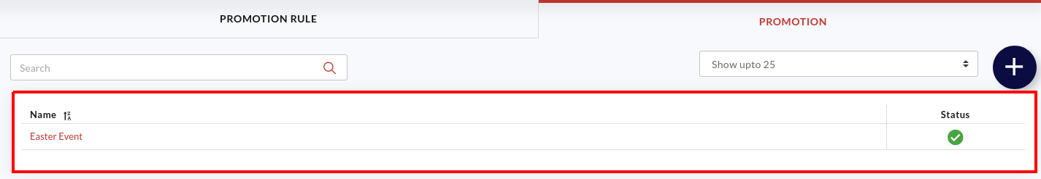

1. The added events will appear under the Promotion tab as shown in the screenshot above.
2. The  under **Status** symbolizes the promotion is active and  means a promotion is inactive. You can tap on the  or  to reverse the action.

### Associate an item with the promotion

Once you have created the promotion and set up the rules, the next step is to associate the items with an apt event. It allows you to offer the items as per the rules set in the promotional rule. For example, you can set the chocolate truffle to be associated with the Easter Event (10% off promotion rule).

| **Note**: You can also associate the entire category with a promotion. This will apply the promotion rule to all the items in that category. To apply the category-level promotion, go to the **Catalog** > **Category** > **select category** from the list > **Additional Settings** and tap the checkbox next to the **Enable Event.** Now select the event to be applied and click **Save**. |
| --- |

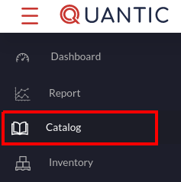

1. Navigate to the **Catalog** section on the left panel.

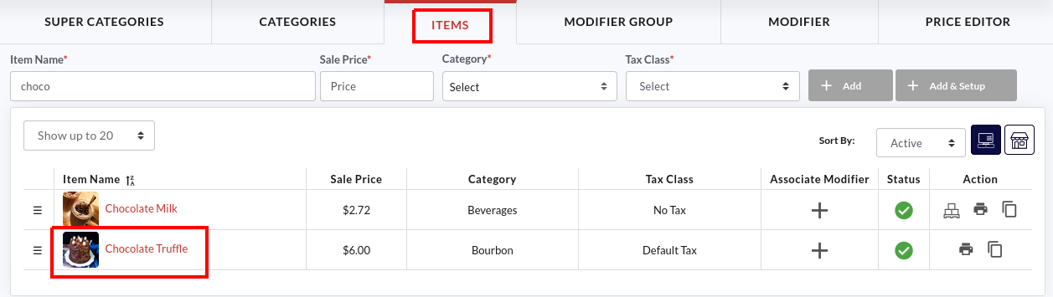

1. Click the **Items** tab and tap on the item that you want to associate with an event.

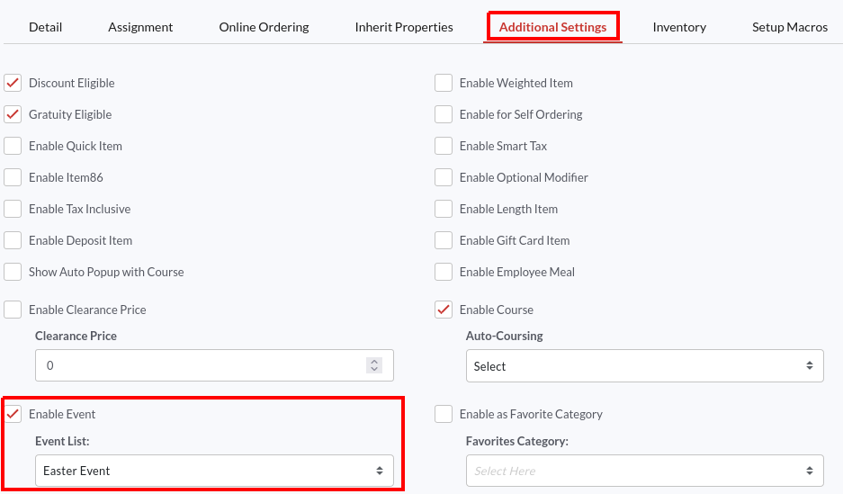

1. Go to the **Additional Settings** tab, select the **Enable Event** option and select the promotion from the **Event List**. The preset rules of the promotion will be applicable to this item. In this example, we have associated the *chocolate truffle cake* with an *Easter Event* promotion, and during that period, the chocolate truffle cake will be offered at 10% less price.
2. Once done, click **Save**.

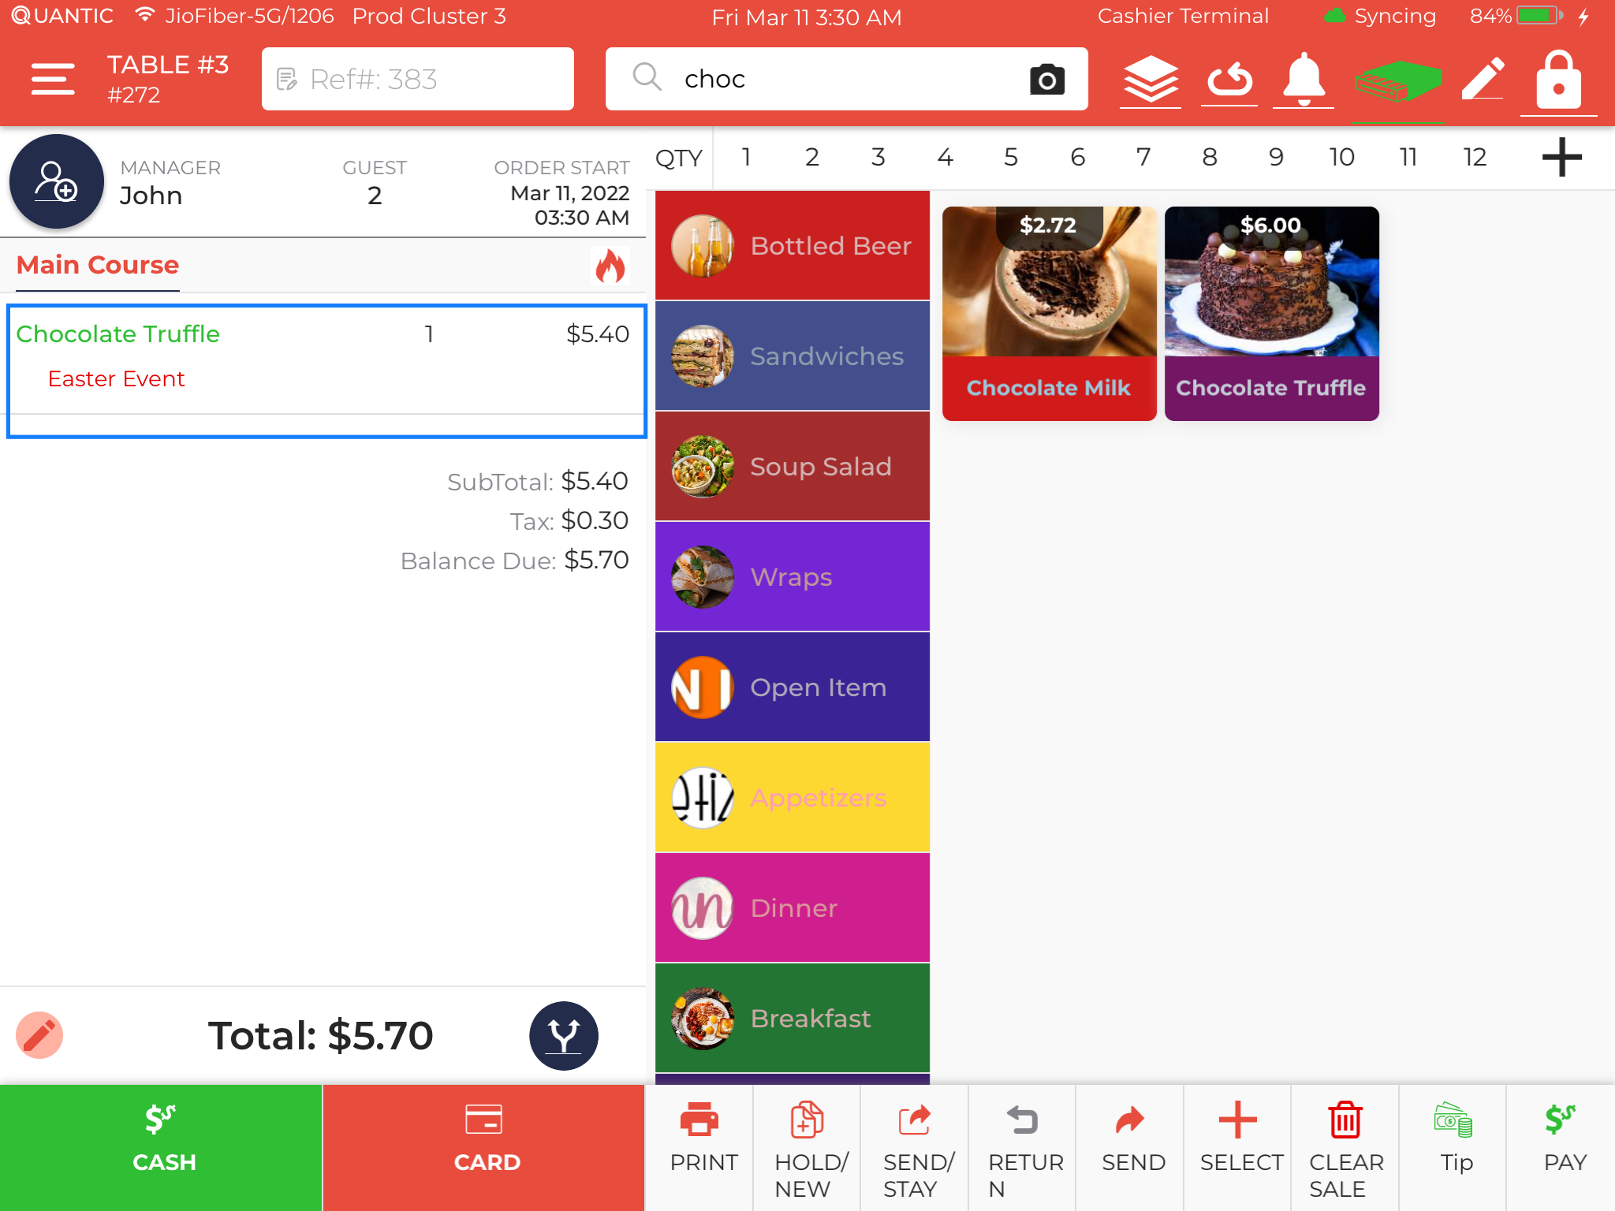

1. Take a look at this POS screen, the chocolate truffle cake has been ordered during the Easter Event promotion period, that’s why the **Easter Event** is written underneath the chocolate truffle cake. The revised item price will be displayed next to the item. Here, you can see the actual price of chocolate truffle cake was $6.00, but during the Easter Event (10% off on cakes), the new price comes out to be $5.40.

## How to Create a Terminal Based Menu?

Restaurants can create terminal-based menus from the backend portal. This new feature will allow them to set different menu items for different terminals. For example, you can create a Bar Terminal and display only the bar related items in that terminal or you can create a specialized menu for the Main Dining Terminal using this feature. Below are the steps you may follow to enable the terminal-based menu on your POS.

### Enable the Terminal Based Menu Configuration

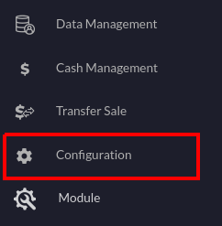

1. Login to your location’s backend portal. Or you can visit the [www.myquantic.com](http://www.myquantic.com) website and use your login credentials to access the backend portal.
2. Tap the **Hamburger** icon  on the top left and click **Configurations**.

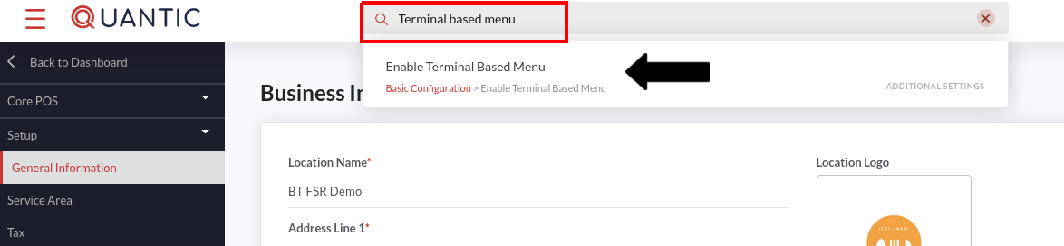

1. Tap the search box on the top, enter the terminal-based menu and click the option “**Enable Terminal based menu**” that appears underneath.

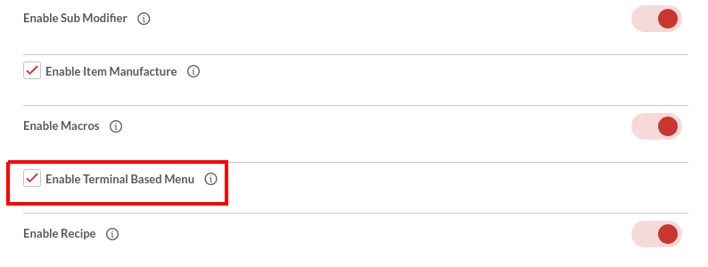

1. Select the checkbox next to **Enable Terminal based** menu.
2. Click the **Back to Dashboard** button.

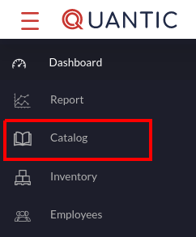

1. Again click the Hamburger icon  on the top left and click **Catalog**.

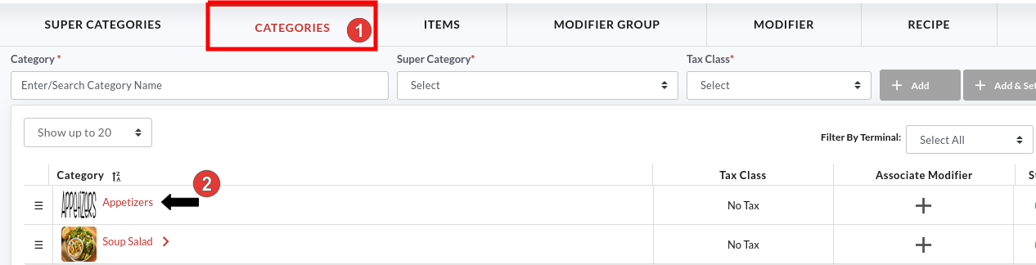

1. Now tap the **Categories** tab. The list of categories will appear on your screen.
2. To assign a terminal to a category, you need to navigate to the category of choice and assign terminal(s) to it.
3. Tap the Category name.

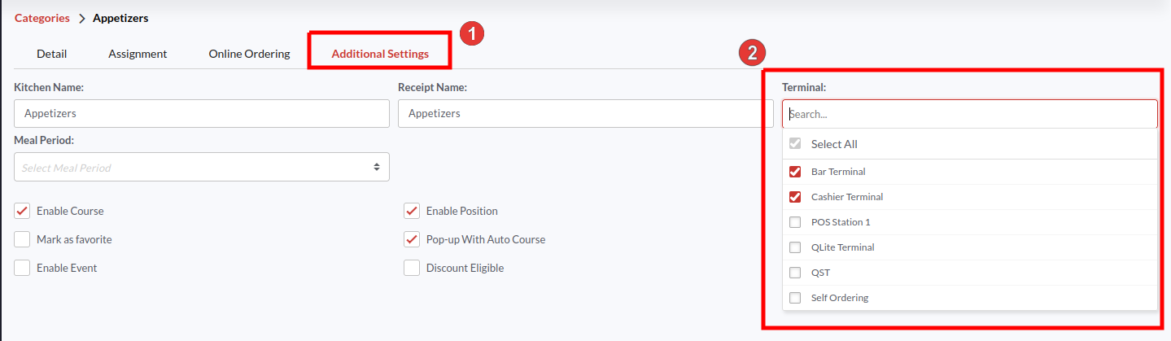

1. Click the **Additional Settings** tab as shown in the screenshot.
2. Tap the **Terminal** field and select the terminal from the drop-down. You may select multiple or all terminals where you want to display your category.
3. In the end, please don’t forget to click the **Save** button to save the changes.

### Filtering the Categories by Terminal

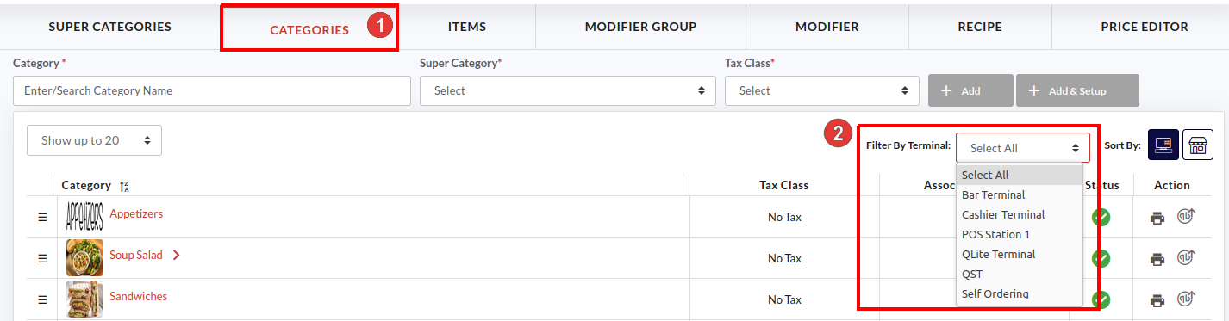

1. Once you have assigned the categories to specific terminals, you can filter them by terminal and review which Terminal has what Categories.
2. Go back to the **Categories** section in **Catalog** and tap the **Filter by Terminal** field.

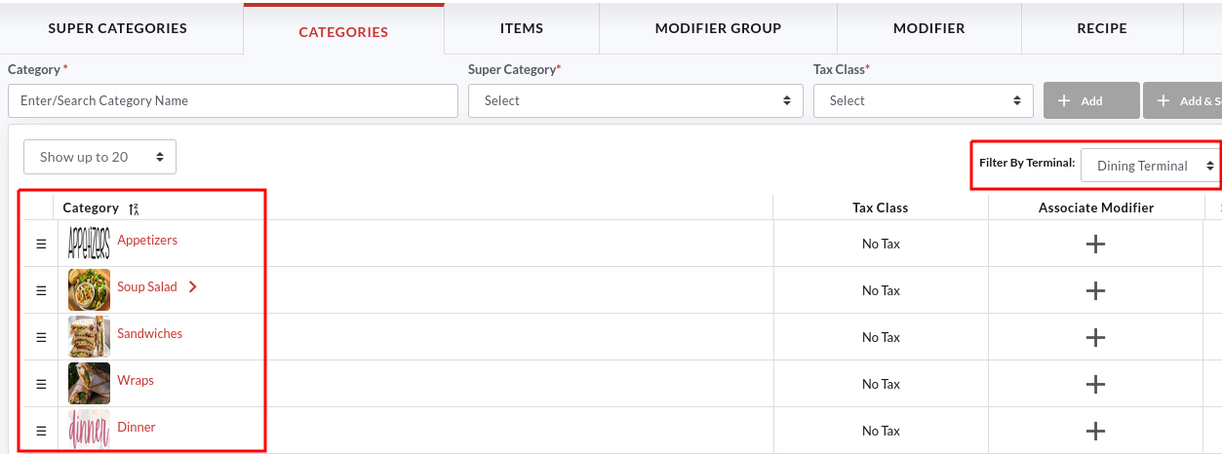

1. So, if you choose the **Dining Terminal**, the associated categories will appear on your screen. Similarly, you can select any terminal and review the associated categories.
2. You can also change the sorting order of categories by pressing the  button and dragging it to the desired position. The same order will reflect on the location’s POS. Below is the representation of how the above sorting order for the Dining Terminal looks in the POS.

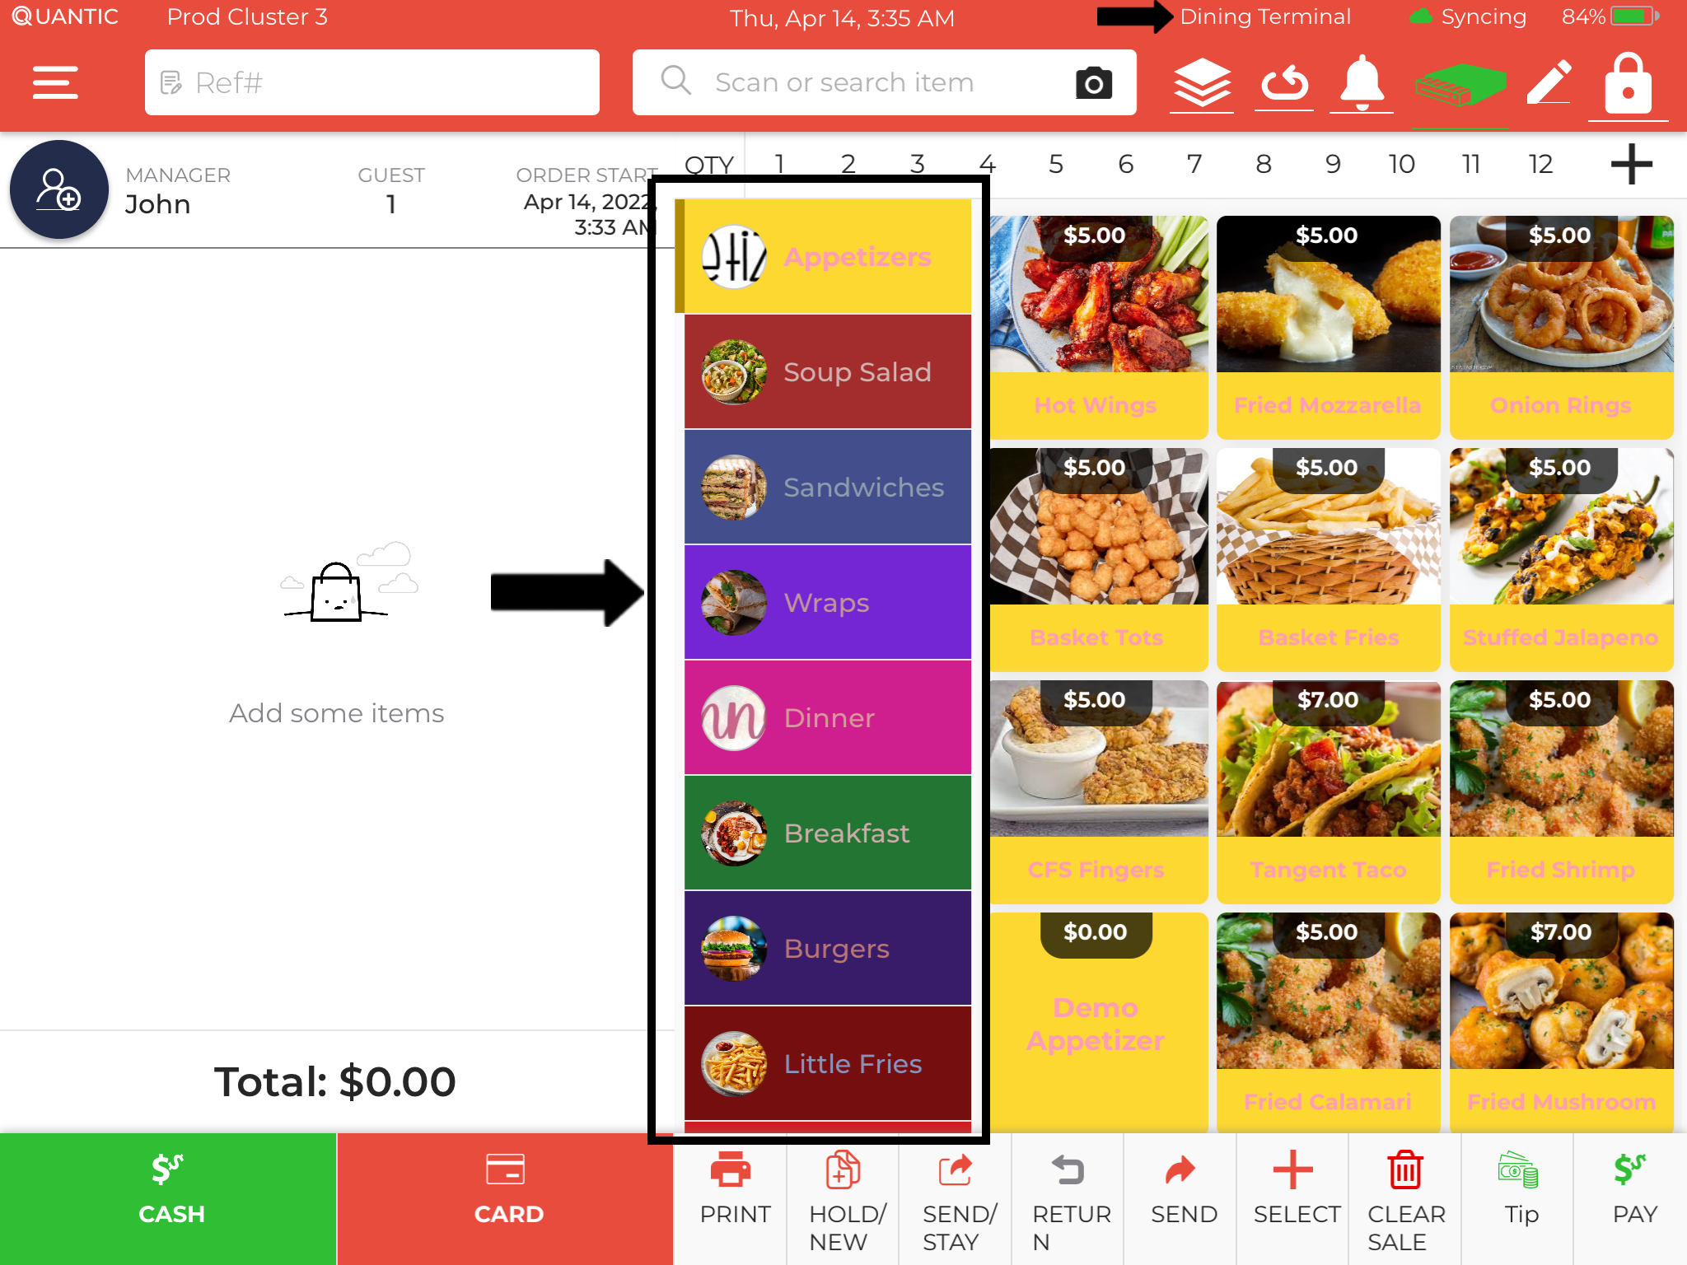

1. The category sorting order in POS will replicate that of the backend portal for a particular terminal. Please make sure that you have enabled the terminal based menu configuration in the POS.

## Setup and Display Suggested Tip Amount on Receipt

Suggested Tips are displayed on the receipts, generally at the bottom. Tip suggestion makes it easy for your guests to select any of the suggested tip amounts and pay for the services of the waitstaff. Quantic allows you to configure the suggested tip amounts from the backend portal. You can set as many Suggested Tip amounts to display on your receipts. Here’s how you can do it.

### Enabling the Suggested Tips on Receipt

The suggested tips can be displayed on the receipts by following the steps given below.



1. Log in to the backend portal.
2. Go to the **Configurations**.

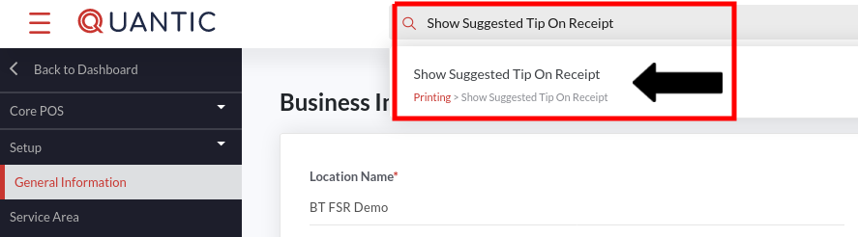

1. Tap the search box on top, enter “**Show Suggested Tip On Receipt”** and select the option underneath as shown in the screenshot.

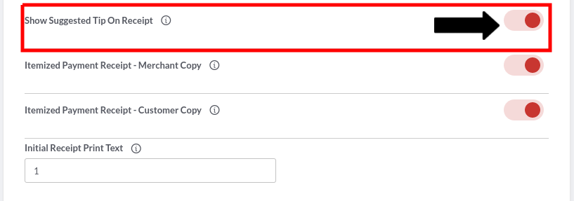

1. Turn on the toggle switch next to “**Show Suggested Tip On Receipt**” to enable this setting.

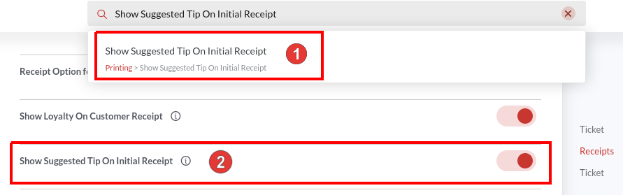

1. Similarly, search for the “**Show Suggested Tip On Initial Receipt**” configuration and turn on the toggle switch next to this configuration. Check the screenshot.

### Customizing the Suggested Tips for Each Service Area

Now as the Suggested Tip is a service area based setting, so you will have to configure it separately for each service area. So, if you want the suggested tips to be shown on the Main Dining service area receipts, you will have to visit the Main Dining service area in the backend portal and set up the suggested tips from there. Below are the steps.

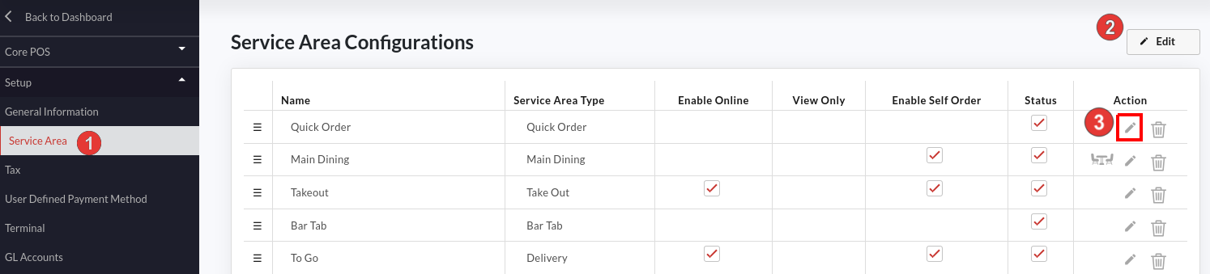

1. Go to the **Configurations**.
2. Under **Setup**, click the **Service Area**.
3. Click **Edit** and tap the  icon next to the service area where you want to set the suggested tips.

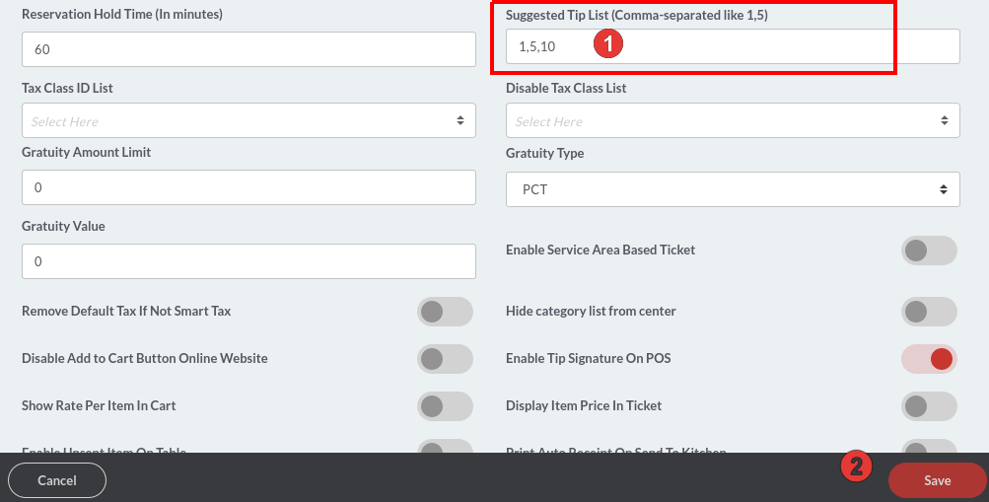

1. Tap the field underneath the **Suggested Tip List** and enter the tip percentage separated by a comma(,). In this illustration, we have set up three suggested tip percentages- 1, 5, and 10.
2. Click **Save** to save the changes. Now onwards your receipts will contain a section that displays your suggested tip % with the tip amount.

**Selecting Tips from the Suggested Tips**

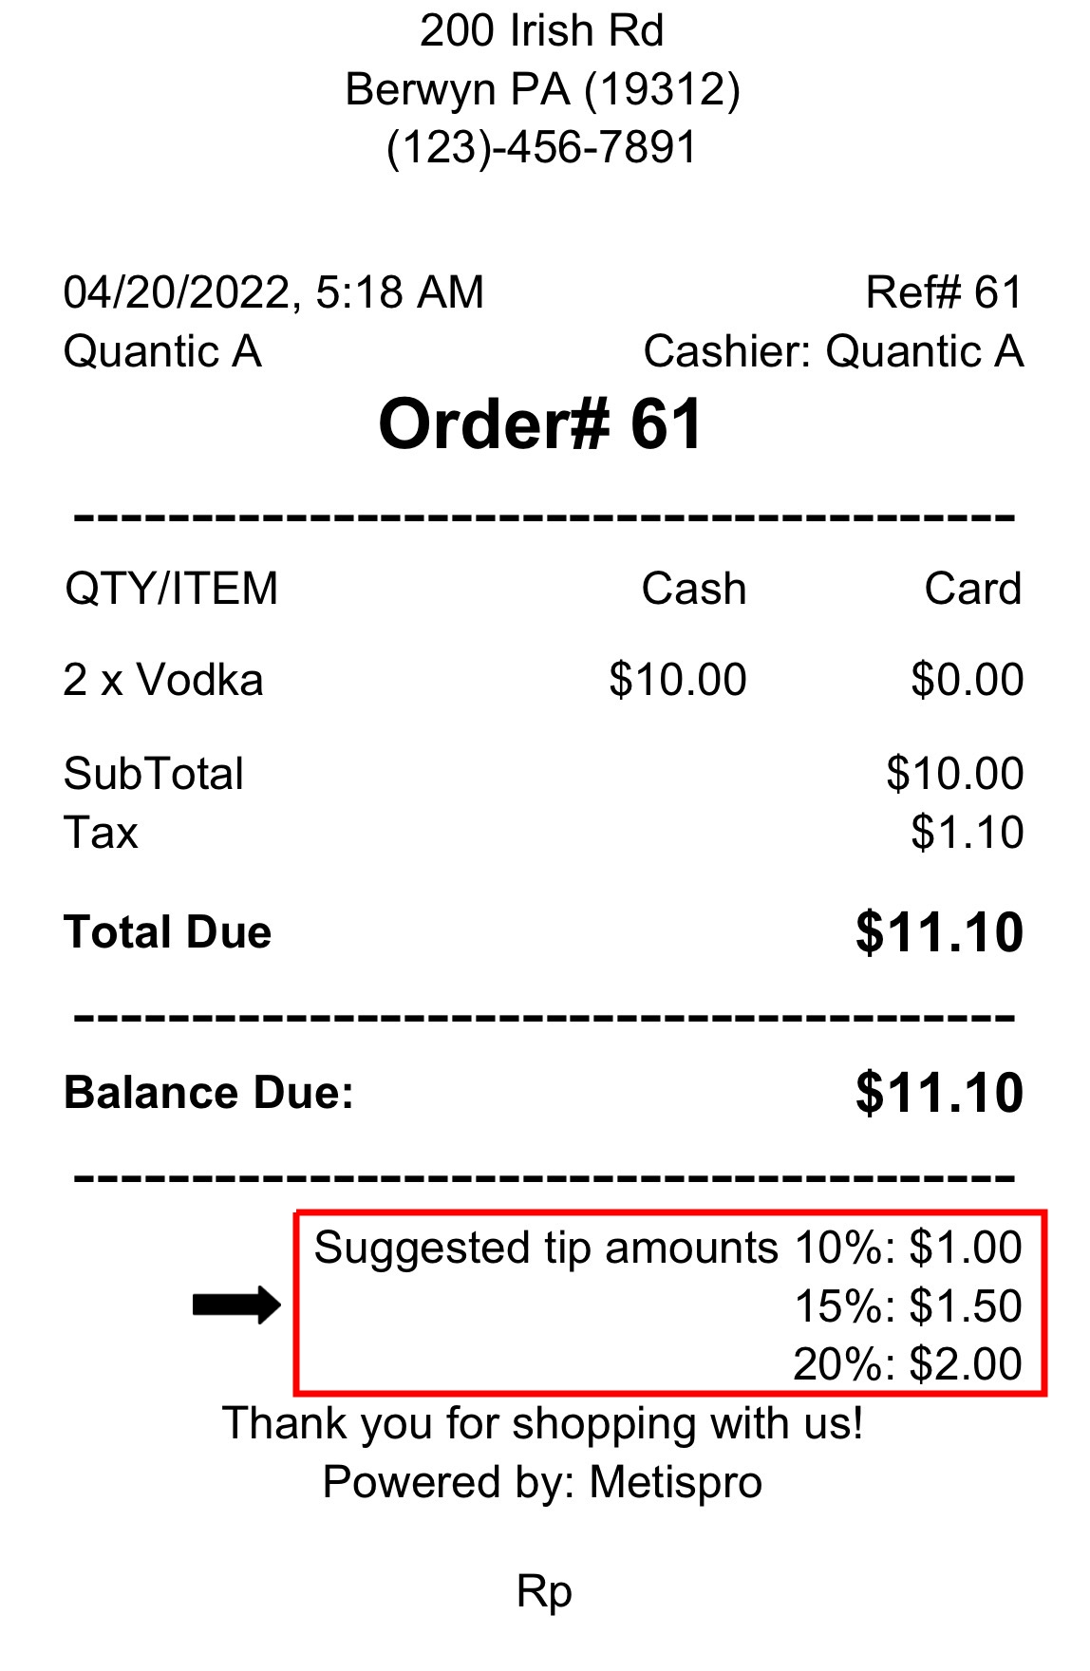

1. After paying for the order, a receipt will be generated with suggested tips mentioned on it. The guest can select from the suggested tips displayed on the order receipts.
2. Tip amount is mentioned on the receipt based on the percentage set at the backend. So, if you have set 1%, 5%, and 10% as the suggested tip percentage in the backend portal, the suggested tip amount will be calculated accordingly and the same amount will reflect on the receipts as well.
3. Now the guest will select the tip from the receipt, sign the receipt (authorizing the restaurant to deduct the chosen tip amount) and the same amount will be deducted by the server from the saved card. Please save the order number, you will require it while adding tips in the POS.

### Applying Tip Amount on the POS

Once the tip amount is deducted, the same has to be applied to the POS for that order.

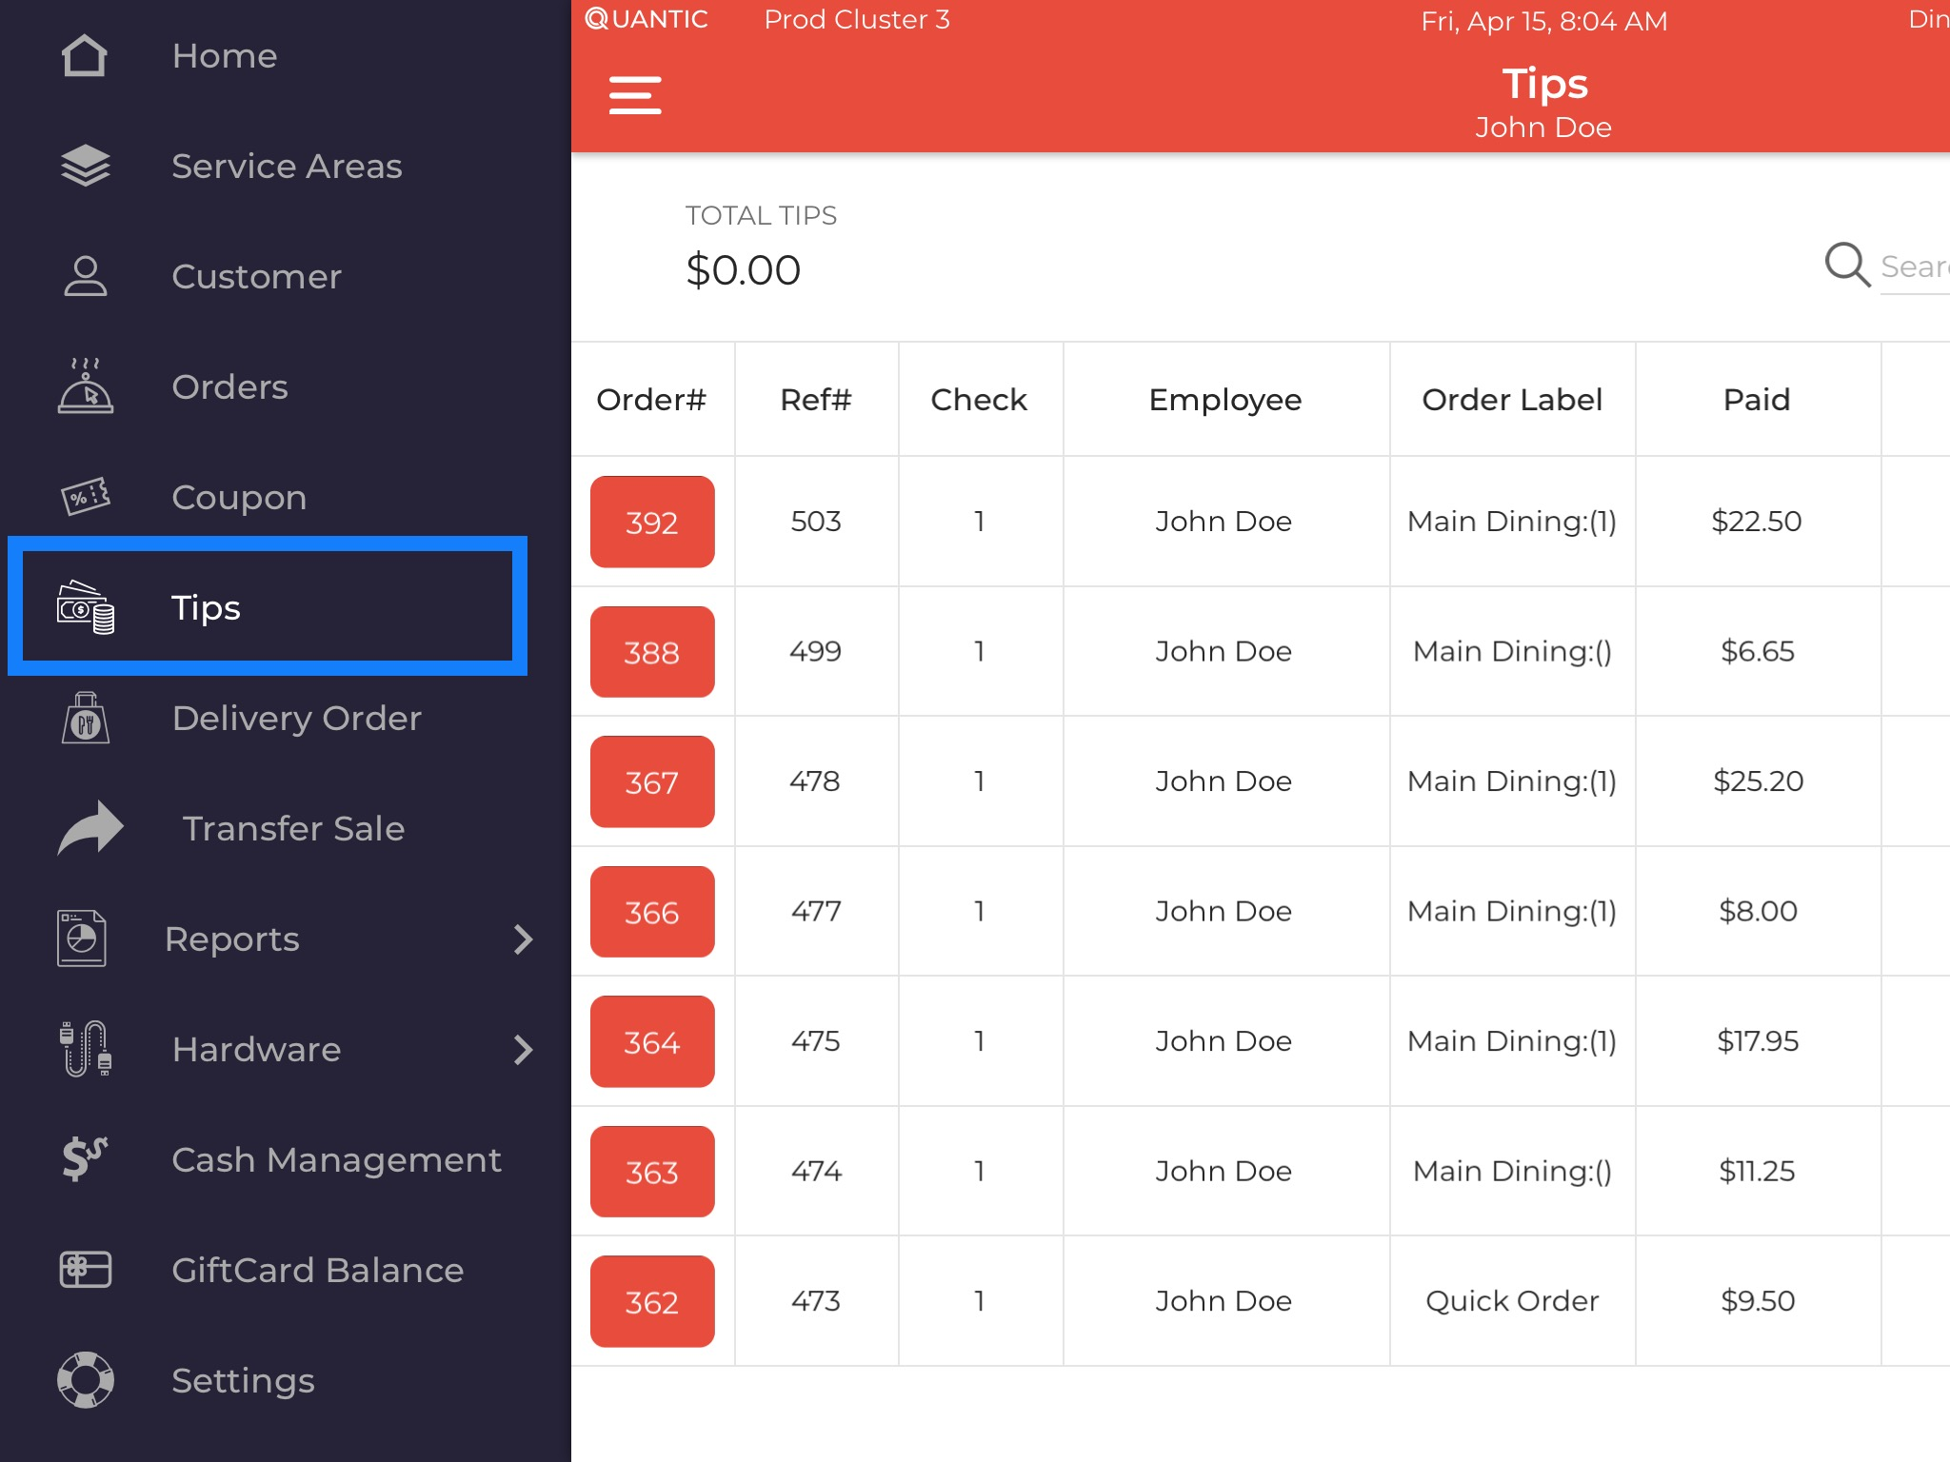

1. Log in to the location’s Quantic POS app.
2. Go to the left navigation menu and select **Tips**.

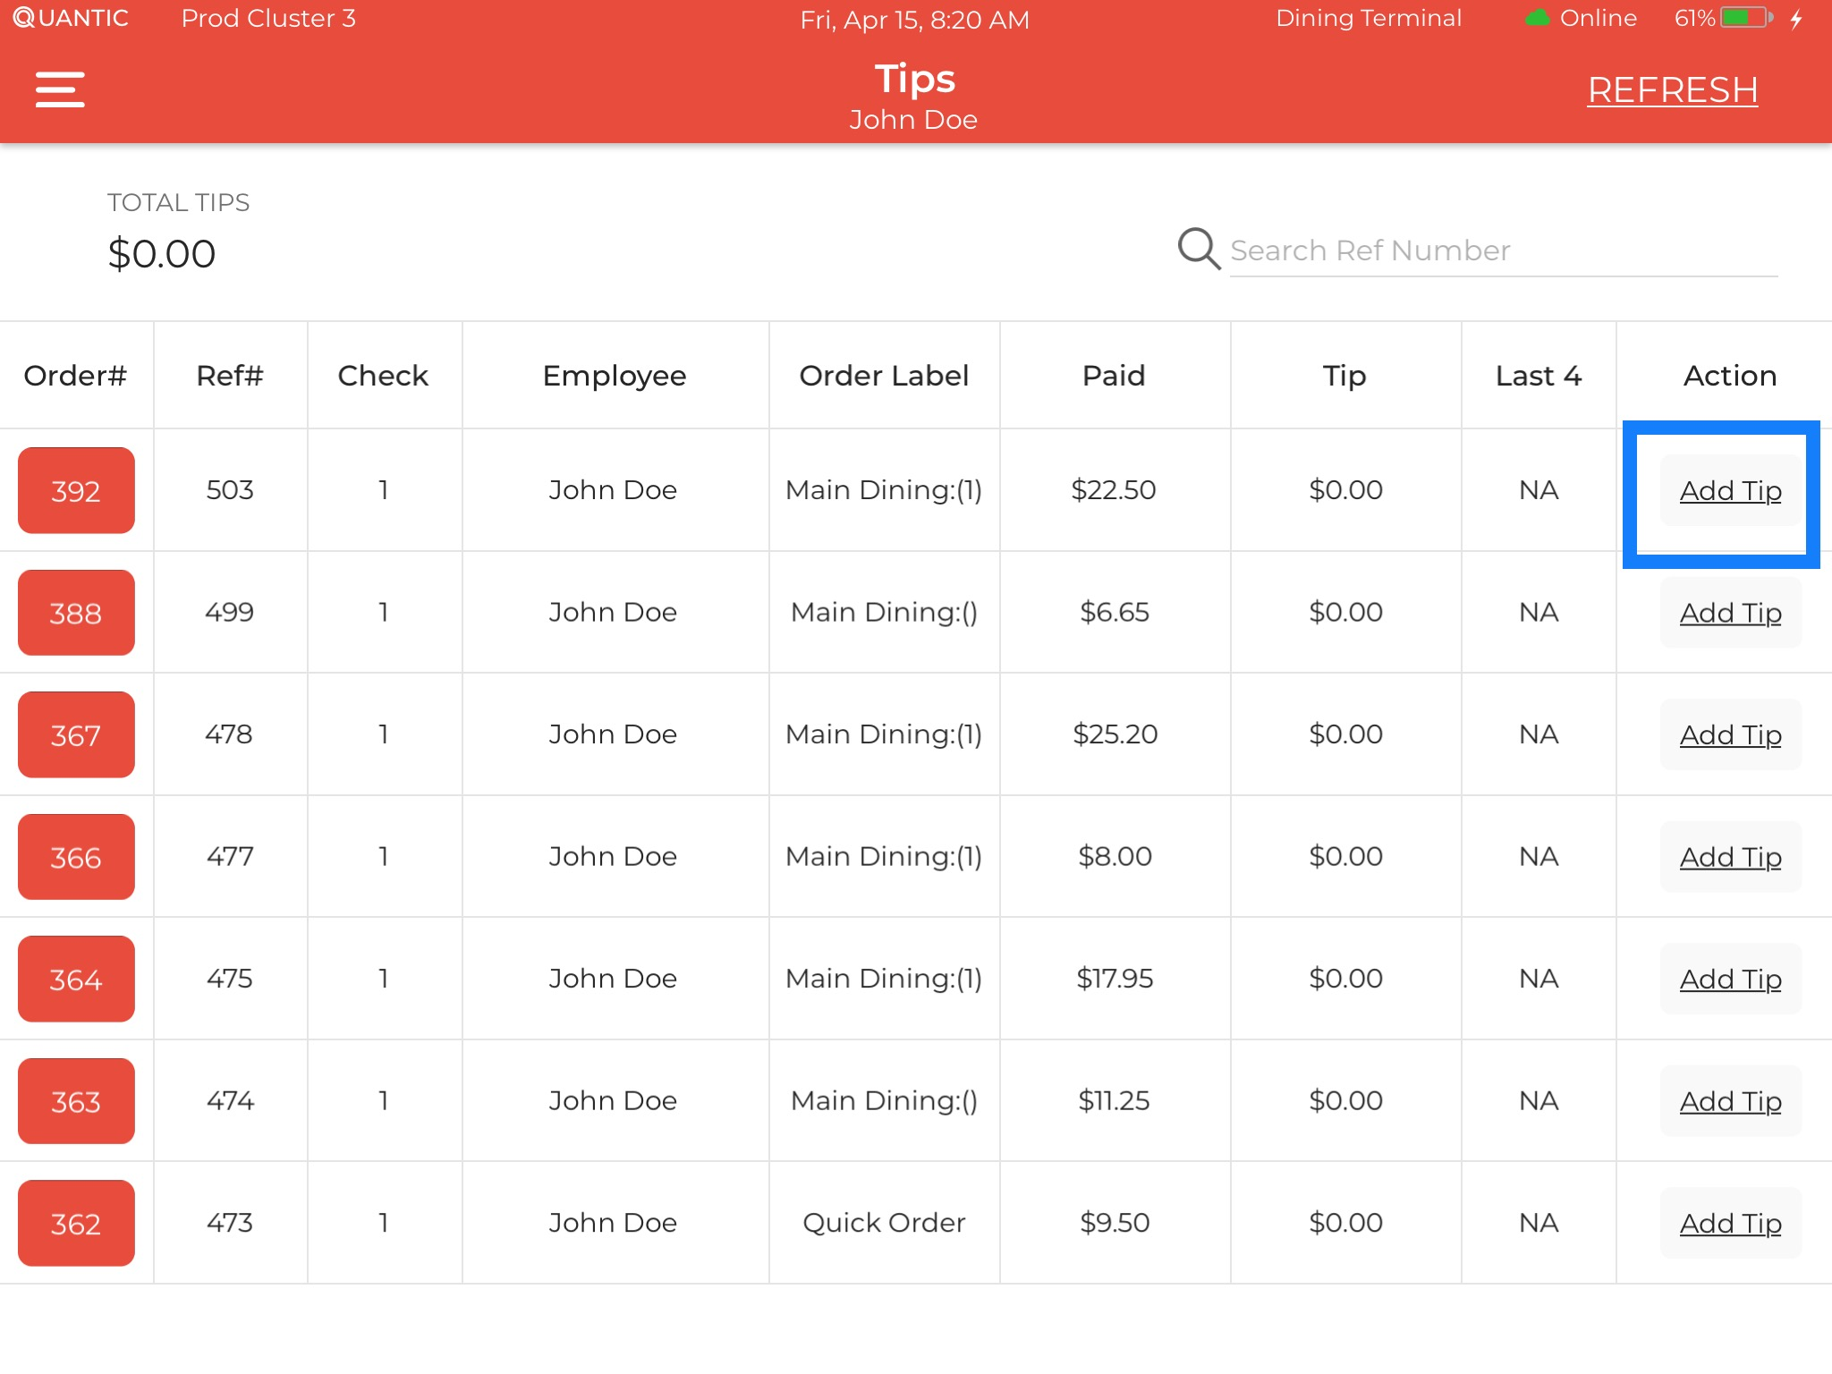

1. Locate the order number for which you have received the tip. Click **Add Tip** next to that order.

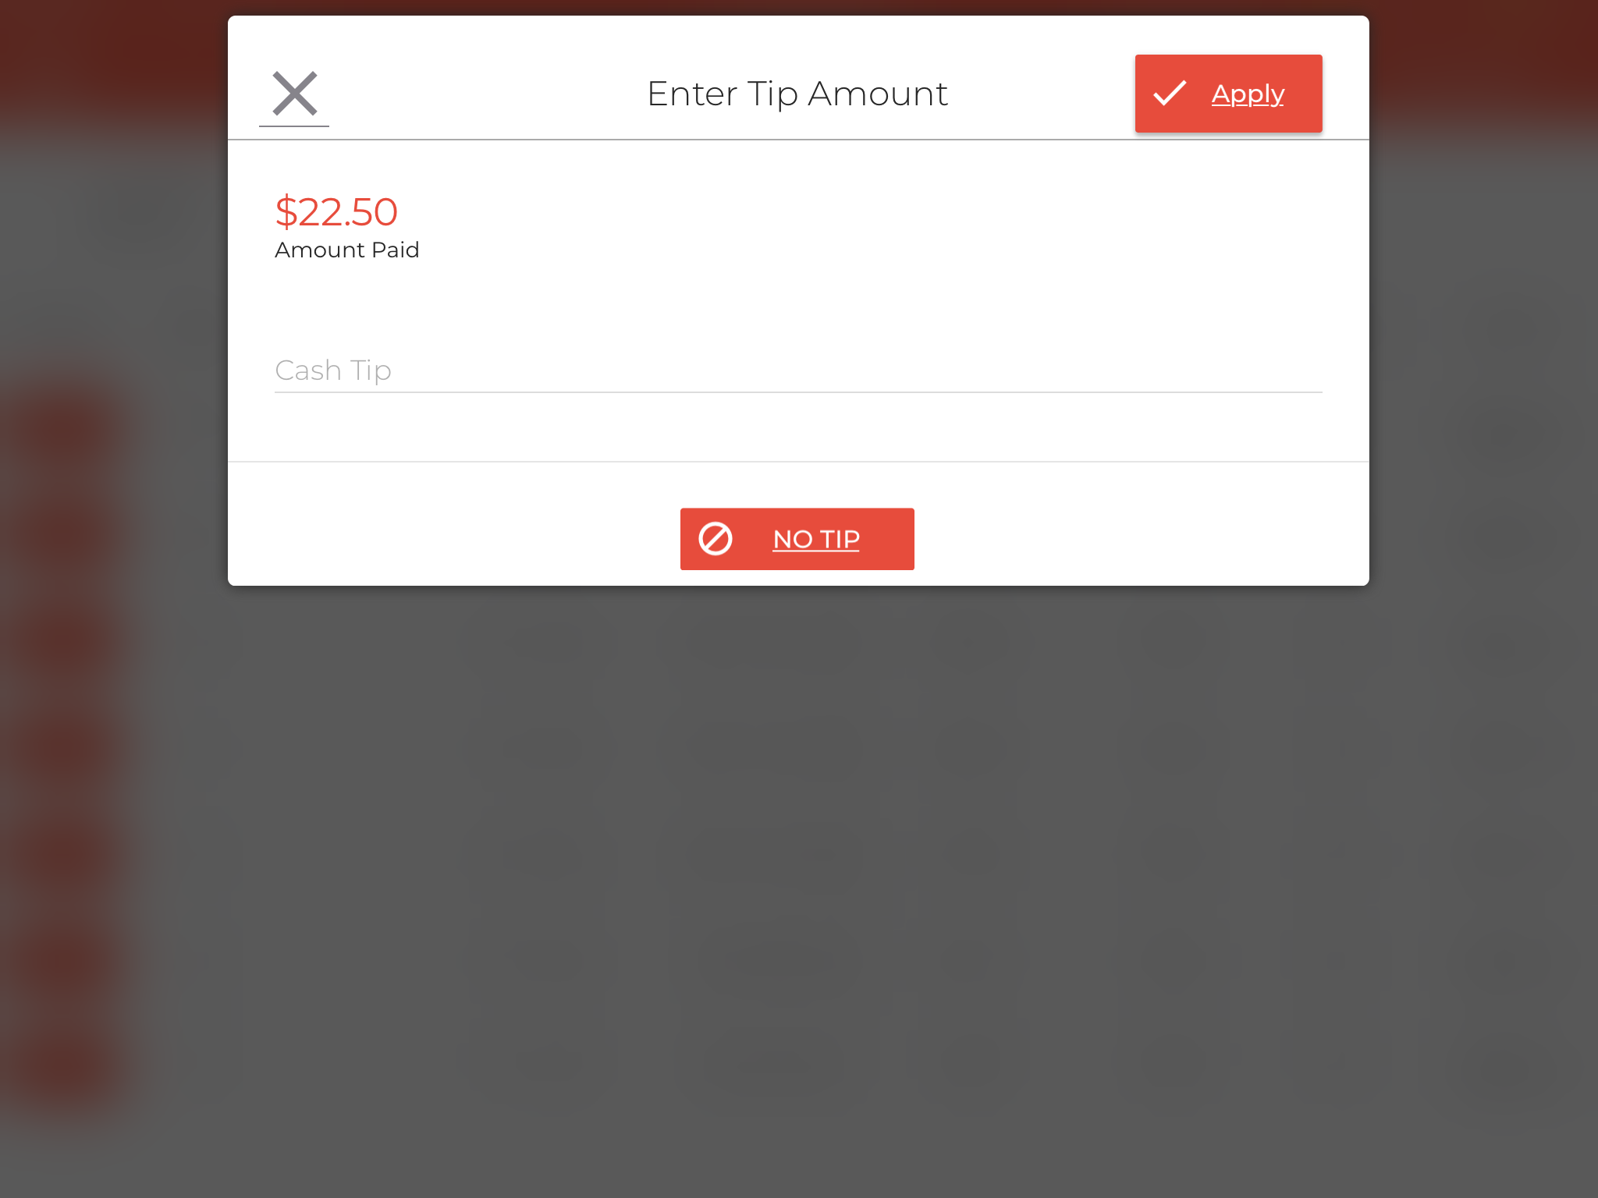

1. Enter the tip amount received in the field.
2. Once done, click **Apply** and the tip amount will be saved for this order.

## How to Setup and Display QR Code on the Receipt

QR codes can be printed on the receipts to accept the payments from the guests. Once the items are added to the cart, the server can click the Print button at the bottom of the POS, the receipt printer will print the receipt with a QR code. Guests can scan that QR code from their mobile’s scanner and pay the balance due online. A few configurations need to be enabled from the backend portal to display the QR on the receipts. Below are the steps to help you set it up on your own.

### Enabling the QR Code on the Receipt



1. Login to the location’s backend portal.
2. Click the **Hamburger** icon on the top left and click **Configurations**.

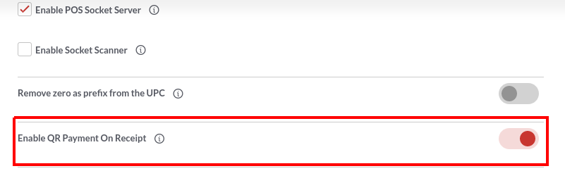

1. Go to the search bar on top and enter “**Enable QR Payment On Receipt**”.
2. Now click the option that appears underneath.
3. Turn on the toggle switch next to “**Enable QR Payment On Receipt**” to enable this setting.

### Printing Receipt from the POS

|  | 1. Login to the location’s POS app. 2. Go to the order screen. 3. Add items to the cart and Tap the **Print** button at the bottom of the POS. |
| --- | --- |

|  | 1. Now the order receipt will print from the receipt printer. The QR code will be printed at the bottom of the receipt which the guest can scan to pay the balance due. |
| --- | --- |

**Scanning the QR Code to Pay**

|  | 1. On scanning the QR code, the payment gateway browser will open on your screen with balance due mentioned on it. 2. Customers can click the **Card** button to proceed to the next screen. |
| --- | --- |

|  | 1. Guests can also pay the tip by entering the tip amount on the screen. 2. Once done, click the **Pay** button to apply the tip to the order. 3. Apply **No Tip** if there is no tip to be paid. |
| --- | --- |

|  | 1. Finally, the card payment screen will appear where guests can enter the card details and click Pay to complete the payment. |
| --- | --- |

## How to Push Inventory from Master to Child Location?

Quantic allows you to send the inventory from Master location to child location. Moreover, the child location’s item level inventory will be visible at the master location. Below are the steps on how you can add the inventory at the child location directly from the master location.

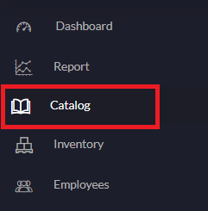

1. Open the master location’s backend portal, and click **Catalog** on the left navigation panel.

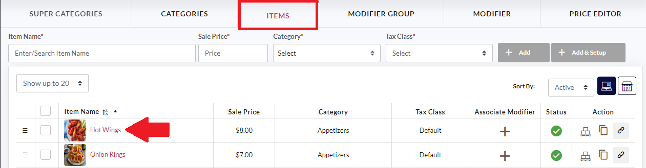

1. Click the **Item** tab on the top and select the item that needs to be pushed to the child location.

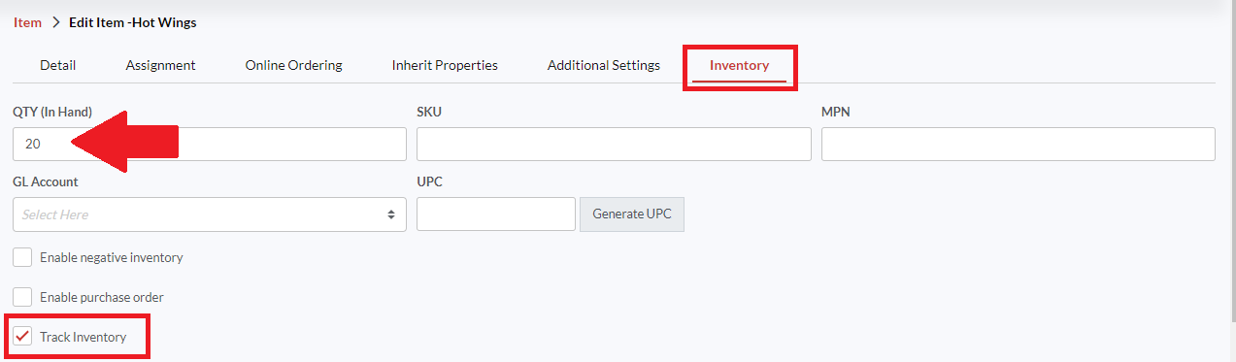

1. Go to the **Inventory** tab, enter the **QTY(In Hand)**- the in hand item quantity and make sure the **Track Inventory** option is checkmarked.
2. Click **Save** to save the changes.

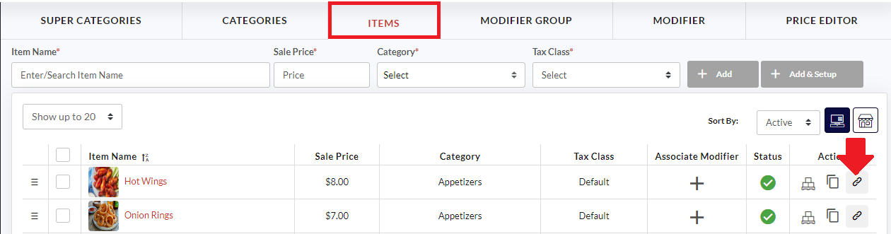

1. Click  next to the item under **Action** to push that item to the child locations.

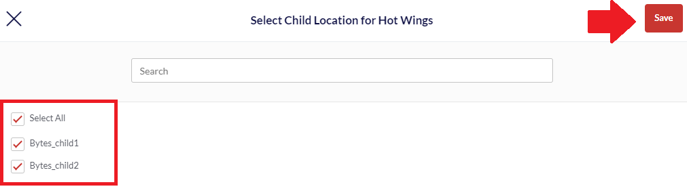

1. Select the child locations from the list and click **Save**.

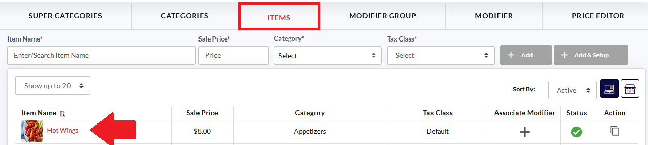

1. Now open the child location’s backend portal.
2. Go to the **Catalog** on the left navigation, select the item that you have pushed from the master location.

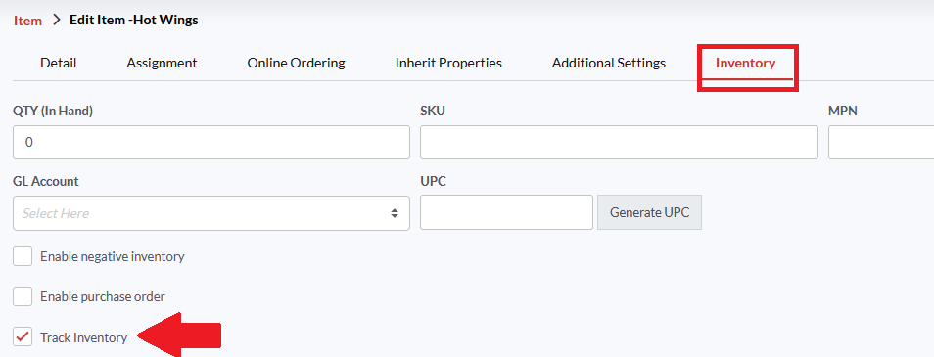

1. Click the **Inventory** tab, select the **Track Inventory** checkbox and click **Save**.

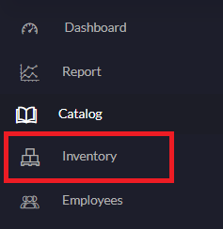

1. Open the Master location’s backend portal, tap **Inventory** on the left navigation.



1. Search for the item and tap the  button.
2. The child locations will be displayed underneath to which this item has been pushed.
3. Now tap the  icon next to that item under the **QTY In Hand** section.

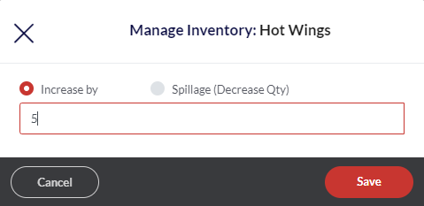

1. Enter the quantity with which you want to increase or decrease the item quantity.
2. Don't forget to click the **Save** button.

|  |  |
| --- | --- |
| **Item inventory at the master location** | **Item inventory at the child location** |

1. Once done, the item quantity will start displaying next to the item name and the same quantity will get updated at the child location’s backend portal.
2. Similarly, you can manage the inventories of all child locations from the master location.

### Pushing all the changes together from the Data Management

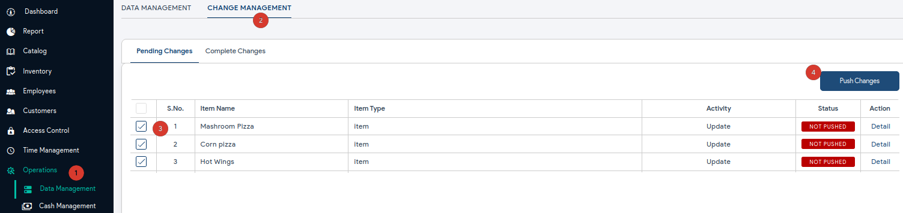

Quantic backend portal allows you to push the inventory changes from the Master location’s back office portal to the Child location. The Change Management section in the Data Management has all the items whose inventory has been changed. It helps you to collectively push all the changes without doing it specifically from the item level.

1. Go to **Operations** and click **Data Management**.
2. Select **Change Management** as shown in the illustration.
3. Select the item(s) to be pushed to the Child location.
4. Tap the **Push Changes** button once you are sure to push the changes.